WAT-E2130 EXAM 2 -- Process control June 07, 2023
Answer the following questions.
- (4p) Explain the following control terms:

  - Controlled variables.
  - Manipulated variables.
  - Disturbances.
Provide some practical examples related to wastewater treatment plants, specifying the instrumentation needed and their use in control loops.

- (4p) Describe the typical elements of a feedback control loop and schematically include them in a block diagram. Present and discuss how a P feedback controller operates.

- (6p) Figure 1 provides the process reaction curve (upper plot) resulting from a step-function change in the manipulated variable (lower plot). Answer to the following:
- Given Figure 1, compute the parameters of process model in the form of $G\left(s\right)= \frac{Ke^{-αs}}{τs+1}$ .
- Briefly explain the meaning of the parameters $K, α$ and $τ$.
- Briefly explain how the model $G\left(s\right)$ can be used for tuning a PID controller.

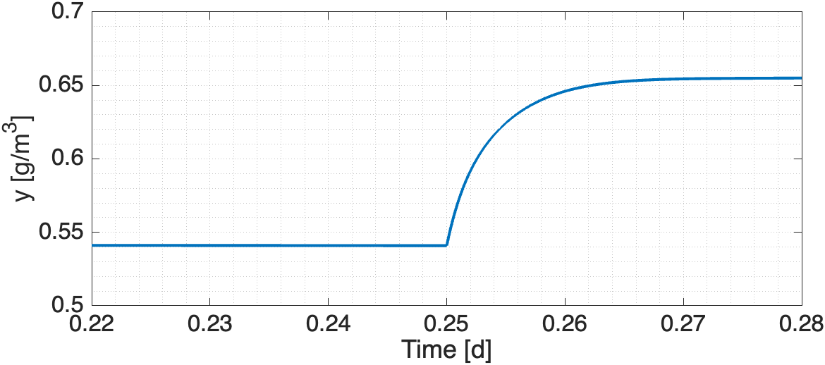
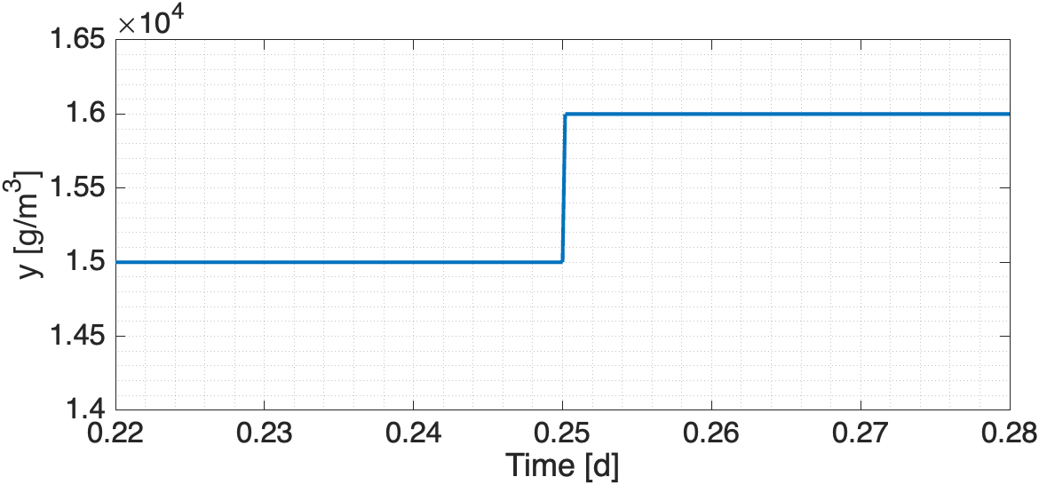
Figure 1. Process reaction curve for question 3.

- (6p) For controlling the plant schematically represented in Figure 2 you have the possibility of acquiring TWO sensors or analysers, answer to the following:
  - Define the measuring instrumentation needed for the task, locate it into the plant. Identify the corresponding manipulated variables and define the corresponding control configuration.
  - Define and justify reasonable values for the set-points of the controlled variables and a plausible range of operation for the manipulated ones.
  - Discuss the possible effects of your control strategy on the plant performances, especially in terms of operating costs and effluent quality.
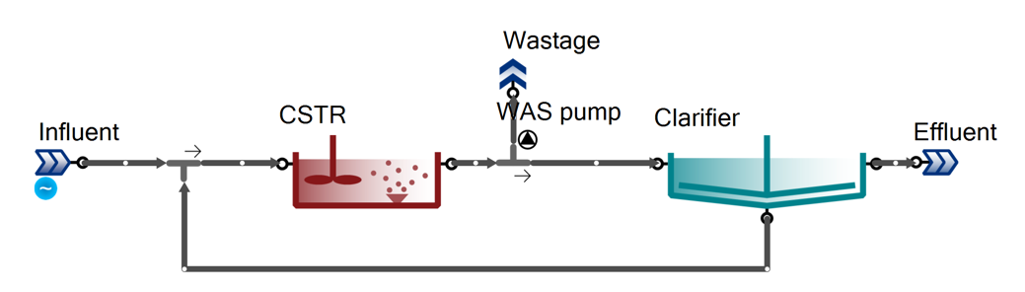
Figure 2. Plant layout for question 4

