Instructions on time management with the help of a timeline
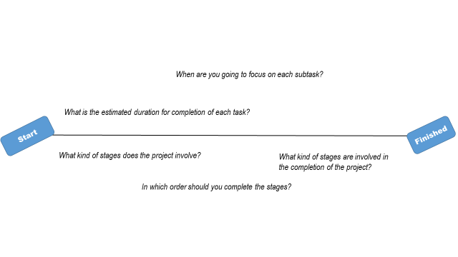
- Take out an empty sheet of paper (one A3-size sheet or several A4-size sheets), place them horizontally and draw as many horizontal lines across the paper as you have courses in the teaching period. Add a box/bullet at the start of each line, where you write ‘Start’ and do a similar one to the other ends of each line and write ‘End/Finished’.
  - Set a personal goal for each course and write it next to the ‘End’ boxes.
  - Divide each line into seven parts (as one period lasts seven weeks).

- Next, think about the stages that passing the course successfully will require. What milestones and subtasks does the project involve (submitting assignments, reading an exam book, studying the lecture slides)?
  - Place the deadlines, exam dates and other key dates on top of the timeline.
  - What is the first thing you should do to further the personal goal you set for the course? Write that at the start of your line.
  - Then write all the rest of the stages needed to pass the course in their order of completion on the line.
  - Try to estimate the duration of each stage and distribute the stages evenly over the duration of the course.

- Finally, look at the overall workload: are there subtasks of several courses concentrated on the same weeks? Could you start some stages earlier or later to even out the workload between the different weeks?
- How will you take care of your energy and wellbeing daily, weekly and monthly? What kind of self-care tasks should you add to your timeline? Add also days-off, holidays and rewards (how do you reward yourself when your goals are reached) on this timeline. More useful ideas about energy-management can be found for example from the article Manage Your Energy, Not Your Time by Tony Schwartz and Catherine McCarthy (Harvard Business Review), so check it out if haven’t already done it!
- Follow your plan and estimate your progress with the help of your timeline.

After you have followed your plan for some weeks, send picture of your timeline and answer these questions:

- How would you describe your timeline (and time management skills in longer periods in general) to somebody else? How realistic has your timeline been so far? If it hasn’t been realistic, what are the main reasons for that?
- What works for you in this kind of “timeline planning” and what does not? What did you learn (and why) about yourself/ time management? If you didn’t learn anything new, why not (did you already knew about these methods, etc)?
- Do you have any useful hints or ways of planning and scheduling studies, which were not mentioned in this set of materials? They may include methods you have used previously or that you came across elsewhere over the time. Make a list of them and explain why they work for you. Give as many ideas you want, but at least one or two.

