[template for Weekly task of global week]

Course: WAT-E1100
Date: 06.09.2023
Group number: Group_number
Group name: Group_name
Group members: N.N., N.N., N.N., N.N.

Title

[short introduction]

SWOT matrix

Place the attributes to below matrix using word tools, or downloading the vector graphic of it from MyCourses and fill it with e.g. Adobe Illustrator. Place all the identified attributes and clearly mark (e.g. bolded) the three most important ones under each category.

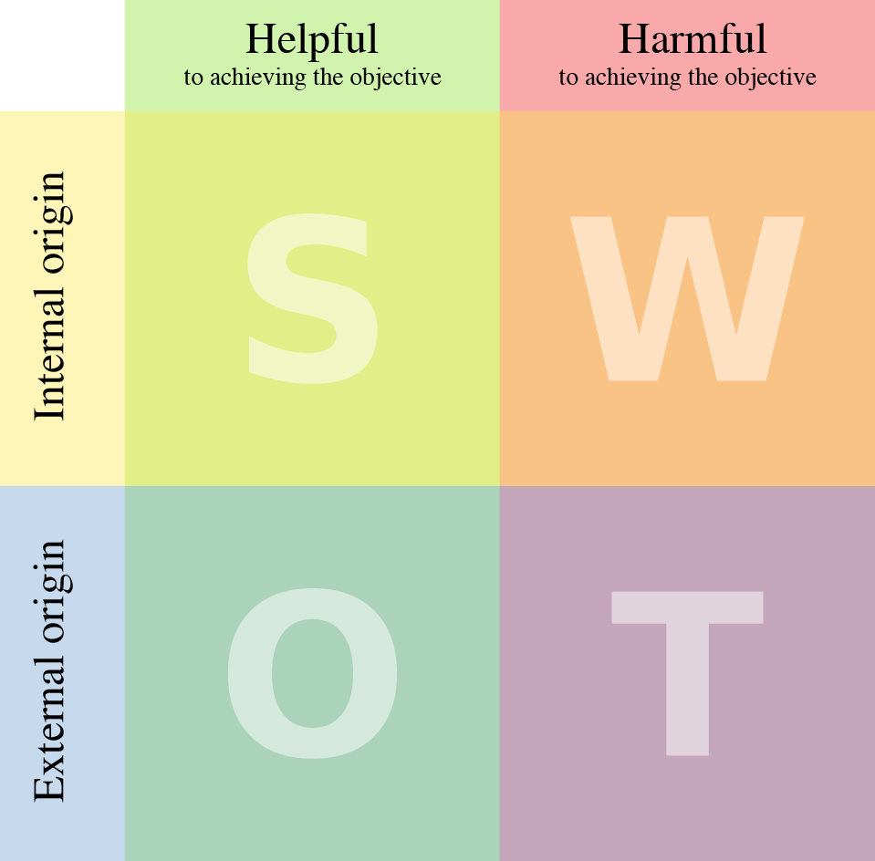

Explanation of attributes
Here, add short justification / explanation of the three most important ones under each category (i.e. in total 12).

STRENGTHS

S1: name_of_attributes
Justification/explanation

S2: name_of_attributes
Justification/explanation

S3: name_of_attributes
Justification/explanation

WEAKNESSES

W1: name_of_attributes
Justification/explanation

W2: name_of_attributes
Justification/explanation

W3: name_of_attributes
Justification/explanation

OPPORTUNITIES

O1: name_of_attributes
Justification/explanation

O2: name_of_attributes
Justification/explanation

O3: name_of_attributes
Justification/explanation

THREATS

T1: name_of_attributes
Justification/explanation

T2: name_of_attributes
Justification/explanation

T3: name_of_attributes
Justification/explanation
References

