[TECHNOLOGY](https://www.theatlantic.com/technology/)

The AI *Mona Lisa*Explains Everything

Depending on how you look at it, generative AI is either astonishingly powerful or totally pointless.

By [Caroline Mimbs Nyce](https://www.theatlantic.com/author/caroline-mimbs-nyce/)

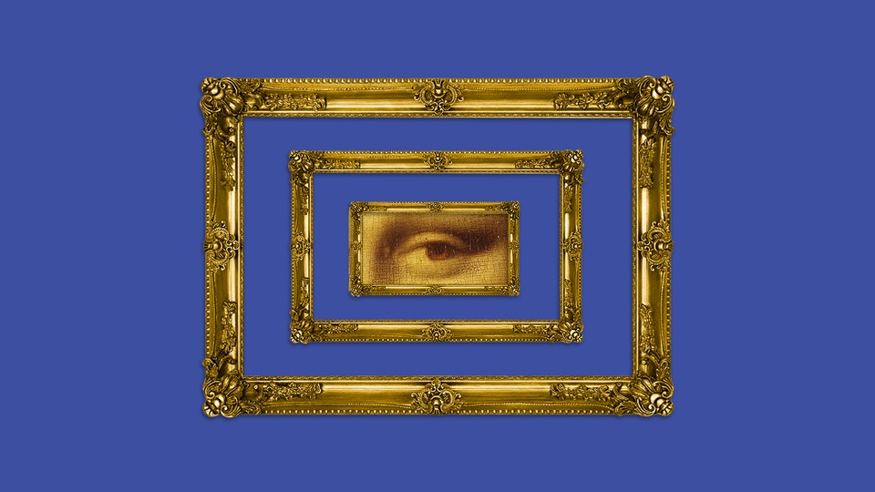

Ben Kothe / The Atlantic. Source: Getty.

*The Atlantic* JUNE 6, 2023

The *Mona Lisa* is small. Less than three feet tall and about two feet wide, it hangs tiny in the [biggest exhibition room at France’s Louvre Museum](https://www.louvre.fr/en/explore/the-palace/from-the-mona-lisa-to-the-wedding-feast-at-cana). And in the past two or so weeks, some vigilante AI artists have decided that it should be bigger—much bigger. They’re making that happen using a beta tool in Adobe Photoshop called “generative fill.” It launched late last month and allows users to fill in, augment, or expand an image using AI—think ChatGPT but for Photoshop. (It uses Adobe’s “Firefly” AI models, which are trained on its stock photography.) Amateur and professional editors alike can use a text prompt to, say, add clouds to a picture of a blue sky, or widen a photo of a beach to include additional, computer-rendered beach.

In [a new, enlarged version of Leonardo da Vinci’s portrait](https://twitter.com/heykody/status/1662168390352666624) created with the tool, the painting’s subject takes up just a small part of the canvas. She is there, familiar as ever, except she’s surrounded by a brooding landscape. And that’s about it. The bottom half of her body is still missing. Another post takes Vincent Van Gogh’s *The Bedroom* and [grows it into a bigger bedroom](https://twitter.com/heykody/status/1662168466080796672). Perhaps the most outrageous of the bunch builds on Piet Mondrian’s *Composition With Red Blue and Yellow*, surrounding the famously minimalist work [with additional rectangles of varying sizes](https://twitter.com/heykody/status/1662168454202552320/photo/1). Others used generative fill to widen [classic album covers](https://twitter.com/dobrokotov/status/1662576774557884416?s=20) or [film shots](https://twitter.com/vashikoo/status/1662313124081590274).

People [got very angry](https://mashable.com/article/ai-art-expanding-classics-mona-lisa-memes-jokes) about these expansions. They [pointed out](https://www.forbes.com/sites/danidiplacido/2023/05/31/tech-bros-are-trying-to-improve-the-mona-lisa-using-ai/?sh=19e93e340f86) that the generated images miss an important point: Artists compose and [constrain their works intentionally](https://twitter.com/WillSloanEsq/status/1663646109737054208?). Da Vinci painted a portrait not because he was incapable of painting a landscape, but because he chose to paint a portrait. The revised works, they complained, weren’t even good! If one were to go about expanding the *Mona Lisa*, one could at the very least have the decency to [give her some legs](https://twitter.com/meganroseruiz/status/1663580612261978112).

But the AI *Mona Lisa* is the perfect metaphor for where we are with generative AI. We can quickly and easily do things that once took a lot of time and skill. Reimagining the*Mona Lisa* from a wider perspective has been possible ever since there *was* a*Mona Lisa*; it just would have required actual craftsmanship, paint, a canvas, and so on. Now a computer can do it for you in mere seconds. But why? Was there something wrong with the original*Mona Lisa*? Even if you’re using the tools in earnest, there’s a good chance their output will be derivative or dull, because generative AI is fundamentally about remixing rather than creating something entirely new.

Most of the use cases for generative AI being sold to us right now are like this. We are told that this AI will completely change the world as we know it—Bill Gates and other technologists are claiming that it is [as revolutionary as the invention of the internet](https://www.gatesnotes.com/The-Age-of-AI-Has-Begun). “AI is the tech the world [has always wanted](https://twitter.com/sama/status/1655220700100313088),” OpenAI CEO Sam Altman tweeted last month. And then we are offered applications that fall well short of world-changing. Bing is [integrating AI into its search functionality](https://www.theatlantic.com/technology/archive/2023/05/microsoft-bing-chatbot-search-information-consolidation/673958/) so that users can … well, what exactly? Find answers in a different way? Meanwhile people are [already losing their job to chatbots](https://www.washingtonpost.com/technology/2023/06/02/ai-taking-jobs/).

AI enthusiasts will breathlessly tell you about how ChatGPT can [draft work emails](https://medium.com/@riki_bril/how-i-make-1000-personalization-emails-in-1-minute-with-google-sheets-x-chatgpt-85bfd846fce0) or [render PowerPoint presentations](https://www.tiktok.com/@aiavalanche/video/7235956828465614107) in seconds. But to what end? People are right to wonder if we really need more emails, just like they’re right to wonder if we really need a bigger *Mona Lisa*. All of this computational firepower is being directed at uses that seem more like corporate gimmicks than anything substantive.

Which isn’t to say that applications of AI won’t someday be world-altering, or that we won’t be able to harness its power in ways that move us. It’s just that AI hype currently outpaces its abilities. Contrast the viral *Mona Lisa* tweet with the other big AI story last week: an open letter signed by hundreds of experts warning that, unchecked, artificial intelligence could pose an [extinction-level threat on par with nuclear war](https://www.theatlantic.com/technology/archive/2023/06/ai-regulation-sam-altman-bill-gates/674278/). Together, these stories offer a perfect synopsis of the moment: AI is going to either kill us, or bore us with endless [riffs on Edward Hopper](https://twitter.com/heykody/status/1662168431976943616).

If this story has a silver lining, it’s that a lot of people—millions, if you trust the analytics on Twitter—are looking at art. That’s a good thing, András Szántó, a museum consultant and the author of *The Future of the Museum*, told me, even if these people are only “superficially engaged” with the works. When’s the last time you remember people raging online about the compositions of Renaissance paintings? Szántó was cautiously optimistic about the possibilities of AI art as a new medium, while acknowledging the thorny legal and ethical questions it raises.

And the idea of expanding the frame isn’t necessarily a bad one. What the Twitter interpretations miss is a distinct point of view, of the kind that human artists embed in their works all the time. “It’s just the same painting, a little wider,” the Pulitzer Prize–winning art critic Jerry Saltz told me. “I would love to see what’s in the wings of a Picasso, of a *Mona Lisa*, of a Michael Jackson album. That’s all interesting. But their answer to it isn’t.” I was reminded of Saltz’s [critique](https://www.vulture.com/article/jerry-saltz-moma-refik-anadol-unsupervised.html) of an AI-art installation at the Museum of Modern Art in February: “If AI is to create meaningful art,” he argued, “it will have to provide its own vision and vocabulary, its own sense of space, color, and form.”

In this particular instance, the computer just tramples on the artist’s perspective. “The AI appears to have missed the fact that in the original *Mona Lisa*, we clearly see a small column on a parapet on the left side of the painting,” Tina Ryan, a curator at the forthcoming Buffalo AKG Art Museum, wrote over email. That the subject is seated in a loggia, Ryan said, “might be symbolic of Leonardo’s fascination with the tension between man and nature.” The AI can deliver renderings of nature, but without any creative intent, they lack tension.

Before Photoshop’s update, the *Mona Lisa* was in the news last month for an entirely different reason. An Italian historian named Silvano Vinceti claims to [have found the ruins of the bridge](https://www.theguardian.com/artanddesign/2023/may/03/italian-historian-claims-to-have-identified-bridge-in-mona-lisa-backdrop) featured in the background of the painting, perhaps solving a long-running mystery. People curious as to what lurks beyond the canvas can now make a pilgrimage to the hills outside the small Tuscan town of Laterina, home to only 3,500 people. Or they could simply ask a generative-AI tool to render its best guess, close their eyes, and choose to inhabit the dreary landscape it dreams up.

[Caroline Mimbs Nyce](https://www.theatlantic.com/author/caroline-mimbs-nyce/) is a staff writer at *The Atlantic.*