Word Title Page
Roman Stepanov
September 13, 2021

Contents
ABSTRACT 1
References 2

Figure 1 (Maslow's Hierarchy of Needs) 2

ABSTRACT
Motivation has been the subject of numerous studies during recent decades, but this essay will focus on Maslow’s hierarchy of needs theory (Maslow, 1943) and Herzberg’s two-factor theory (Herzberg, 1966).

Figure 1 (Maslow's Hierarchy of Needs)
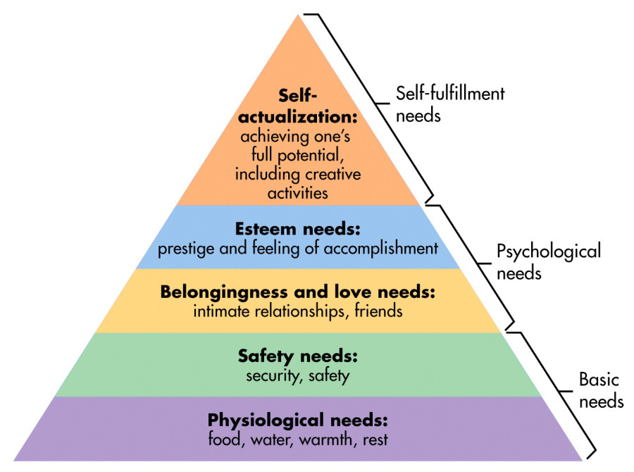

Their contemporary relevance to the need to motivate employees effectively will be examined critically (Ewen, 1966), given that this can be considered crucial to a firm’s survival in the current economic climate.

References
Ewen, R. B. (1966). An empirical test of the Herzberg two-factor theory. Journal of Applied Psychology 50 (6), 544 - 550.
Herzberg, F. (1966). Work and the nature of man. London: Staples Press.
Maslow, A. (1943). A theory of human motivation. Psychological Review, 50 (4), 370 - 396.

Journal article
Book

