Maritime Vessel Dynamic Positioning System description Marine Risks and Safety 2023

This guide aims to provide the reader with a basic introduction to Dynamic Positioning Systems to be used as the basis for Hazard and Risk analysis. It represents a simplified summary of industry standards, environment, systems, and components.
- Objectives
The Objectives of this document are to:
  - Support you in the Marine Risks and Safety 2022 assignment.
  - Describe the systems and the components of a DP system.
  - Detail the vessels operational context
  - Describe the tasks and functions associated with a DP system.

- General Overview
A Dynamic Positioning Systems (DPS) is a computer-controlled system that automatically keep vessels or offshore structures at a fixed position by using the thrust from a propeller or thruster, without using fixed devices such as an anchor or mooring lines. Dynamic positioning may either be absolute in that the position is locked to a fixed point over the bottom, or relative to a moving object like another ship. One may also position the ship at a determined angle towards wind and waves. The advantages of fully DP operated vessels is the ability to operate in deep-water, the flexibility to quickly establish position and leave locations.
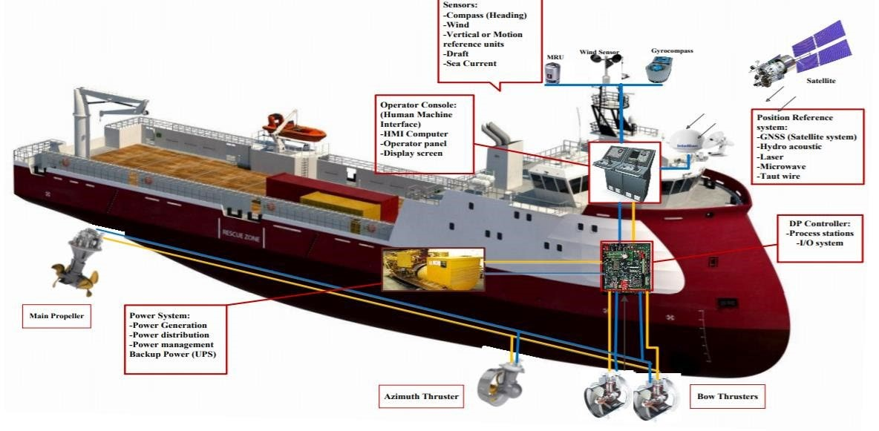
Figure 1 Figure overall description.

3. DPS Synopsis
The DPS described in this document is comprised of three sub-systems:
- Power system,
- Thruster system, and
- DP Control System
Each of these three systems work in unison to maintain the vessels heading and position, by controlling the horizontal movement of the vessel.

Power System
The power system is comprised of all component and associated systems necessary to supply the DP system with power, which includes, but is not limited to:
- Prime movers
- Generators
- Switchboards
- Distribution systems (cabling and cable routing)
- Uninterruptible power supplies and batteries

Thruster System
The thruster system is comprised of all the components and associated systems necessary to supply the DPS with variable force and direction thrust, which include:
- Thrusters with drive units and necessary auxiliary systems including piping, cooling, hydraulic and lubrication system
- The main propulsion system; propellers and rudders, z-drives, azipods, water jets, etc
- Auxiliary thrusters, tunnel thrusters, drop down thruster, z-drives
- Thruster control systems
- Manual thruster control
- Associated cabling and cable routing

DP Control System
The DP control system is comprised of all control components and associated systems, hardware, and software necessary to coordinate with the other sub-systems to maintain position, which includes:
- Computer system
- Joystick system
- Sensor system
- Control stations and display system
- Position reference system
- Associated cabling and cable routing
- Networks
- Alarm unit.

4. Functionality of DPS System components
When analyzing operational requirements, understanding vessel performance is a crucial aspect of the process.
- Power Systems: The DP ship power subsystem consists of power plants, distribution and switchboards system, transformers, electronic power units such as adjustable frequency drive (AFD), motor control system (MCS), energy-storing devices (ESD) and observing and robotics system. The power system is adequate to provide continuous power to the DP control system, thruster/propulsion systems and all the vessels other operational loads or power demands, so that the DPS can maintain the vessels desired position and heading.
    - The power system is divided into four systems controlled by two redundant DPS switchboards; (primary system 1 which serves as the prime mover, secondary system 1 comprised of three generators which are capable of powering the system with 60% combined power, secondary system 2 comprised of long life lithium-ion batteries for uninterrupted power, secondary system 3 which is an emergency generator and is redundancy for SS1) so that in the event of failure of one system, there will be at least one other system in operation to maintain the vessel in position.
    - Two automatic power management systems (PMS), that operate as redundant system according to the DPS class and for blackout prevention.
    - Secondary system 3 has the ability to provide for enough power to maintain the vessels position after worst-case failure.
    - All cabling is connected to the two redundant switchboards for ease of power control change.
    - General piping

- Thruster System: In the main DPS components, the thruster subsystem consists of important mechanisms, such as electronic drive units, principal propellers, bow, stern, and azimuth thrusters. They are controlled by DPS to compute allocating thrust force and tracking the path. Moreover, the thrust distribution system (TDS) which estimates the corresponding thrust power to command the direction of each thrusting motors. Furthermore, the effect of minimum control level of thrusting in calm to rough sea environments is emphasized to prevent the corrosion of mechanical parts, avoid the shutdown, and harmonic distortion in power delivery, respectively. The thruster system is arranged to provide the vessel with adequate maneuverability under all operating conditions. By providing adequate thrust to control surge, sway, and yawing. The thruster system has been arranged so that the failure of any part of the system including pitch, azimuth or speed control should not increase the thrust magnitude or direction.
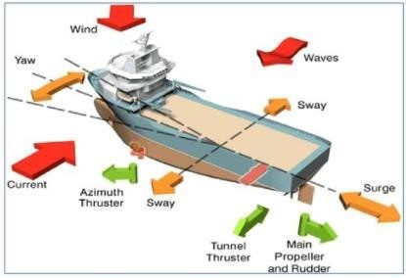
Figure 2 Ship movements and disturbances.

    - Azimuth and tunnel thruster for position stability.
    - The thruster emergency stop system is closed loop to detect any faults. The emergency stop facility is independent of the DP Control system, manual position control systems and manual thruster control systems are in place.
    - The thruster system is designed for continuous operation.
    - Built-in features are to be provided to prevent overloading of the drive system. Manual override of control is present so that pitch, rpm, azimuth, or other parameters of individual thrusters can be controlled, and the thruster can be stopped if necessary.
    - Thrusters in DP operation are to provide controllable thrust from zero load to full load in step-less increments. This can be achieved through control of the propeller pitch or the speed of the propeller, or other parameters.
    - The manual thruster control system is to be independent of the DP control systems so that it will be operational if the automatic control systems fail. The system is to provide an effective means of individually controlling each thruster from main DP control station. The system is to provide an individual lever for each thruster and to be located at the main DP control station.
    - Any failure in the manual position control system is not to affect the capabilities of the manual thruster control system to individually control each thruster or related group of thrusters.
    - Manual thruster control must be available at all times, also during all failure conditions in the main DP control system.
- Control System Computers: The control computers receive input from various sensors and reference systems to determine the vessels heading, position and the external forces being applied to the vessel. This information is then processed to determine the amount and direction of force that must be applied in order to counteract the external forces. The Power and Thrust sub-system then execute the commands given from the control system and exerts the desire force needed to maintain the desired heading and position.
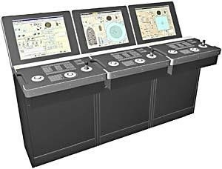
Figure 3 Control system.

  - The DPS control system is comprised two control stations: the first on the bridge, and second in the cargo control room.
  - Within each control room there is one computer systems so that in case of any single failure, automatic position keeping ability will be maintained. Each computer is connected to the onboard sensor system and control terminals.
  - Differential position sensors comprise of an 'All in One' signal processing core with advanced algorithms and true parallel processing of all available signals including SBAS (e.g. WAAS, EGNOS, MSAS). DGPS, DGLONASS, Galileo and Beidou corrections from different sources are combined by the unique MULTIREF capability. Ability to utilize high precision correction services, giving accuracy on decimeter level.
  - Thruster monitoring is provided at the control station, this system is continuously available to monitor:
    - RPM, pitch, azimuth
    - CPP hydraulic oil pressure and temperature
    - Thruster load and motor temperature
    - Thruster motor/semiconductor converter coolant leakage
    - Thruster motor/semiconductor converter temperature
    - Thruster motor power availability
    - Thruster motor short circuit
    - Lube oil pressure and temperature
    - Thruster operation (on-line/off-line)
  - There is an automatic control transfer process in place, so that in the event of a detected failure control can be handed off to the alternate computer system with no loss of position and/or heading.
  - In the control unit, the operator can set the maximum limit for position and heading deviation. During the DP operation, If the position or heading of vessel deviates from these provided limits the alarm unit then generates warnings and alarm to notify the operator.
  - For safety and review of operation two black box data retrieval points exist; one is integrated into the computers providing a secure uplink for remote access, the second is an onboard physical system.

- Position Reference System (PRS): For the DPS to maintain the vessel in a desired position, it must utilize a position reference system (PRS). The PRS identifies the vessels current position. This position will be either an Absolute Positions geographic location) or a Relative Position (relative to a target). Accurate, reliable and continuous position information is essential for dynamic positioning. A DPS requires data at a rate of once per second to achieve high precision. The dynamic position ships have some position reference system independent of the normal navigation system. The vessel utilizes both a Relative PRS and Absolute PRS to improve seakeeping and improve positional accuracy.
  - Relative PRS
    - A laser based PRS: a series of sensors are incorporated to form a robust motion stabilized rotating laser sensor which measures range and bearing to one or several retro-reflective targets installed on the vessel. Automatic wave motion stabilization provides optimum target lock. The onboard unit allows for easy configuration and monitoring of the vessel and is hardwired into the computer control systems.
    - Vertical reference unit (VRU): measures the vessel heave, roll and pitch motions. Angular velocities are also often available. One of the main functions for the VRU is to adjust the position measurements provided by GPS, hydroacoustic position reference (HPR) systems, etc. for roll and pitch motions. For deep-water DP operations the accuracy of the roll and pitch signals must be high providing accurate HPR position measurements.

  - Absolute PRS: Multiple PRS systems are used, each being based on different principles and suitable for the vessels operating conditions.
    - DPGS: is used to the systems high reliability, accurate and quality-controlled position, and velocity measures.
    - DGNSS: functions as a secondary system and is based on an enhancement to primary GNSS which enables the broadcasting of differential information to the vessel. This system is not the primary positioning system and in event of the DPGS failing couples the HPR system for greater reliability and to improve the accuracy of the vessels position.
    - Hydroacoustic Position Reference (HPR) System: By using one or several transponders located on fixed position on the seabed and one or several transducers mounted under the hull, the position of the vessel is measured. The accuracy of this system depends on the water depth and the horizontal distance between the transponder and the transducer. The system is intended as a support system to compliment the general DPS and to increase the reliability of the DGNSS.

  - Environment and Motion Sensors
    - Gyrocompass and/or magnetic compass: which measures the heading of the vessel. Provides the DP computer with the vessels current heading data to maintain and/or control vessel headings.
    - Wind Sensors: wind sensors inputs are for the control to measure the effects of wing on the sail area of the vessel.
    - IMU (Inertial Measurement Unit): typically contains gyros and accelerometers in 3-axes that can be used to measure the body fixed accelerations in surge, sway and heave, the angular rates in roll, pitch and yaw and the corresponding Euler angles (represent the 3D orientation of an object using a combination of three rotations about different axes).

- Operator Control Station: The DPS operator control station displays information from the power system, thruster system and control system to ensure that these systems are functioning correctly. The equipment present includes:
    - CPU Processor/joystick systems console
    - Instrument sensor unit
    - Navigation system
    - Acoustic system
    - Interface control unit, which is used as an interface to read the thrusters, switchboard feedback signals, as well as outputting command signals from the DP system to external systems.

