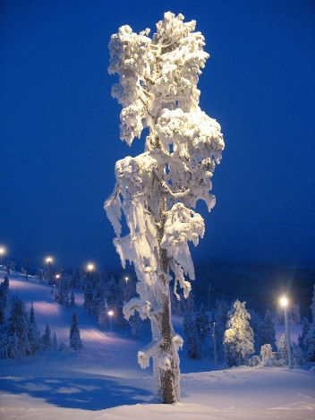
Get to know Finland
1 credit
12.9. – 10.10.2023
- Wednesdays at 14:15 -15:45 in U401 Otakaari 1

Passing the course:

- Regular attendance: 80 % present in the lessons (max. 1 absence).
- Completing 90 % of the pre-tasks and other assignments in MyCourses. Please see the course page for more info and deadlines.

- Three assignments:

1) Helsinki City tour (1 day) (DL 10.10.23)
2) Cross-cultural journal (1 page) (DL 10.10.23)
3) Presentation (10 min) (DL 17.10.23)

- Grading Pass/Fail

Other info:

- Teacher: Malka Gotthilf, malka.gotthilf@aalto.fi

Course page:
Lesson | Topic
12.9.2023  Finnish history | Course info  Getting to know each other  Finnish history
19.9.2023  Communication and cultural competence | Finnish communication culture  Cultural competence  Stereotypes
26.9.2023  The Finnish way of life | Finnish customs and manners Finland as a society of trust  The happiest country in the world
3.10.2023  Finnish society and education | Finnish welfare system  Finnish education
10.10. 2023  Creative industries and presentations | Student presentations about Finland Creative industries in Finland: focus on

