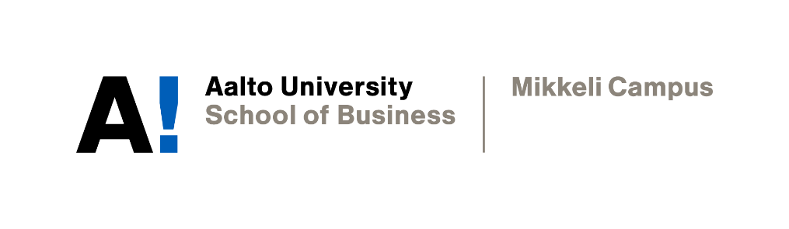

PERSONAL WRITING TARGETS and reflections

Yevhenii Kalashnyk

Academic Writing
Instructor: Sophia Butt
Date of submission: 20.11.2021

Declaration

By completing this cover sheet and declaration, I confirm that this assignment is my own work, is not copied from the work (published or unpublished) of any other person, and has not previously been submitted for assessment either at Aalto University, or another educational establishment. Any direct or indirect uses of material (e.g.: text, visuals, ideas…) from other sources have been fully acknowledged and cited according to the conventions of the Harvard Referencing System.

First Name & Surname | Yevhenii Kalashnyk | ID no. | XXXXX
Instructor Name | Prof. Sophia Butt | Date | 01.11.2021
1. Your Strengths & Weaknesses
Ensuring the sources are credible and the claims are supported by solid evidence is crucial in academic writing. I consider these skills to be my strengths. Additionally, to ensure objectivity in academic writing, I put effort into fact-checking the information. Although not wholly confident with referencing, I consider it my strength as I like following formal rules.

As a non-native speaker, I have not had much experience with academic writing in English, and I am not confident with writing in most genres, including essays. Grammar and punctuation can also be the areas I am not skilled enough to be confident in. Finally, my biggest weakness is not being confident about my writing overall. For example, sometimes it takes over two hours to write a short e-mail because I try to ensure that the main point is clear and the correct language and style are used.
2. Group Work
Working in groups can provide access to a more diverse range of ideas. Working together may create peer pressure which could result in higher productivity. Teamwork can also improve team members’ communication skills.

When it comes to drawbacks, teamwork includes dealing with different people and different opinions. There can be conflicts, which may demotivate team members. Teamwork can disadvantage some productive team members who work in a team with less effective and motivated members.

Writing the group assignment involves contribution from all team members, and dividing the work can be problematic. There might be different opinions on what can be considered a fair contribution and of what quality the contribution should be.

My skills in product management may be beneficial for dividing the tasks and providing structure to work. Setting group norms can help build a safer environment for all team members to speak their opinions and develop warmer relationships to foster creativity within the team.
3. Expectations & Targets
With the help of this Writing Course, I hope to learn more about identifying credible sources and building a solid argument. I also hope to improve my communication and organization skills while working in a group.

The most important personal writing targets for the next three weeks are gaining confidence in writing overall, learning about specific writing genres, and developing a personal voice.

1. Reflecting
As this course comes to an end, I have a feeling of having accomplished more than I expected. My confidence in writing has increased, and considerable progress has been made in developing my personal voice.

My understanding of many writing skills, such as avoiding colloquialisms, using strong collocations and correct style, has improved. The new skills I acquired are the use of personal pronouns and hedging language.

Among all genres of writing, I feel most confident about Editorial. It is probably because of the lack of limits that are present in academic writing. On the other hand, I feel least confident about the Academic Report, since it was a much bigger piece of work and involved communication with the group.

While working in a team was a useful experience, much time was spent on compromising and negotiating. This might be a normal process of all teamwork, but it also was quite an exhausting experience. However, our team did not have to deal with any conflicts, and everyone was open to critical feedback.
2. Reviewing
The most common repeat errors in my assignments are related to tense choice, register, the use of word forms, and sentence clarity. The progress that I made includes paying more attention to the text cohesion and coherence, grammar, and vocabulary.
3. Acting – Future Goals
To improve my writing, I will start by focusing on the techniques that improve my comprehension skills: close reading, vocabulary practice, and paying close attention to phrases used by native speakers in formal writing. I will also research verb tense consistency.

As time management was an important component of managing assignments for this course, I learned that keeping team meetings brief and within scheduled time helps to stay focused, avoid groupthink, and reduce negative feelings. Also, having structure for every task helps to stay organized and be more efficient. Better time management and structuring skills learned during this course will be used for future projects.

To ensure that future personal targets are met, I will continue improving my communication and time management skills.

