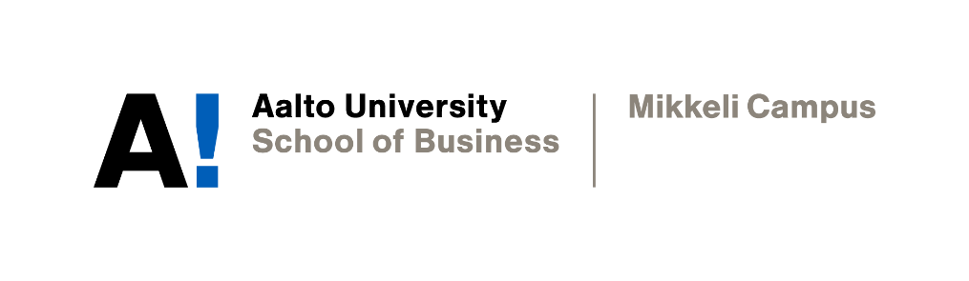

PERSONAL WRITING TARGETS

Nguyen Hoang Gia Bao

Academic Writing
Instructor: Professor Sophia Butt
Date of submission: 22/11/2021

Declaration

By completing this cover sheet and declaration, I confirm that this assignment is my own work, is not copied from the work (published or unpublished) of any other person, and has not previously been submitted for assessment either at Aalto University, or another educational establishment. Any direct or indirect uses of material (e.g.: text, visuals, ideas…) from other sources have been fully acknowledged and cited according to the conventions of the Harvard Referencing System.

First Name & Surname | Nguyen Hoang Gia Bao | ID no. | XXXXX
Instructor Name | Prof. Sophia Butt | Date | 22/11/2021
- Your Strengths & Weaknesses
Throughout GBE, I have acquainted myself with and built confidence for writing reports. More specifically, I am now well-versed in the use of language (tenses, lexical resources, etc.) and report writing style. I know which information needed emphasizing and how to summarise information as well as paraphrase statements. For analysis, I have tried to apply business models into my reports such as Porter’s Diamond, Porter’s Five Forces, etc., but my implementation is still artificial with room for improvement. On the other hand, while my style is neutral in tone and aims to inform readers about the situation of the targeted establishment, I am capable of expressing my voice through the use of statistics and professional statements. However, since GBE was my first-time using referencing, my procedure was slow and I missed some citations in my final report. To conclude, although I am highly confident in my use of grammar, lexical resources, and punctuation, I am in need of guidance for better referencing technique as well as effective integration of business frameworks.
- Group Work
In my opinion, working in groups have many advantages with the most apparent one being the sharing of ideas. More specifically, each person will give and receive fresh perspectives on the given matters. This, in turn, enhances the brainstorming process and offers a wide range of ideas and suggestions. Furthermore, when group members have established a common ground, the collective decision-making process will be more decisive and deliberate, helping boost the efficiency and confidence of the entire group. On a personal note, working in groups can give students valuable experience in communication, social organization, and management; these skills are crucial to the success of any organization and thus groupwork offers essential practice for our future careers. However, there are also several challenges when working in groups. These include the occurrence of conflicts, the loss of valuable resources, and the uneven distribution of tasks. When group members clash with each other, progress will be halted and even decline. Furthermore, the loss of time and material is also a looming threat when communication between group members fails or when conflicts worsen. To avoid falling into these pitfalls, group members should try to set a firm and unanimous goal initially, thus reducing the risk of idea clashes. Also, it is advisable that group members get to know each other better outside the working environment to enhance the overall chemistry of the workforce.
- Expectations & Targets
As I have stated in my strengths and weaknesses, I am in need of guidance to better my writing style for reports as this will help me immensely with my upcoming thesis and further work in my career. However, with Academic Writing, I also aim to develop first-hand experience in writing other genres such as editorial and abstract. I believe being knowledgeable in a vast array of writing genres can develop a flexible mindset and writing skills for future purposes. This three-week intensive writing course will set me on track to unlock the critical thinking skills in writing and the efficient time management in researching and writing. But most importantly, this course will boost my confidence and passion for dealing with written work as I am not well-acquainted with extensive writing. With that being said, I hope this Academic Writing help me prepare sufficiently for my future thesis and further academic works in my Master’s program.

