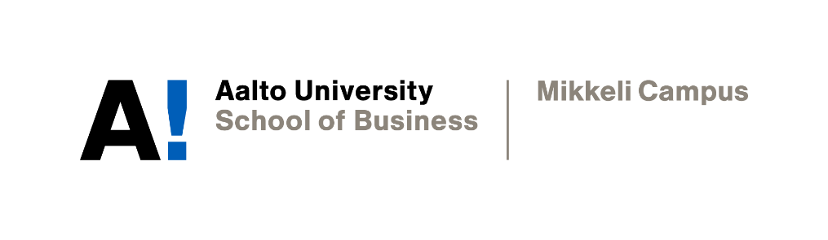

PERSONAL WRITING TARGETS

Laura Pennanen

Academic Writing
Instructor: Sophia Butt
Date of submission: 22 November 2021

Declaration
By completing this cover sheet and declaration, I confirm that this assignment is my own work, is not copied from the work (published or unpublished) of any other person and has not previously been submitted for assessment either at Aalto University, or another educational establishment. Any direct or indirect uses of material (e.g.: text, visuals, ideas…) from other sources have been fully acknowledged and cited according to the conventions of the Harvard Referencing System.
First Name & Surname | Laura Pennanen | ID no. | XXXXX
Instructor Name | Prof. Sophia Butt | Date | 22/11/2021
- Your Strengths & Weaknesses
One strength that I have as a writer is my ability to analyse and interpret texts. In high school the International Baccalaureate program heavily emphasized analytical skills, specifically finding literary devices within different text types. This has taught me to look at texts in an analytical nature. Additionally, establishing the credibility and reliability of a text has become one of my strengths. For instance, I have learned to look at current events from multiple different news sources and establish what sort of biases are present in each text.
One weakness I would like to work on is the organisation of my written tasks. Finding a way to smoothly transition from one topic to another within one written piece is challenging for me, thus, I believe this course will help me improve on that. Referencing is an important part of this course, and as I have only used APA and MLA referencing in the past, I hope to properly learn and feel comfortable using Harvard style refencing. I am confident that I will be able to complete assignments on time and keep my effort consistent throughout the course.

- Group Work
Group work is a very effective way to learn new skills and explore new ideas in collaboration with others. Working with others allows for new perspectives and opportunities to learn more about certain topics. There are many benefits to working in groups, however, there is always variation to the amount of effort every person would like to contribute to the assignment. This may lead to one member feeling that they contributed more work compared to another. Additionally, in writing assignments specifically, everyone has their own style and there is also variation with English proficiency. Although these may be slight drawbacks, ensuring that each member of the group is encouraged to put in the same amount of work and working collaboratively throughout the assignment so the writing styles would stay similar would help.
- Expectations & Targets
Through this course I am expecting to improve my overall academic writing skills and prepare myself for writing a thesis. I am expecting to achieve a new perspective on the process involved in formulating an idea, creating a draft, and finalizing a written academic assignment. My most important personal target for the next three weeks is to understand the proper techniques used to format and write academic assignments, as well as learn to formulate thesis statements and understand the general procedure for writing an academic report.

