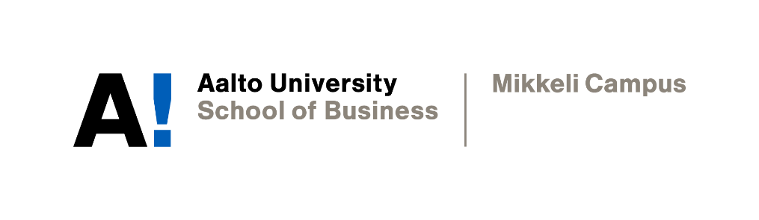

work plan

Yevhenii Kalashnyk, Hien Thu Thi Nguyen, Dieu Anh Nguyen

Academic Writing
Instructor: Sophia Butt
Date of submission: 9.11.2021

Declaration

By completing this cover sheet and declaration, I confirm that this assignment is my own work, is not copied from the work (published or unpublished) of any other person, and has not previously been submitted for assessment either at Aalto University, or another educational establishment. Any direct or indirect uses of material (e.g.: text, visuals, ideas…) from other sources have been fully acknowledged and cited according to the conventions of the Harvard Referencing System.
AALTO UNIVERSITY  SCHOOL OF BUSINESS  BScBA Program  Mikkeli Campus |  | Academic Writing Course 2021-22  Group Academic Report  WORK PLAN

Group members:  Yevhenii Kalashnyk, Hien Thu Thi Nguyen, Dieu Anh Nguyen | Group no.:  1
Tentative working title of Academic Report:
The Misinformation Business
Briefly identify the rationale behind choosing this topic area:
First, we believe that the business aspect of disseminating conspiracy theories is fascinating and deserves more attention. Second, we want to thoroughly examine these companies' practices to determine how they can successfully manipulate and profit from people. Third, we want to discuss the role of social media in understanding why it can lead to the rapid spread of misinformation.
Describe the research problem/hypothesis:
Some companies in the U.S. have earned substantial profits from purposefully spreading misinformation about the Covid-19 pandemic on online platforms. Therefore, social media platforms should take a firmer stance to prevent the situation from deteriorating.
Identify up to 3 concise research questions (if relevant):
How do people profit from spreading misleading claims about the coronavirus pandemic and vaccine?
What is the role of social media in the misinformation business?
What should social media do to end the issue?
Identify the research objectives:
To understand the reasons of people's susceptibility to conspiracy theories.
To explore the role of social media platforms in disseminating misinformation.
To investigate organizations' strategies for capitalizing on the spread of misinformation.
State the importance and/or significance of the research:
The misinformation business has had an enormous influence on societies around the globe, causing harm, sometimes with fatal consequences. While a wide variety of actors contribute to the problem and its solutions, this report will primarily focus on the conspiracists and the role of social media in the misinformation business in the U.S.
Describe the research methodology:
The main source of information for the report is secondary data. Hence, the research methodology used in this paper is analytical research – gathering the facts and information that are relative to the research questions, critically thinking, and evaluating that information. The specific method to conduct analytical research in this report is literary research, in which we examine several scholarly articles, research, and reports.
Literature to be used:
https://aaltofi-my.sharepoint.com/:w:/g/personal/yevhenii_kalashnyk_aalto_fi/EbzmHd3eL_VFkhi2c8BKGKwBwMb7ZNpFJy35smvMHeWmLw?e=h8GZbU
Describe your plan of action:
For any problems, the group would collectively seek solutions, usually by holding a vote. Having a break between meetings to refresh the mind and restart is a promising solution when members find it hard to manage a task.

1/11: Agree on communication channels (WhatsApp and Zoom).
1/11-5/11: Literature research: highlight key points and take notes.
5/11: Choose a topic and decide on a thesis statement. Every team member suggests their ideas, and then the team holds a vote.
6/11: Choose three main issues the report will focus on based on the thesis statement. Assign each issue to a section of the report. Team members pick the issue to write about.
7/11: For each section, write topic sentences for each of the body paragraphs.
10/11: Match topic sentences with support examples.
10/11: Write an introduction and conclusion for each of three main issues.
11/11: Write the introduction, conclusion, and recommendations for the report.
12/11: Complete the first draft of the report.
19/11: Receive peer feedback and make the final report.

