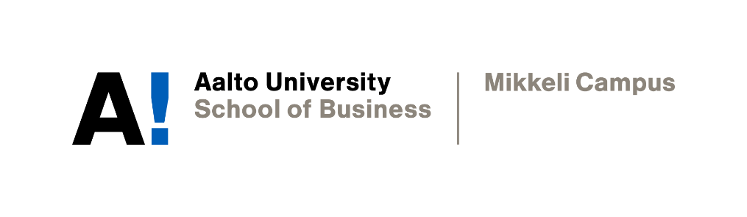

PERSONAL TIMED ESSSAY

Trang Nguyen Tinh Vu

Academic Writing
Instructor: Professor Sophia Butt
Date of submission: 26//11/2021

Declaration

By completing this cover sheet and declaration, I confirm that this assignment is my own work, is not copied from the work (published or unpublished) of any other person, and has not previously been submitted for assessment either at Aalto University, or another educational establishment. Any direct or indirect uses of material (e.g.: text, visuals, ideas…) from other sources have been fully acknowledged and cited according to the conventions of the Harvard Referencing System.

According to a recent study, nearly a third of the US population believes in conspiracy theories. While the number appears to be shocking at first, it reflects a more alarming issue: the era of information has gradually transformed into the era of misinformation. Moreover, the problem is now being exacerbated with the emergence of notorious myths related to the Covid-19 pandemic: vaccine containing 5G tracking function, or Covid-19 as a biological weapon of China. Taking advantage of the situation, conspiracy theorists financially exploit the uncertainty and fear of people to sell health fraud scams, resulting in serious health issues for consumers and social unrest. Governments, private companies, and individuals must collaborate to tackle the unethical conspiracy-based business practices.

The primary reason for our group to select this topic is its significance and relevancy, especially admis the new wave of Covid-19. While the direct consequence of these conspiracy-based can be health risks for buyers, we recognise the underlying danger of these fake news on social harmony and the worldwide prevention of the Covid-19 virus. For example, according to several statistics, consumers who purchase from conspiracy sites are more likely to deny the necessity of vaccine and protest safety measures such as lockdown. In addition, the second motive for us to examine the commercialisation of misinformation is personal interest. We are particularly puzzled by the psychology behind conspiracy theory and wish to understand the mechanism through which theorists manage to capture the attention of audience and successfully persuade them into believing misinformation. Lastly, we want to learn how to detect, debunk, and prevent misinformation. While notorious conspiracy theories can be fact-checked with ease, there are more subtle and sophisticatedly constructed fake news that require skills and knowledge to identify and counter.

Regarding our approach to analyse the topic, we first discussed our pre-existing knowledge on the matter and exchange our personal stance. After finalising the focus of the report and writing the thesis statement, we created a persuasion map to build a more detailed structure. Specifically, the four main components of the report are the psychology behind conspiracy theory, the monetisation of misinformation, the far-reaching impacts of this unethical business practice, and the needed skills to distinguish fake news. We also analysed the problem on different levels – the government, private companies, individuals – and for different states within the US territory.

As for our methodology, we initially endeavoured to find direct statements from conspiracy theorists like Alex Jones. However, it was apparent that search engines and social platforms had removed the majority of the sites as an effort to tackle the problem of fake news. Therefore, we shifted our focus to reliable newspaper sites, including Business Insider, BBC, and The Economist. From these sites, we were able to select and study specific conspiracy theories that lay the foundation for unethical misinformation-based business. At the same time, we obtained scholarly publications from trust-worthy websites such as Research Gate, Journal Storage, and Infodemic. We also fact-checked certain facts or figures to make sure that the information was objective.

In conclusion, the capitalisation of conspiracy theory is a socio-economic issue worth studying and tackling. Our dedication to this topic for the academic report can also be considered as our personal responsibility in combating misinformation for a better world.

