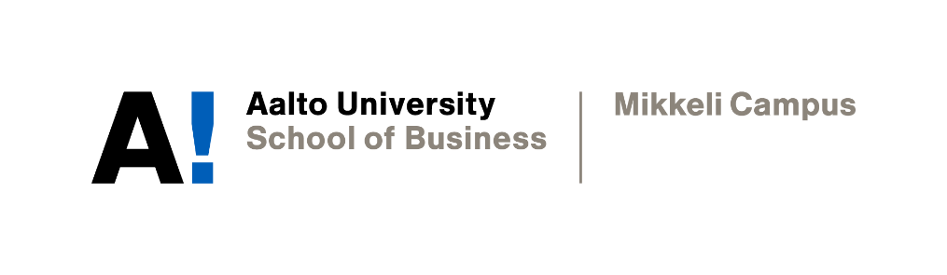

ABSTRACT & EDITORIAL

Misinformation during COVID-19: The ethics of limiting the freedom of expression

Pham Phuong Khanh

Academic Writing
Instructor: Professor Sophia Butt
Date of submission: 10.12.2021

Declaration

By completing this cover sheet and declaration, I confirm that this assignment is my own work, is not copied from the work (published or unpublished) of any other person, and has not previously been submitted for assessment either at Aalto University, or another educational establishment. Any direct or indirect uses of material (e.g.: text, visuals, ideas…) from other sources have been fully acknowledged and cited according to the conventions of the Harvard Referencing System.
Abstract
During the COVID-19 pandemic, there has been a significant rise in fake news across Facebook and Twitter, creating greater division and radicalization within the public. As a result, people have lost faith in medical professionals, which can cause public health problems. Additionally, the dissemination of misleading information also leads to serious societal consequences such as mass poisonings, vandalism, and mob attacks. Therefore, it is critical that these social media giants take appropriate actions to prevent the situation from exacerbating. This report primarily discusses whether the removal of misleading content on these two platforms violates the laws on freedom of speech. It also aims to assess the effectiveness of actions taken by Facebook and Twitter thus far to combat the issue.

Following a general description of the key terms, the report investigates the three most popular conspiracy theories about the pandemic and discusses the repercussions of spreading false information on social media sites. Then, it examines and evaluates how Facebook and Twitter have devised and implemented their policies in response to the given problem. Later, the study argues for the act of limiting misleading content by these social media platforms from legal and ethical perspectives. More specifically, it analyzes official United States legal documents and the corporate social responsibilities stated in the mission statements of the two companies.

The findings in the report demonstrate that legal officials demand more effort from Facebook and Twitter, although their policies have yielded certain positive results. It also indicates that the United States laws grant Facebook and Twitter immunity from liability for the content they publish and protect their legal actions. Furthermore, the study successfully illustrates the differences in the mission statements of the two social media platforms from a moral standpoint. While Twitter effectively communicates the message that they do not limit freedom of expression, Facebook seemingly avoids mentioning the issue.

Editorial
5G masts are spreading COVID-19. Wait, the virus was indeed created by the elite to control the entire population. Since the dawn of the pandemic, social media sites have been flooded with fake news and conspiracy theories like those previously mentioned. Preposterous as they may sound, people still fall prey to them, resulting in the blatant defiance of preventative measures recommended by health experts like wearing masks or getting the vaccine. That is not to mention serious societal consequences such as mass poisonings, mob attacks, or vandalism associated with the beliefs in misinformation. For example, due to the dissemination of the so-called “home remedies for COVID-19”, 800 people in 87 countries were reported dead, while 5,900 others were hospitalized. Thankfully, Facebook and Twitter – the two social media giants – have enacted their policies to save people from such reckless actions when they buy into misleading content.

Nevertheless, some may argue that the removal of misinformation by Facebook and Twitter on their platforms is at odds with freedom of expression. This is somewhat reasonable since these companies state that their platforms can be seen as spaces where anyone can share “what is on their minds”, which is literally the first thing any Facebook user can spot when they scroll down their newsfeeds. Yet when consulting the US laws, there is irrefutable evidence showing that free speech is solely required to be implemented by the government, not privately owned corporations. In other words, Facebook and Twitter are not legally obligated to take action to restrict misinformation or to promote freedom of speech.

Additionally, the act of limiting misleading content on these social media sites can also be justified from a moral perspective. Studies have demonstrated that those who take a gloomy view of the world are more likely to give credence to fabricated content that is intentionally harmful. Moreover, the beliefs in conspiracy theories are partly attributable to spikes in COVID-19 cases and a lower vaccination rate. Therefore, it can be deduced that the restriction of misinformation can lead to an improvement in societal welfare.

To sum up, only when Facebook and Twitter implement their restricting policies will the dissemination of fake news on their platforms be mitigated and the world soon escape from the nightmare of COVID-19.

