1. Water flows at a velocity $u_{∞}=1$ m/s over a flat plate of length L=0.6 m. Consider two cases, one for which the water temperature is approximately 300 K and the other for an approximate water temperature of 350 K. In the laminar and turbulent regions, experimental measurements show that the local convection coefficients are well described by
$$h_{lam}\left(x\right)=C_{lam}x^{-0.5}$$
$$h_{turb}\left(x\right)=C_{turb}x^{-0.5}$$

where x has units of m. At 300 K,
$$C_{lam}=395 W/{m^{1.5}∙K}$$
$$C_{lam}=2330 W/{m^{1.8}∙K}$$
while at 350 K,
$$C_{lam}=477W/{m^{1.5}∙K}$$
$$C_{lam}=36000 W/{m^{1.8}∙K}$$
As is evident, the constant C depends on the nature of the flow as well as the water temper- ature because of the thermal dependence of various properties of the fluid.
Determine the average convection coefficient, $\overline{h}$, over the entire plate for the two water temperatures.
$$x_{c}=\frac{{Re}_{c,x}μ}{ρμ_{∞}}$$
$$\overline{h}=\frac{1}{L}\int_{0}^{L}{hdx}=\frac{1}{L}\left[\int_{0}^{x_{c}}{h_{lam}dx+\int_{x_{c}}^{L}{h_{lam}dx}}\right]$$
Assumptions:
1. Steady-state conditions.
2. Transition occurs at a critical Reynolds number of $R_{e_{x,c}}=5×{10}^{5}$.
Properties: Water (T 300 K): $ρ=υ^{-1}=997 {kg}/{m^{3}}$, $μ=855×{10}^{6} {N.s}/{m^{2}}$
Water (T 350 K): $ρ=υ^{-1}=974 {kg}/{m^{3}}$, $μ=365×{10}^{6} {N.s}/{m^{2}}$
Known: Water flow over a flat plate; expressions for the dependence of the local convection coefficient with distance from the plate’s leading edge, x; and approximate temperature of the water.
Find: Average convection coefficient, $\overline{h}$.
Schematic:
Analysis: The local convection coefficient is highly dependent on whether lami- nar or turbulent conditions exist. Therefore, we first determine the extent to which these conditions exist by finding the location where transition occurs, xc. From Equation, we know that at 300 K,
$$x_{c}=\frac{{Re}_{c,x}μ}{ρμ_{∞}}$$
Similarly, we know $x_{c}$at 350K
$$x_{c}=\frac{{Re}_{c,x}μ}{ρμ_{∞}}$$
From Equation we know that
$$\overline{h}=\frac{1}{L}\int_{0}^{L}{hdx}=\frac{1}{L}\left[\int_{0}^{x_{c}}{h_{lam}dx+\int_{x_{c}}^{L}{h_{lam}dx}}\right]$$
The local and average convection coefficient distributions for the plate are shown in the figure below.
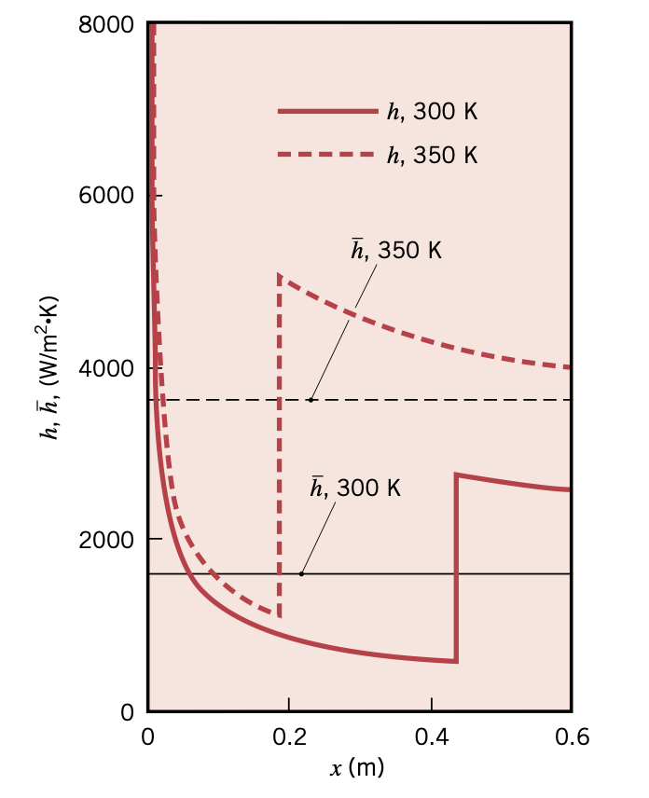

Comments:
- The average convection coefficient at T 350 K is over twice as large as the value at T 300 K. This strong temperature dependence is due primarily to the significant shift of xc that is associated with the smaller viscosity of the water at the higher temperature. Careful consideration of the temperature dependence of fluid properties is crucial when performing a convection heat transfer analysis.
- Spatial variations in the local convection coefficient are significant. The largest local convection coefficients occur at the leading edge of the flat plate, where the laminar thermal boundary layer is extremely thin, and just downstream of xc, where the turbulent boundary layer is thinnest.
2. The local atmospheric pressure in Denver, Colorado (elevation 1610 m), is 89.6 kPa. Air at this pressure and 15 °C flows with a velocity of 12 m/s over a 1.5 m 6 m flat plate whose temperature is 280°C (Fig. 7-13). Determine the rate of heat transfer from the plate if the air flows parallel to the
(a) 6-m-long side (10P)
(b) the 1.5-m side. (10P)
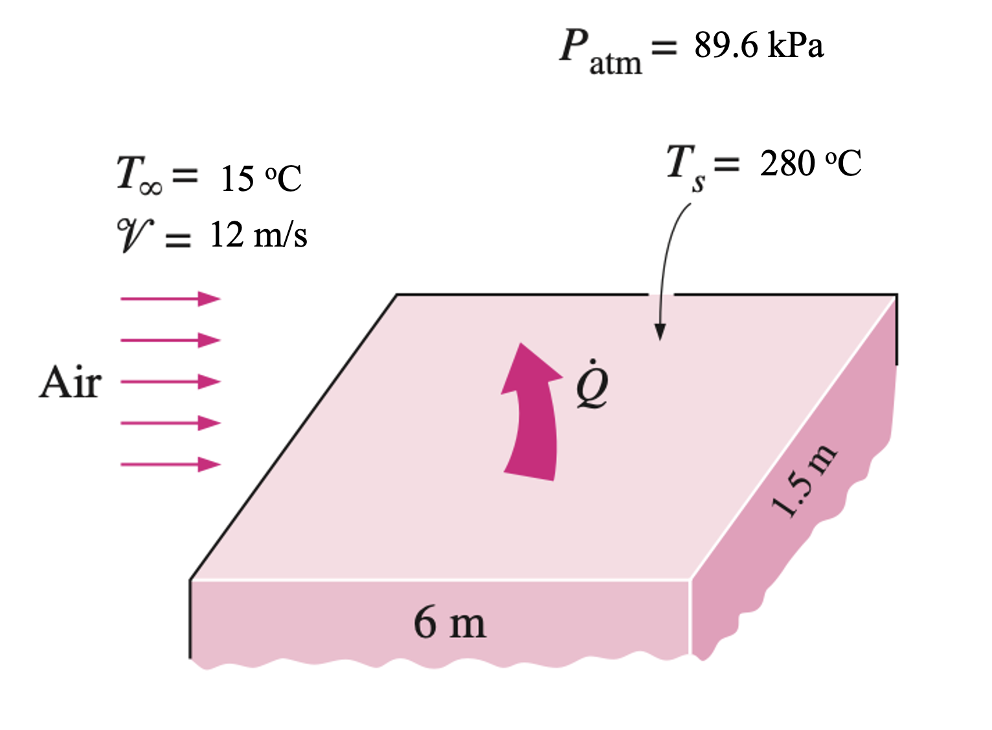
SOLUTION The top surface of a hot block is to be cooled by forced air. The rate of heat transfer is to be determined for two cases.
Assumptions 1 Steady operating conditions exist. 2 The critical Reynolds num- ber is $Recr= 5×105$. 3 Radiation effects are negligible. 4 Air is an ideal gas.
Properties The properties $k,μ , Cp$, and $Pr$ of ideal gases are independent of pressure, while the properties $ν$ and $α$ are inversely proportional to density and thus pressure. The properties of air at the film temperature of $T_{f} =\frac{\left(T_{s}+T_{∞}\right)}{2}=\frac{280+15}{2}=147.5 ℃$ and 1 atm pressure are
$$k=0.02953\frac{W}{m}∙℃$$
$$Pr=0.7154$$
$$ν_{@1 atm}=2.097×{10}^{-5}{m^{2}}/s$$
The atmospheric pressure in Denver is
$P=\frac{89.6kPa}{101.325kPa/atm}=0.823 atm$. Then the kinematic viscosity of air in Denver becomes
$ν=ν_{@1 atm/P}=\frac{\left(2.097×{10}^{-5}{m^{2}}/s\right)}{0.823}=2.548×{10}^{-5}{m^{2}}/s$
(a) When air flow is parallel to the long side, we have L =6 m, and the Reynolds number at the end of the plate becomes
$${Re}_{L}=\frac{VL}{ν}$$
which is greater than the critical Reynolds number. Thus, we have combined laminar and turbulent flow, and the average Nusselt number for the entire plate is determined to be
$$Nu=\frac{hL}{k}$$
Then
$$h=\frac{k}{L}Nu$$
$$A_{s}=wL$$
$$\dot{Q}=hA_{s}(T_{s}-T_{∞})$$
Note that if we disregarded the laminar region and assumed turbulent flow over the entire plate, we would get Nu 3466 from below equiations, which is 29 percent higher than the value calculated above.
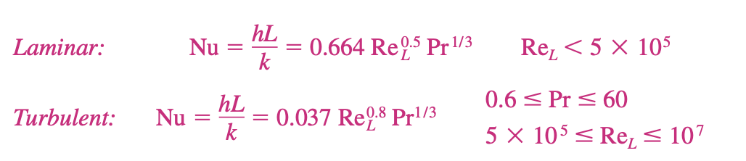
(b) When air flow is along the short side, we have L =1.5 m, and the Reynolds number at the end of the plate becomes
$${Re}_{L}=\frac{VL}{ν}$$
which is less than the critical Reynolds number. Thus we have laminar flow over the entire plate, and the average Nusselt number is
$$Nu=\frac{hL}{k}=0.664{Re}_{L}^{0.5}{Pr}^{1/3}$$
Then
$$h=\frac{k}{L}Nu$$
$$\dot{Q}=hA_{s}(T_{s}-T_{∞})$$
3. What is the rate of heat transfer by radiation, with an unclothed person standing in a dark room whose ambient temperature is 18.0ºC. The emissivity of skin is 0.97 in the infrared, where the radiation takes place. (a) With woman has a normal skin temperature of 33ºC and a surface area of 1.50 m². (b) With woman has a normal skin temperature of 33.2ºC and a surface area of 1.50 m². (c) With child has a normal skin temperature of 33.5ºC and a surface area of 0.6 m². (20P)

Strategy
We can solve this by using the equation for the rate of radiative heat transfer.

Solution
Insert the temperatures values $T_{amb}=291K$ and $T_{man}=306K$, $T_{woman}=306.2K and T_{child}=306.5K$, so that
$$\frac{Q}{t}=εσA\left(T_{2}^{4}-T_{1}^{4}\right)$$

Discussion
This value is a significant rate of heat transfer to the environment (note the minus sign), considering that a person at rest may produce energy at the rate of 125 W and that conduction and convection will also be transferring energy to the environment. Indeed, we would probably expect this person to feel cold. Clothing significantly reduces heat transfer to the environment by many methods, because clothing slows down both conduction and convection, and has a lower emissivity (especially if it is white) than skin.
4. Planck’s Law of blackbody radiation, a formula to determine the spectral energy density of the emission at each wavelength (Eλ) at a particular absolute temperature (T).
(20P).
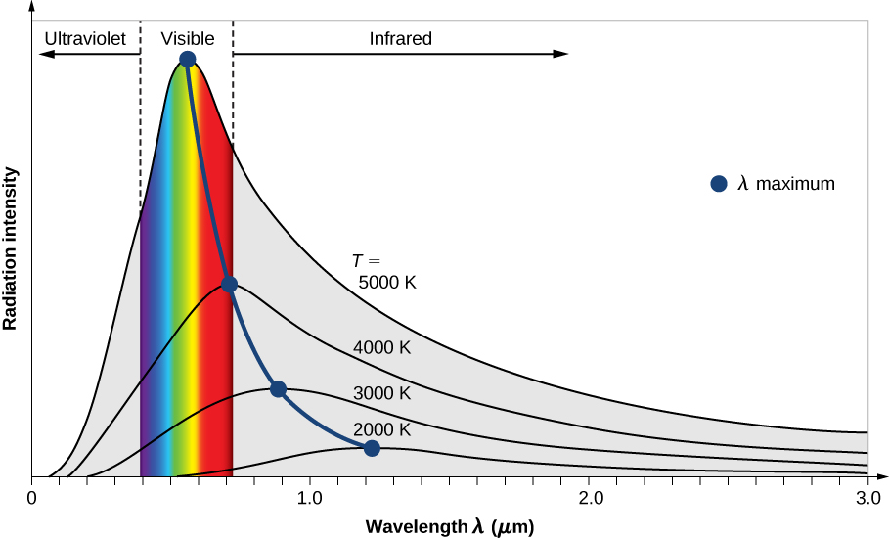
Fig. 5 The intensity of blackbody radiation versus the wavelength of the emitted radiation. Each curve corresponds to a different blackbody temperature, starting with a low temperature (the lowest curve) to a high temperature (the highest curve).

$$E\left(λ,T\right)=\frac{2hc^{2}}{λ^{5}}*\frac{1}{e^{\left(\frac{hc}{λkT}\right)}-1}$$
Where,
$h=Planck^{'}s constant=6.626×{10}^{-34} J∙s$
$$c=speed of light=2.997925×{10}^{8} m/s$$
$$λ=Wavelength (m)$$
$$k=Boltzmann^{'}s constant=1.381×{10}^{-23} J∙s$$
$$T=Temperature (K)$$
- Could you write a Matlab script and plot a similar figure as Fig. 5? The temperature sweep is start from 1000 K to 5000 K with the interval of 500 K. The wavelength sweep is from 0 to 5 $μm$ with an interval of 0.2 $μm$. (25P)
- Briefly explain the relation of the temeprature and color. (5P)

