COE-C2007 Thermodynamics & Heat Transfer, Spring 2024
Learning Exercise 3
The exercise is to be completed independently (do not copy-paste from other students) and returned as a single pdf report with appropriate use of pictures and charts, as well as presentation of used equations in possible calculations. Name the uploaded pdf-file so that it tells the course, learning exercise number and your name, like Thermodynamics_LE1_Lastname.pdf
No single question/problem is compulsory, but a minimum of 50 % of points is required in order to pass the exercise. Also include your name and student number on the first page of the report. A proper length of an answer per question would be maximum 1 page. The time for answering this exercise is estimated not to exceed 8 hours, provided that you have attended lectures.
Return Deadline of LE1: Friday February 02, 2024, 23:55, in MyCourses.

Questions:
1. A simple ideal Brayton cycle operates with air with minimum and maximum temperatures of 27°C and 727°C. It is designed so that the maximum cycle pressure is 2000 kPa and the minimum cycle pressure is 100 kPa. Use constant specific heats at room temperature.
Properties: The properties of air at room temperature are c_{p}=1.005kJ/kg.K and k=1.4.
- Draw the T-s diagram (5p).
- Determine the net work produced per unit mass of air each time this cycle is executed and the cycle’s thermal efficiency (15p).
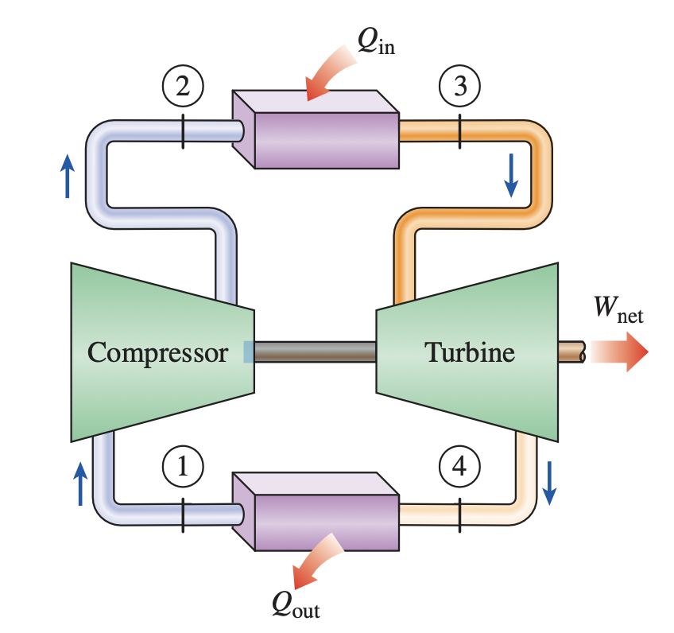
Assumption
1. Steady operating conditions exits.
2. The air-standard assumptions are applicable
3. Kinetical and potential energy changes are negligible
4. Air is an ideal gas with constant specific heats
Properties
The properties of air at room temperature are cp=1.005kJ/kg.K and k=1.4
Analysis
Using the isentropic relations for an ideal gas,
$$T_{2}=T_{1}{\left(\frac{P_{2}}{P_{1}}\right)}^{{\left(k-1\right)}/k}$$
Similarly,
$$T_{4}=T_{3}{\left(\frac{P_{4}}{P_{3}}\right)}^{{\left(k-1\right)}/k}$$
Applying the first law to the constant-pressure heat addition process 2-3 produces
$$q_{in}=\left({h_{3}-h}_{2}\right)=c_{p}\left(T_{3}-T_{2}\right)$$
Similarly,

$$q_{out}=\left({h_{4}-h}_{1}\right)=c_{p}\left(T_{4}-T_{1}\right)$$
The net work production is then
$$w_{net}=q_{in}-q_{out}=$$

and the thermal efficiency of this cycle is
$$η_{th}=\frac{w_{net}}{q_{in}}$$

2. A Carnot heat pump is to be used to heat a house and maintain it at 25°C in winter. On a day when the average out- door temperature remains at about 2°C, the house is estimated to lose heat at a rate of 55,000 kJ/h. If the heat pump consumes 4.8 kW of power while operating, determine (a) how long the heat pump ran on that day; (b) the total heating costs, assuming an average price of 0.11€/kWh for electricity; and (c) the heating cost for the same day if resistance heating is used instead of a heat pump. (20 p)

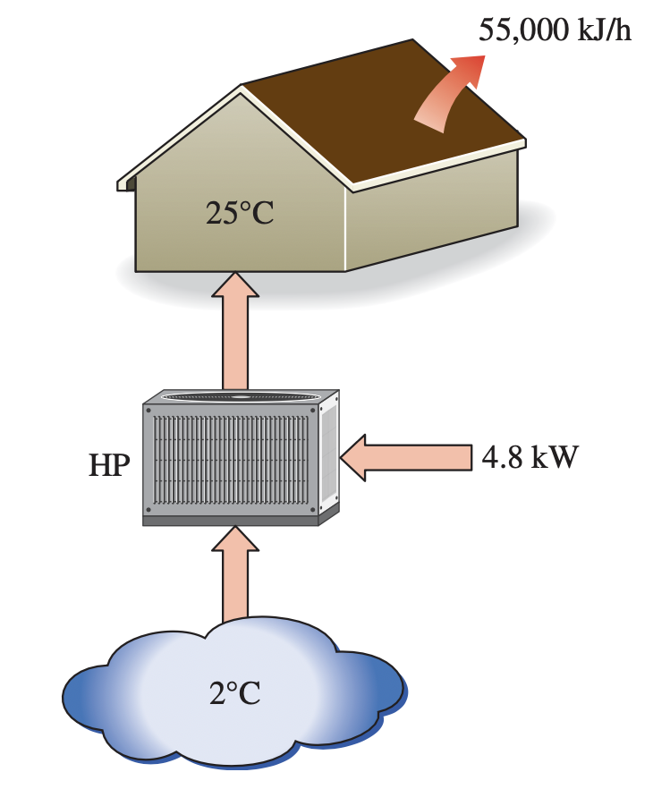
Analysis
(a) The coefficient of performance of this Carnot heat pump depends on the temperature limits in the cycle only, and is determined from
$$γ_{HP}=\frac{T_{H}}{T_{H}-T_{C}}$$
The amount of heat the house lost that day is
$$Q_{H}={\dot{Q}}_{H}×24\left(hour\right)$$
Then the required work input to this Carnot heat pump is determined from the definition of the coefficient of performance to be
$$W_{net,in}=\frac{Q_{H}}{γ_{HP}}$$
We know the total work generate from the pump and the power of the heat pump.
Therefore, $∆t= \frac{W_{net,in}}{{\dot{W}}_{HP}}$
(b) The total heating cost at that day is
$${Cost}_{HP}=W×price$$
(c) if the resistance heating were used, the entire heating load for that day would have to be met by electrical energy. Therefore, the heating system would consume 1320000kJ of electricity, that would cost
$${Cost}_{Electricity}=Q_{H}×\frac{1kWh}{3600kJ}×price$$

3. An ideal Otto cycle has a compression ratio of 8. At the beginning of the compression process, air is at 100 kPa and 17°C, and 800 kJ/kg of heat is transferred to air during the constant-volume heat-addition process. Accounting for the variation of specific heats of air with temperature, determine,
(a) Draw the P-v (pressure-specific volume) and T-s (Temperature-entropy) diagram, (5p)
(b) the maximum temperature and pressure that occur during the cycle (5p)
(c) the net work output (5p)
(c) the thermal efficiency (5p)
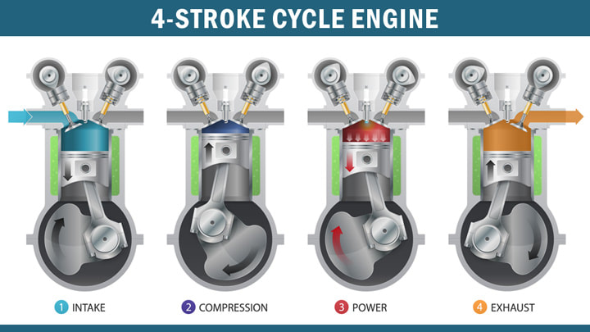
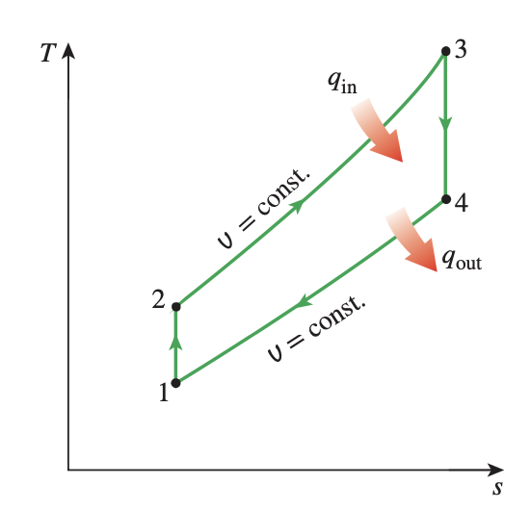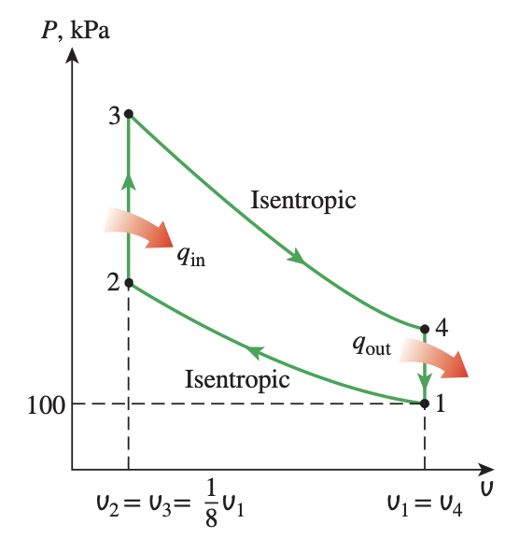
SOLUTION An ideal Otto cycle is considered. The maximum temperature and pressure, the net work output, the thermal efficiency, the mean effective pressure, and the power output for a given engine speed are to be determined.
Assumptions
1 The air-standard assumptions are applicable.
2 Kinetic and potential energy changes are negligible.
3 The variation of specific heats with temperature is to be accounted for.
Analysis The P-v diagram of the ideal Otto cycle described is shown in above Figure. We note that the air contained in the cylinder forms a closed system.
(a) The maximum temperature and pressure in an Otto cycle occur at the end of the constant-volume heat-addition process (state 3). But first we need to determine the temperature and pressure of air at the end of the isentropic compression process (state 2), using data from following Table:

Parameter
$$T_{1}$$ | 290 K
$$u_{1}$$ | 206.91kJ/kg
$$υ_{r1}$$ | 676.1
$$T_{2}$$ | 652.4K
$$u_{2}$$ | 475.11kJ/kg
$$T_{3}$$ | 1575 K
$$υ_{r3}$$ | 6.108
$$T_{4}$$ | 795.6 K
$$u_{4}$$ | 588.74kJ/kg

Process 1-2 (isentropic compression of an ideal gas):
$$\frac{υ_{r2}}{υ_{r1}}=\frac{υ_{2}}{υ_{1}}=r$$
$$υ_{r2}=υ_{r1}×r$$
According to the idea gas law: $Pv=nRT$.
$$\frac{P_{2}υ_{2}}{T_{2}}=\frac{P_{1}υ_{1}}{T_{1}}$$
Therefore, $P_{2} can be solved$
Process 2-3 (constant-volume heat addition):
$$q_{in}=u_{3}-u_{2}$$
According to the parameter given in the table

$$\frac{P_{3}υ_{3}}{T_{3}}=\frac{P_{2}υ_{2}}{T_{2}}$$
We can get $P_{3}$
(b) The net work output for the cycle is determined either by finding the boundary (P dV) work involved in each process by integration and adding them or by finding the net heat transfer that is equivalent to the net work done during the cycle. We take the latter approach. However, first we need to find the internal energy of the air at state 4:
Process 3-4 (isentropic expansion of an ideal gas):

$$\frac{υ_{r4}}{υ_{r3}}=\frac{υ_{4}}{υ_{3}}=r$$
Process 4-1 (constant-volume heat rejection):

$$q_{out}=u_{1}-u_{4}$$
Thus,
$$W_{net}=q_{net}=q_{in}-q_{out}$$
(c) The thermal efficiency of the cycle is determined from its definition:
$$η_{th}=\frac{W_{net}}{q_{in}}=?$$

4. Steam is the working fluid in an irreversible Rankine cycle, the turbine and the pump each have an isentropic efficiency of 85%. Saturated vapor enters the turbine at 8.0 MPa and saturated liquid exits the condenser at a pressure of 0.008 MPa. The net power output of the cycle is 100 MW. analysis that. Determine for the modified cycle (a) the thermal efficiency, (b) the mass flow rate of steam, in kg/h, for a net power output of 100 MW, (c) the rate of heat transfer Qin into the working fluid as it passes through the boiler, in MW, (d) the rate of W t / m heat transfer Qout from the condensing steam as it passes through the condenser, in MW, (e) the mass flow rate of the condenser cooling water, in kg/h, if cooling water enters the condenser at 15°C and exits as 35°C.
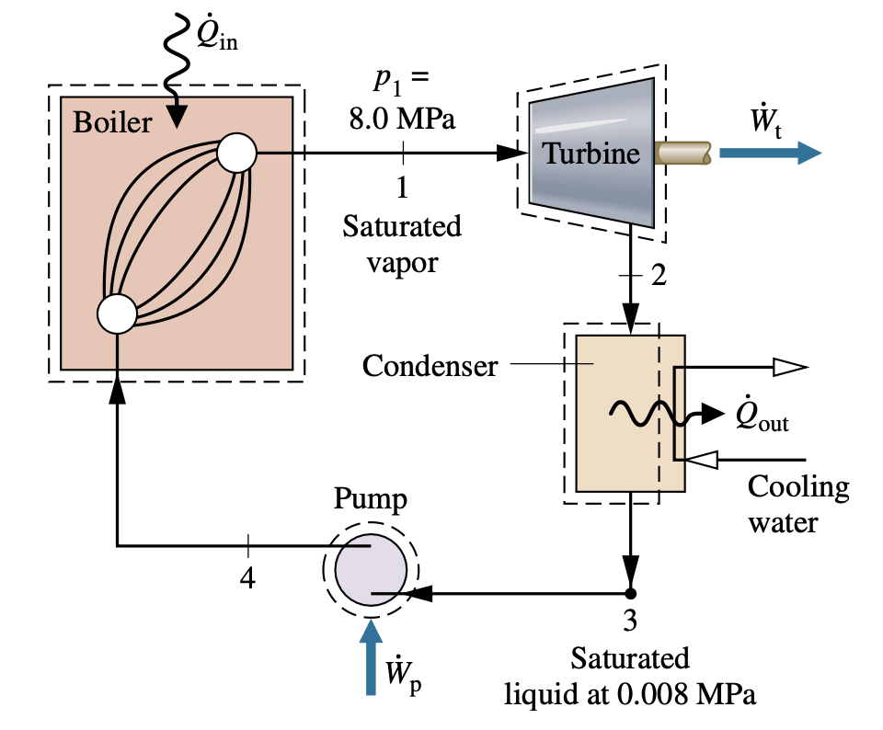

Solution
Know
A vapor power cycle operates with steam as the work- ing fluid. The turbine and pump both have efficiencies of 85%.
Find
Determine the thermal efficiency, the mass flow rate, in kg/h, the rate of heat transfer to the working fluid as it passes through the boiler, in MW, the heat transfer rate from the con- densing steam as it passes through the condenser, in MW, and the mass flow rate of the condenser cooling water, in kg/h.
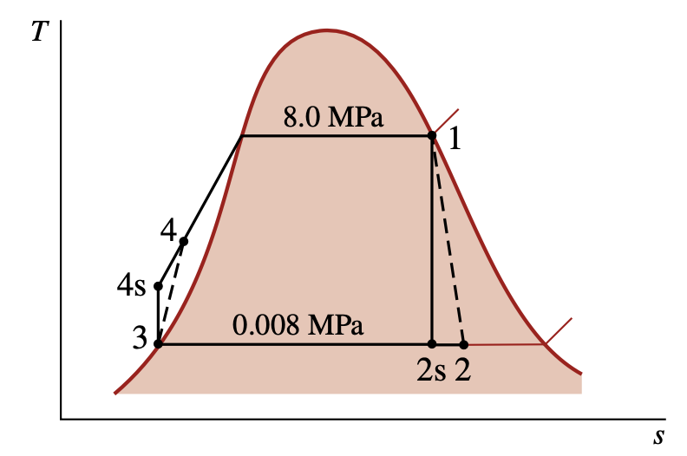
Assumptions:
- Each component of the cycle is analyzed as a control volume at steady state.
- The working fluid passes through the boiler and condenser at constant pressure. Saturated vapor enters the turbine. The condensate is saturated at the condenser exit.
- The turbine and pump each operate adiabatically with an efficiency of 85%.
- Kinetic and potential energy effects are negligible.
Owing to the presence of irreversibilities during the expansion of the steam through the turbine, there is an increase in specific entropy from turbine inlet to exit, as shown on the accom- panying T–s diagram. Similarly, there is an increase in specific entropy from pump inlet to exit. Let us begin the analysis by fixing each of the principal states.
State | Parameter | Value
1 | $$h_{1}$$ | 2758.0 kJ/kg
 | $$s_{1}$$ | 5.7432 kJ/kg ⋅ K
2 | $$h_{2s}$$ | 1794.8 kJ/kg
3 | $$h_{3}$$ | 173.88 kJ/kg
 | $$υ_{3}$$ | 1.0084 ⋅ 10−3 m3/kg
 | $$h_{cw,out}$$ | 146.68 kJ/kg
 | $$h_{cw,in}$$ | 62.99 kJ/kg
State 1 is the same as in Example 8.1, so h1 = 2758.0 kJ/kg and s1 = 5.7432 kJ/kg ⋅ K.
The specific enthalpy at the turbine exit, state 2, can be determined using the isentropic turbine efficiency,
$$η_{t}=\frac{{{\dot{W}}_{t}}/{\dot{m}}}{{\left({{\dot{W}}_{t}}/{\dot{m}}\right)}_{s}}=\frac{h_{1}-h_{2}}{h_{1}-h_{2s}}$$

where $h_{2s}$ is the specific enthalpy at state 2s on the accompanying T–s diagram. From the Table, h2s = 1794.8 kJ/kg. Solving for $h_{2}$ and inserting known values
$$h_{2}=h_{1}-η_{t}\left(h_{1}-h_{2s}\right)$$
State 3, h3 = 173.88 kJ/kg.
To determine the specific enthalpy at the pump exit, state 4, reduce mass and energy rate balances for a control volume around the pump to obtain $\frac{{\dot{W}}_{p}}{\dot{m}}=\left(h_{4}-h_{3}\right)$. On rearrangement, the specific enthalpy at state 4 is
$$h_{4}=h_{3}+\frac{{\dot{W}}_{p}}{\dot{m}}$$
To determine $h_{4}$ from this expression requires the pump work. Pump work can be evaluated using the isentropic pump efficiency: Solving for $\frac{{\dot{W}}_{p}}{\dot{m}}$ results in
$$\frac{{\dot{W}}_{p}}{\dot{m}}=\frac{υ_{3}\left(p_{4}-p_{3}\right)}{η_{p}}$$
The specific enthalpy at the pump exit is then
$$h_{4}=h_{3}+\frac{{\dot{W}}_{p}}{\dot{m}}=$$
- The net power developed by the cycle is
$${\dot{W}}_{cycle}={\dot{W}}_{t}-{\dot{W}}_{p}=\dot{m}\left[\left(h_{1}-h_{2}\right)-\left(h_{4}-h_{3}\right)\right]$$
The rate of heat transfer to the working fluid as it passes through the boiler is
$${\dot{Q}}_{in}=\dot{m}\left(h_{1}-h_{4}\right)$$
Thus, the thermal efficiency is
$$η=\frac{\left(h_{1}-h_{2}\right)-\left(h_{4}-h_{3}\right)}{h_{1}-h_{4}}$$
- With the net power expression of part (a), the mass flow rate of the steam is
$$\dot{m}=\frac{{\dot{W}}_{cycle}}{\left(h_{1}-h_{2}\right)-\left(h_{4}-h_{3}\right)}$$
c.With the expression for Qin from part (a) and previously de- termined specific enthalpy values
$${\dot{Q}}_{in}=\dot{m}\left(h_{1}-h_{4}\right)$$

The rate of heat transfer from the condensing steam to the cooling water is
$${\dot{Q}}_{out}=\dot{m}\left(h_{2}-h_{3}\right)$$
e. The mass flow rate of the cooling water can be determined from
$${\dot{m}}_{cw}=\frac{\dot{m}\left(h_{2}-h_{3}\right)}{\left(h_{cw,out}-h_{cw,in}\right)}$$

5. Methane (CH4) at 25°C enters the combustor of a simple open gas turbine power plant and burns completely with 400% of theoretical air entering the compressor at 25°C, 1 atm. Products of combustion exit the turbine at 730 K, 1 atm. The rate of heat transfer from the power plant is estimated as 3% of the net power developed. Determine the net power developed, in MW, if the fuel mass flow rate is 20 kg/min. For the entering air and exiting combustion products, kinetic and potential energy effects are negligible (20p).
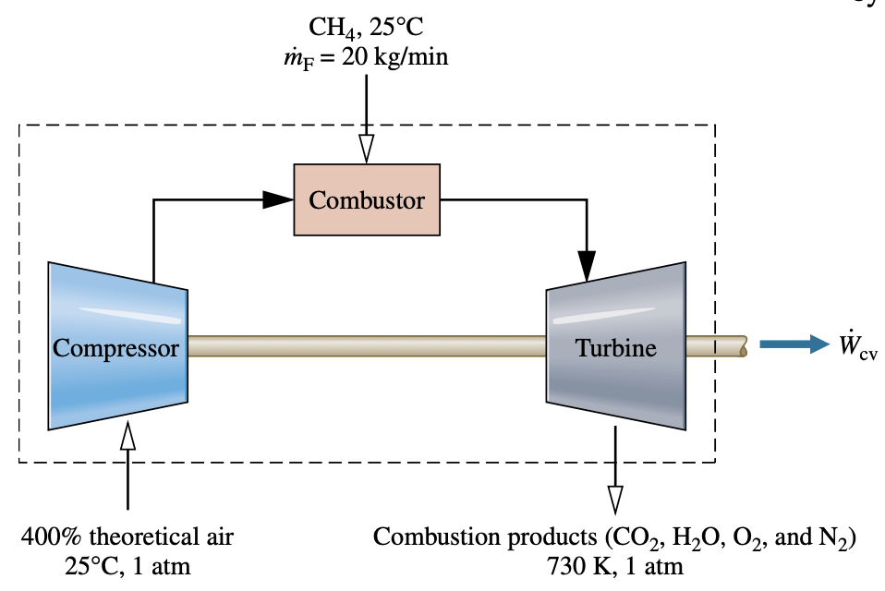
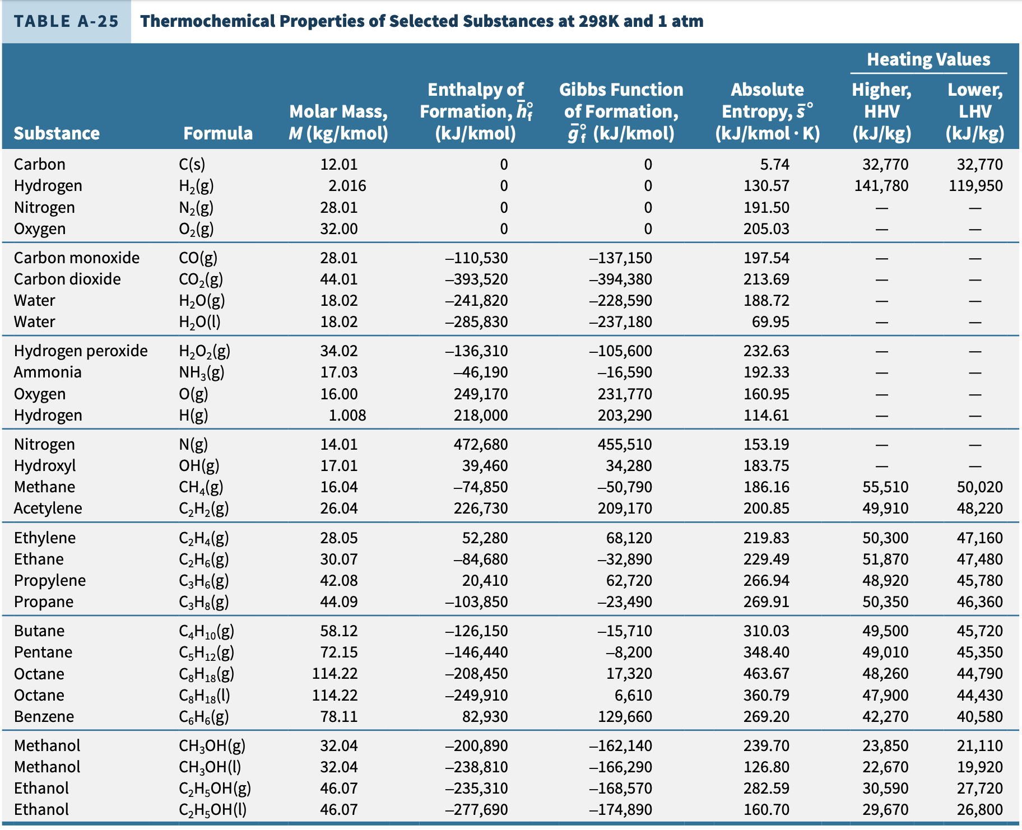
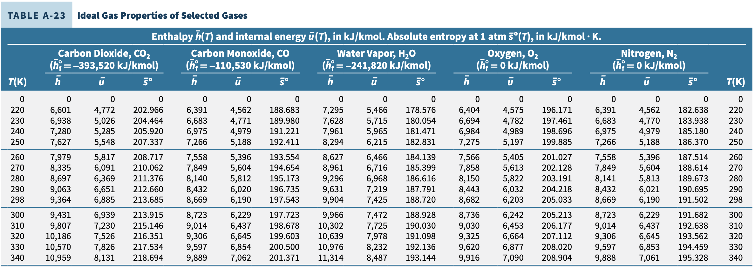
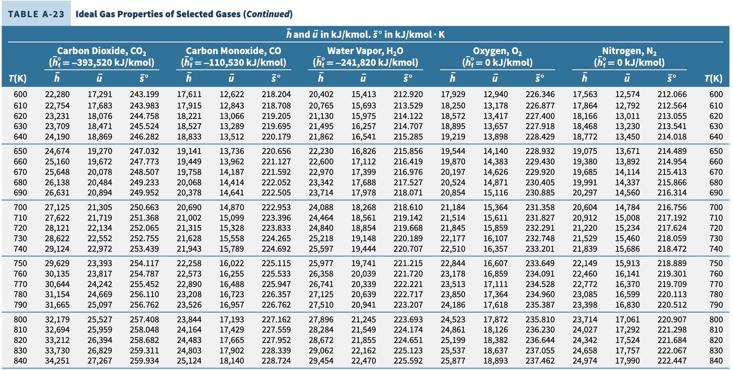

solution
Known Steady-state operating data are provided for a simple gas turbine power plant.
Find The net power developed, in MW, for a given fuel mass flow rate.
Engineering model
1. The control volume identified by a dashed line on the accom- panying figure operates at steady state.
2. Kinetic and potential energy effects can be ignored where mass enters and exits the control volume.
3. The ideal gas model is applicable to the fuel; the combustion air and the products of combustion each form ideal gas mixtures.
4. Each mole of oxygen in the combustion air is accompanied by 3.76 moles of nitrogen, which is inert. Combustion is complete.
analysis The balanced chemical equation for complete com- bustion of methane with the theoretical amount of air is given by Eq. 13.4:
CH4 + 2(O2 + 3.76N2 ) → CO2 + 2H2O + 7.52N2
For combustion of fuel with 400% of theoretical air
CH4 + (4.0)2(O2 + 3.76N2) → aCO2 + bH2O + cO2 + dN2
Applying conservation of mass to carbon, hydrogen, oxygen, and nitrogen, respectively,
C: 1=a
H: 4 = 2b
O: (4.0)(2)(2) = 2a + b + 2c
N (4.0)(2)(3.76)(2) = 2d
Solving these equations, a = 1, b = 2, c = 6, d = 30.08.
The balanced chemical equation for complete combustion of the fuel with 400% of theoretical air is
CH4 + 8(O2 + 3.76N2 ) → CO2 + 2H2O(g) + 6O2 + 30.08N2
The energy rate balance reduces, with assumptions 1–3, to give
$$0=\frac{{\dot{Q}}_{cv}}{{\dot{n}}_{F}}-\frac{{\dot{W}}_{cv}}{{\dot{n}}_{F}}+{\overline{h}}_{R}-{\overline{h}}_{P}$$
Since the rate of heat transfer from the power plant is 3% of the net power developed, we have Q = −0.03W . Accordingly, the energy rate balance becomes
$$\frac{{\dot{1.03W}}_{cv}}{{\dot{n}}_{F}}={\overline{h}}_{R}-{\overline{h}}_{P}$$
Evaluating terms, we get
$$\frac{{\dot{1.03W}}_{cv}}{{\dot{n}}_{F}}=\left\{{\left[{\overline{h}}_{f}^{o}+Δ\overline{h}\right]}_{CH4}+{8\left[{\overline{h}}_{f}^{o}+Δ\overline{h}\right]}_{O2}+{30.08\left[{\overline{h}}_{f}^{o}+Δ\overline{h}\right]}_{N2}\right\}-$$
$$\left\{{\left[{\overline{h}}_{f}^{o}+Δ\overline{h}\right]}_{CO2}+{2\left[{\overline{h}}_{f}^{o}+Δ\overline{h}\right]}_{H2O(g)}+{{6\left[{\overline{h}}_{f}^{o}+Δ\overline{h}\right]}_{O2}+30.08\left[{\overline{h}}_{f}^{o}+Δ\overline{h}\right]}_{N2}\right\}$$
where each coefficient is the same as the corresponding term of the balanced chemical equation and Eq. 13.9 has been used to evaluate enthalpy terms. The enthalpy of formation terms for oxygen and nitrogen are zero, and ∆h = 0 for each of the reactants because the fuel and combustion air enter at 25°C.
With the enthalpy of formation for CH4(g) from Table A-25
$${\overline{h}}_{R}={\left({\overline{h}}_{f}^{o}\right)}_{CH4\left(g\right)}=-\frac{74,850kJ}{kmol} (fuel)$$

With enthalpy of formation values for CO2 and H2O(g) from Table A-25, and enthalpy values for CO2, H2O, O2, and N2 at 730 K and 298 K from Table A-23
$${\overline{h}}_{P}=\left\{{\left[{\overline{h}}_{f}^{o}+Δ\overline{h}\right]}_{CO2}+{2\left[{\overline{h}}_{f}^{o}+Δ\overline{h}\right]}_{H2O(g)}+{{6\left[{\overline{h}}_{f}^{o}+Δ\overline{h}\right]}_{O2}+30.08\left[{\overline{h}}_{f}^{o}+Δ\overline{h}\right]}_{N2}\right\}$$
Using the molecular weight of methane from Table A-1, the molar flow rate of the fuel is
$${\dot{n}}_{F}=\frac{{\dot{n}}_{F}}{M_{F}}$$
Inserting values into the expression for the power
$${\dot{W}}_{cv}=\frac{{\dot{n}}_{F}\left({\overline{h}}_{R}-{\overline{h}}_{P}\right)}{1.03}$$
The positive sign indicates power is from the control volume.
6. Your free feedback on the first weeks and time spent on this learning exercise. (This does not affect the grading)

