COE-C2007 Thermodynamics & Heat Transfer, Spring 2024
Learning Exercise 1
The exercise is to be completed independently (do not copy-paste from other students) and returned as a single pdf report with appropriate use of pictures and charts, as well as presentation of used equations in possible calculations. Name the uploaded pdf-file so that it tells the course, learning exercise number and your name, like Thermodynamics_LE1_Lastname.pdf
No single question/problem is compulsory, but a minimum of 50 % of points is required in order to pass the exercise. Also include your name and student number on the first page of the report. A proper length of an answer per question would be maximum 1 page. The time for answering this exercise is estimated not to exceed 8 hours, provided that you have attended lectures.
Return Deadline of LE1: Friday January 19, 2024, 23:55, in MyCourses.

Questions:
1. The Manometer and pressure gauge are two common tools to measure pressure in laboratories and industrial processes. According to the figure below, both manometer and gauge are attached to a gas tank to measure its pressure. If the reading on the pressure gage is 80 kPa, determine the distance (h) between the two fluid levels of the manometer if the fluid is:
(a) mercury with density of ρ =13,600 kg/m3 (10p)
(b) water with density of ρ =1000 kg/m3 (10 p)
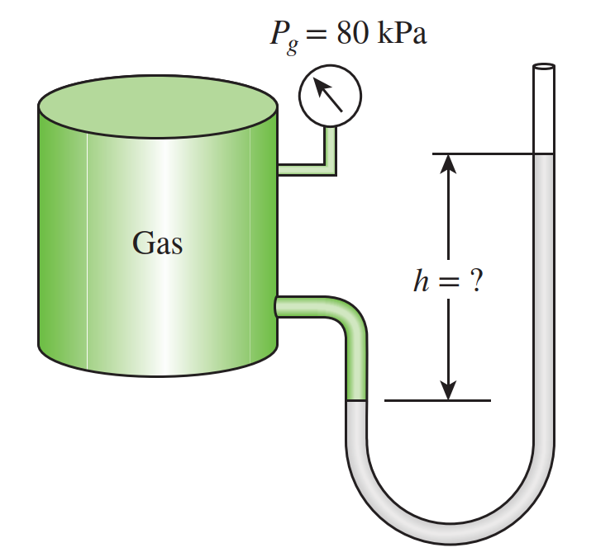
2. A hydraulic lift is to be used to lift a 1900-kg weight by putting a weight of 25 kg on a piston with a diameter of 10 cm. Determine the diameter of the piston (D₂) on which the weight is to be placed. (20 p)

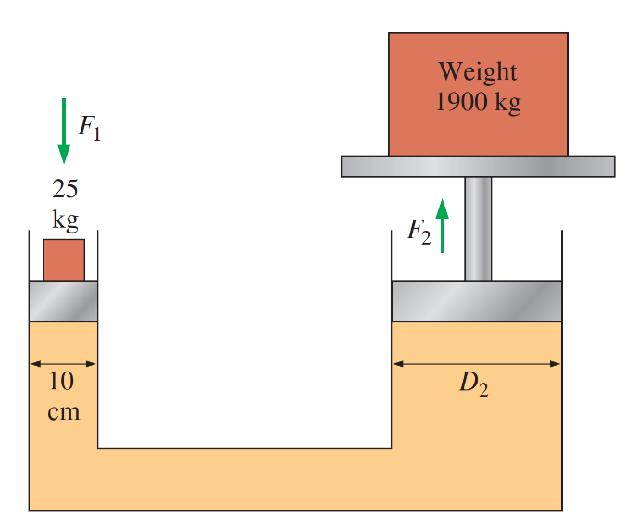

3. Consider a wind turbine with a blade span diameter of 100 m installed at a site subjected to steady winds at 8 m/s. Taking the overall efficiency of the wind turbine to be 32% and the air density to be 1.25 kg/m3, answer the following questions:
(a) electric power generated by this wind turbine (10 p)
(b) assuming steady winds of 8 m/s during a 24-h period, determine the amount of electric energy and the revenue generated per day for a unit price of $0.09/kWh for electricity. (10 p)

4. Constant heat flux of 25 W/m² passes through a wooden blade having a thickness of 10 cm. The temperature at the two ends of the wooden blade is 10°C and 35 °C respectively. Considering a steady state heat transfer:
(a) How much is the thermal conductivity constant of wood? (10 p)
(b) How much is the heat transfer rate for the same wooden blade with a length of 5 cm and volume of 0.45 m³? (10 p)

5. As a future engineer, you need to find a solution for a clean energy source to replace the current carbon-based energy sources. Review different advanced clean energy technologies and select one of them for discussion. Write an essay (400-500 words) to explain your solutions. (20 p)

6. Your free feedback on the first weeks and time spent on this learning exercise. (This does not affect the grading)

