# ELEC-E8406 2023 Electricity Distribution Network Planning Assignment: Due on March 20, midnight (or before!)

### (Worth 0-50% of your final grade, whatever helps you the most, to be done in groups of 3 to 6)

## A (Working-) Life Skill – Multiculturalism and Celebrating Differences

First, a few comments on a working life skill that has been integrated into this course. You are the victims of a group-forming algorithm that I use to create diverse groups, in terms of country of origin, academic discipline, gender and personality. In ‘my’ opinion (a subjective and partial view), country of origin, skin colour and religion are more superficial ‘initial distinctions’ than personality, but personality is very difficult to assess in a quick questionnaire – e.g., when I fill in a personality profile test, am I responding as I actually am, or as I would like to appear to the world? Have you noticed this?

What am I, actually? One view: an incredibly complex transient interweaving of evolving genetic proclivities interacting (epigenetically and memetically?) with multitude streams of conditioning. If we probe deeply what culture or rather culturing is, things like skin colour and even some crude personality stamping seem highly inadequate and limiting, and the crude attempts to classify human beings in these terms should be treated with some humour! One delightful recent finding is that the first “Englishmen” were dark-skinned [1]! It should also be stated clearly that there is nothing superior (or inferior) about a particular gender, skin colour, odour, ethnicity, country of origin, academic discipline, proclivity or personality type. Some of these are just symbols used for convenience in communication and social grouping, and others were appropriate instruments for survival in the savannah and jungle, but need not be overly identified with. For example, I do not have to cling to being a male to be a male – I just happen to be male – a rather unfashionable slightly off-white heterosexual male! Another observation from this life is that humans seem to be the most aggressively defensive about the things that have the least inherent reality (it is hardly necessary to defend the self-evident, and perhaps the ‘self’ itself is the biggest fiction of all [2]?)... Another observation is that how we are is largely accidental (“I” did not choose my parents, the environment I was born into, the genetic material I inherited, etc., etc…). This is not an excuse for fatalism. It just means that while we strive to do our best, act with integrity, clarity and compassion, we realise with gratitude that being able to do our ‘best’ is due to good luck in terms of conditioning (both environmental and genetic). We are all better off if we work to remove the institutional and cultural barriers that shackle both us, and the large swathe of humanity who are not so ‘lucky’, but equally worthy. I hope such a sentiment unites humanity, regardless of whether we lean left or right in our politics!

In the last few years, international students have been a bit thinner on the ground, but we have an increasing number of females in this field of study, which is long overdue! If some males contend engineering is in some sense “male”, that is because males have made it so. It is to be hoped that a more heterogeneous grouping of human animals will increase the field’s empathy, and help integrate the ‘externalities’ to end the days of exploitation and resource depletion that have accompanied the technological wealth accumulation for the minority.

What we have is a mixture of groups, ranging from 3 to 6 members, all of which are to some degree heterogeneous. Each of the 7.8 billion human life expressions on this planet are unique but, once again, this is not stuff to cling to. If it is, it is, and ‘your’ uniqueness is as incredible as ‘mine’...

In your group work, then, try to celebrate the differences (which may occur even in the apparently homogeneous groups). Perhaps the biggest challenge in this course is dealing with the curly-haired disordered Kiwi, John, who tries to balance teaching, research, supervision, music, meditation, and friends and family in a rather too busy life! Realise that each of our views of the world or any particular part of it are filtered and bound to be distorted (unconscious bias [3]). Meeting people and situations where our views are challenged is of incredible benefit.

**So, if you encounter disagreements, cross-cultural misunderstanding, or any stress-causing factor at all, that is part of the learning process! Take a few breaths, let go into the physical feeling of stress (or joy!), it is just what is arising, neither ‘me’ nor ‘mine’... Speak to John if things become dysfunctional in your group! Let him know if things are going fine! Is Covid still a thing? The geopolitical strife on earth, our only home, is very evident. How do we still allow this?**

**Take it easy on yourselves. Close the laptop (and the mobile phone!) sometimes. Take a brief walk or do some stretches! Breathe!**

Let this 2+7 week period of group work be an opportunity to reflect on interpersonal dynamics, as you collectively work towards the common goal of a good set of distribution network plans, and debate about the essay topic to craft a content and thought-rich essay! Let us hold our views lightly and be aware of our own highly conditioned nature, even whilst working, interacting and living passionately, and do not be afraid to challenge John’s (slightly left-leaning) opinions!

References

[1] <https://www.theguardian.com/science/2018/feb/07/first-modern-britons-dark-black-skin-cheddar-man-dna-analysis-reveals>

[2] Jay L. Garfield, “Losing Ourselves: Learning to Live without a Self”, Princetown University Press, Jul 19, 2022, ISBN: 9780691220284

[3] <https://www.unconsciousbiasproject.org/resources/explain-unconscious-bias> (accessed Dec. 30, 2022)

## The Contemplation Exercise and Essay

i. **Get in touch with** your group members and decide whether you want to do the contemplation exercise (Exercise ii) as a group or individually, and begin discussions about which existential questions(s) (part iii) you will explore.

ii. A secular **contemplation exercise**: Audio recording of these instructions will be available soon.

* Sit with back upright but relaxed
* Start with the eyes relaxed and half-closed
* Let the eyes stay half-closed, or open, or close…
* Allow a few deeper breaths, but don’t strain
* Let the breathing do its own thing, and be with the breathing
* Try and find the ‘who’ that is breathing, the seat of your attention, the ‘you’ in all this
* Smile with the paradox! (An eye or an “I” cannot see itself, fingertips cannot feel themselves!)
* Let go of any trying
* Just be with, and be OK with, whatever is arising (thoughts, emotions, sounds, images, whatever...)

iii. (**The essay**): What are the major existential crises (plural) your group identifies in our only home, planet earth? Choose one (or more) of these crises, not necessarily the most related to this course, that you would like to investigate in terms of root causes (including inappropriate human attitudes and behaviour). Suggest possible ways for humanity to negotiate its way through the crisis you have identified (including promoting appropriate human attitudes and behaviour). Provide an essay with 1 page per student member (so 5 pages for a group with 5 members). The essay can be passionate and express ‘angst’, it is not a language test, but some well-referenced fact-based material should also be included! You may use AI but please think critically and list all references (including Chat GTP, Grammarly, etc.). Any large chunks of text taken from any source should be put in quotation marks with a citation, e.g.,

"To be or not to be", Shakespeare, William. Hamlet. Edited by G. R. Hibbard, Oxford UP, 2008.

If you have time and are willing, repeat Exercise ii as a group after collectively creating the essay! Feel free to comment on this exercise in your essays and/or the “Learning Together” forum in MyCourses and/or in private discussion with John.

Suggested due date for essay: ***Midnight, February 14***

## The Planning Task

The planning task gives you the opportunity to plan a realistic section of distribution network using futuristic load and DG data, and note, the *future* is approaching faster than expected! Each group is assigned a pair of fictitious primary substations, and a set of about 16 secondary substations, which should be sensibly placed in the region between (or close to) the two primary substations. Each substation has a given mix of consumption and generation that is based loosely on measured data from renewable DG-rich Germany and some demand increase to account for domestic electric vehicle charging and general electrification. The given load growth is chosen to nearly double the demand and distributed generation over the next 20 years. Your task is to plan and cost an MV (20 kV) network, including appropriate switching, backup, line type and conductor sizing. You will need the parameters given in the Appendices (A to E) to perform the distribution network planning task. You will complete the planning task **by verifying at least one aspect of your plan with a software tool**, such as Matlab Simscape® or a GIS/power flow tool developed by an AEE project group and former student of this course, Joona Kukkonen.

***This document should contain sufficient help, data and information to perform the tasks. Organising the tasks evenly among group members will be logistically challenging, but that is part of the exercise. You should schedule at least two 20 minute meetings (per group) with John. In addition, he will be available in the lecture halls during the lecture periods when there are no lectures - it is advised that you use these ‘free-from-lecture’ sessions for working on the assignment. Zoom meetings are also an option if it is challenging for members of your group to come to campus. It is expected that you will need 30-40 hours per person, so get started and good luck!***

***John Millar, January 29, 2024.***

# Introduction

Figure 1 presents the assignment planning area and primary substation positions, taken from a beautiful region somewhere in the far north of this extraordinary planet that we are lucky to find ourselves on. The coordinates and information given in the Appendix will show you how to accurately locate the primary substations for your particular group’s planning task on a map background to help you sensibly locate the secondary substations, plan the lines to suitably connect the substations, and measure their distances.

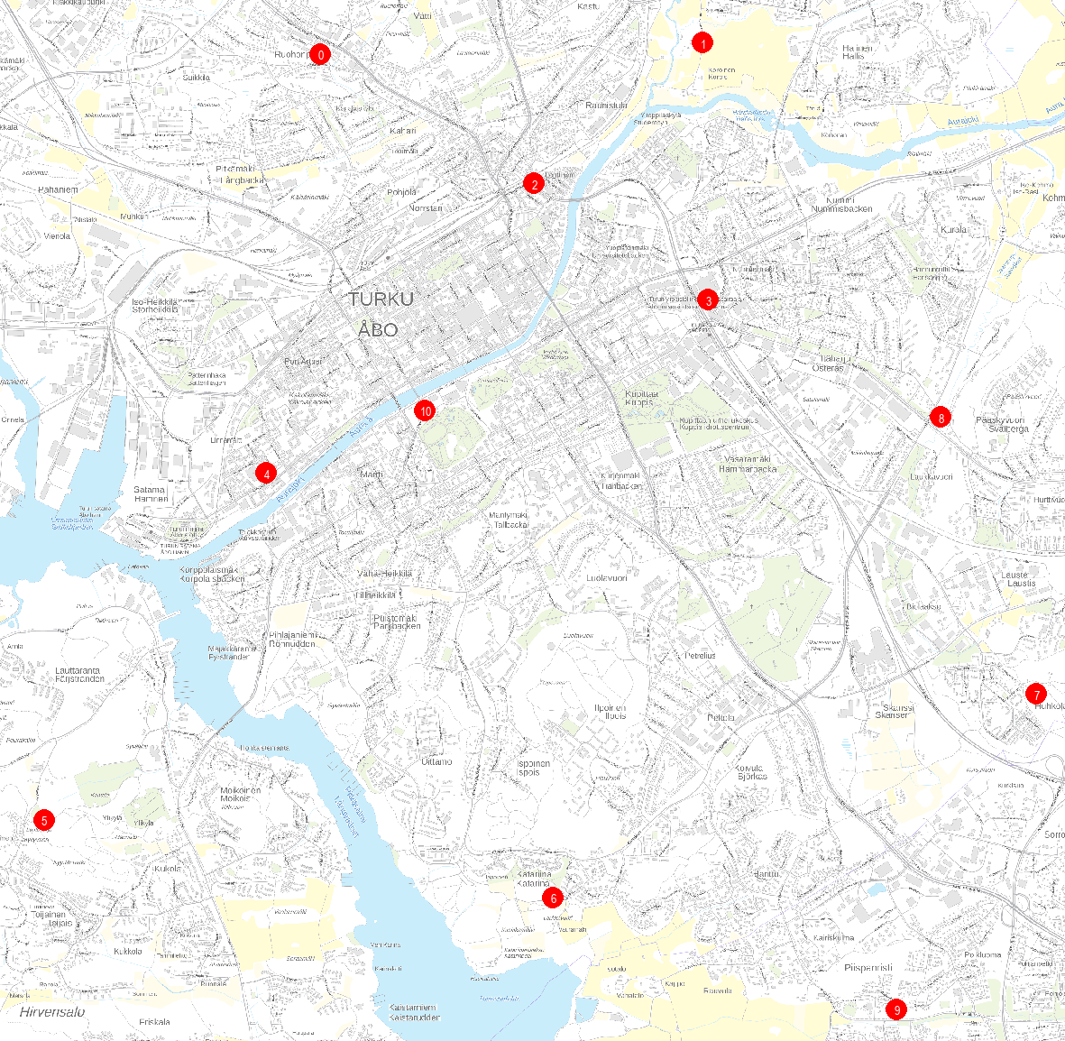

Figure 1 Planning area for 2023 assignment. Primary substation coordinates are ETRS89/ETRS-TM35FIN and are taken from the open-source map interface provided online by Fingrid ([https://karttapalaute.fingrid.fi/#](https://karttapalaute.fingrid.fi/)), Maan-Mittaus-Laitos (<https://kartta.paikkatietoikkuna.fi/>) and Google Maps

# Task

## Plan and cost (NPV) a radially operated network with appropriate switches and backup connections, and verify one aspect of your plan (e.g. one of the technical constraints) with an external software tool such as Matlab Simscape®



Figure 2 Regions between primary substations where each group should suitably locate their allocated secondary substations. Group 08 has only one primary substation

Plan and cost a distribution network that radially connects your group’s allocated secondary substations to the feeding primary substation. These are listed in Table 2 in Appendix A. You can choose underground cables or bare overhead conductors in your network, or a combination of both. For switching, you can use manual and/or remote-operated load breaking switches, and even network circuit breakers, if appropriate. Use the fixed design parameters in Table 1.

* Assume a load growth of 3%/year for **20** years and a total review time of **40** years. Your costing should include:
  + investment costs (in the present)
  + the present value of the line (3*I2R*) losses over the entire review period (**40** years)
  + the present value of the interruption costs from permanent faults.
* Line sections connected to the primary substations have circuit breakers, and each primary substation (main 20 kV feeder) connection has a cost.
* The network should be radially operated. Show where the open point(s) are. **You should be aware of the 6 h interruption limit for urban/suburban customers and plan accordingly if that’s where your planning area is…**
* Your network plan should be technically viable, also during contingencies, and reasonably cost-effective!
* You should verify (at least) one of the technical constraints with an external tool, such as Matlab Simscape®

Appendix B gives a couple of useful map links and shows one way of calculating line route lengths. The data uses the coordinate system ETRS89/ETRS-TM35FIN.

Table 1 Fixed parameters for Task A

|  |  |  |
| --- | --- | --- |
| p | interest rate | 4 % |
| r | load growth | 3.0 % for 20 years |
| a & b | CIC values | 1.23 €/kW & 12.3 €/kWh |
| cl | Cost of energy losses | 0.06 €/kWh |

Other costs and parameters, e.g., for switches, feeder connections and lines, can be found in Appendix C. Interruption costs and other nodal data are given in Tables 2, 3 and 4.

Assume a voltage of **19.5 kV at every secondary substation** node in the network – that will push currents up and thus err on the safe side. You do not need to run a full load flow (unless you want to!), but use upstream summation of the active and reactive power components to calculate the load transfers in each line section assuming that there are no losses in the lines. The cost of losses, however, should of course be calculated, and for that, you will need the utilisation time for losses, ***T*losses**, related to the maximum (demand-related) power flow in each line section, which, to make things simpler, are assumed to be 3000 h/year for every node, as given in Table 4 in Appendix A. See Appendix D for the discount factors that you will need to convert the yearly loss-based costs and load-based costs to the net present value (NPV). **You should use higher than nominal voltages at the primary substations** for maximum 3-phase short circuit currents (**e.g. 20 kV + 10%**).

## Submission instructions

Provide your final solution (one per group) for each part in a word-based report and your calculations in Excel. Make both documents as clear as possible – showing the methodology and results in the word document, and the numerical calculations in Excel. **Please have mercy on John!** Make your work easy to grade! Make sure all the data used on one sheet is visible on that sheet! Remember that you will have the chance to earn back 2 points if you correct 2 errors – so clear work will help you do this if needed!

Either submit the documents (the essays, the planning task and a power point presentation with the main conclusions from both) **via MyCourses**, or if there is a problem with that, email the documents to [john.millar@aalto.fi](mailto:john.millar@aalto.fi) before midnight on March 20, with the subject heading “**ELEC-E8406: Distribution Network Planning Assignment for group xx**”, where “xx” is your group number!

## Appendix A: Nodal Data

Table 2 gives the substation node references for each group. HV grid and primary substation parameters are given in Table 3, and their coordinates are given in red in Table 4. You can also get the load data for each node (secondary substation) from Table 4. Please make sure that the load data for all your nodes are in Table 4. Let John know if there are any problems, missing data or you have a primary substation in the middle of a lake! You must locate the secondary substations yourselves by studying maps and using common sense. Note, you will have to make two load flow calculations, one for maximum demand / minimum generation (*P*max and *Q*max), and another for minimum demand /maximum generation (*P*min and *Q*min). Remember load growth for technical constraints!

Table 2 Substation node references, a column for each group. Note that the second and third rows (in red) are the node references for your primary substations. The rest of the rows in your column give the node references for the secondary (20/0.4kV) substations.

|  |  |  |  |  |  |  |  |  |  |  |  |
| --- | --- | --- | --- | --- | --- | --- | --- | --- | --- | --- | --- |
| **G 1** | **G 2** | **G 3** | **G 4** | **G 5** | **G 6** | **G 7** | **G 8** | **G9** | **G10** | **G11** | **G12** |
| **0** | **1** | **2** | **3** | **2** | **3** | **4** | **7** | **5** | **6** | **6** | **10** |
| **2** | **2** | **3** | **8** | **10** | **10** | **10** | **8** |  | **7** | **9** | **6** |
| 11 | 27 | 43 | 59 | 75 | 91 | 107 | 123 | 139 | 155 | 171 | 187 |
| 12 | 28 | 44 | 60 | 76 | 92 | 108 | 124 | 140 | 156 | 172 | 188 |
| 13 | 29 | 45 | 61 | 77 | 93 | 109 | 125 | 141 | 157 | 173 | 189 |
| 14 | 30 | 46 | 62 | 78 | 94 | 110 | 126 | 142 | 158 | 174 | 190 |
| 15 | 31 | 47 | 63 | 79 | 95 | 111 | 127 | 143 | 159 | 175 | 191 |
| 16 | 32 | 48 | 64 | 80 | 96 | 112 | 128 | 144 | 160 | 176 | 192 |
| 17 | 33 | 49 | 65 | 81 | 97 | 113 | 129 | 145 | 161 | 177 | 193 |
| 18 | 34 | 50 | 66 | 82 | 98 | 114 | 130 | 146 | 162 | 178 | 194 |
| 19 | 35 | 51 | 67 | 83 | 99 | 115 | 131 | 147 | 163 | 179 | 195 |
| 20 | 36 | 52 | 68 | 84 | 100 | 116 | 132 | 148 | 164 | 180 | 196 |
| 21 | 37 | 53 | 69 | 85 | 101 | 117 | 133 | 149 | 165 | 181 | 197 |
| 22 | 38 | 54 | 70 | 86 | 102 | 118 | 134 |  | 166 | 182 | 198 |
| 23 | 39 | 55 | 71 | 87 | 103 | 119 | 135 |  | 167 | 183 | 199 |
| 24 | 40 | 56 | 72 | 88 |  | 120 |  |  |  |  |  |
| 25 | 41 | 57 | 73 | 89 |  | 121 |  |  |  |  |  |
| 26 | 42 | 58 | 74 | 90 |  | 122 |  |  |  |  |  |

***Note, it may be that I’ve got something wrong in the table above, so if you find that you have a primary substation in the middle of nowhere, shift it to a more sensible location, but make sure you give John the new coordinates! It is your job to place your secondary substations appropriately!***

Table 3 HV grid and primary substation parameters

|  |  |  |  |
| --- | --- | --- | --- |
|  | 110 kV grid | Main transformer | |
| Node IDs | *S*k  (MVA) | *u*k  (p.u.) | *S*N  (MVA) |
| 0 to 10 | 2400 | 0.1 | 2x40 |

Table 4 Network nodal parameters – select the ones relevant for your group planning task. Nodes 0 to 13 are feeding primary substations

|  |  |  |  |  |  |  |  |  |  |  |
| --- | --- | --- | --- | --- | --- | --- | --- | --- | --- | --- |
| **Node ID** | **Coordinates, ETRS89/ETRS-TM35FIN** | | **Load** | | | | | | **CIC-parameters** | |
| ***X* (East)** | ***Y* (North)** | ***P*max** | ***P*min** | ***Q*max** | ***Q*min** | ***T*losses[1]** | ***fcoincidence*** | ***a*** | ***b*** |
| **(m)** | **(m)** | **(kW)** | **(kW)** | **(kvar)** | **(kvar)** | **(h/a)** | **(€/kW)** | **(€/kWh)** |
| **0** | 238504.04 | 6712910.74 | **0** | **0** | **0** | **0** | **0** | **0** | **0** | **0** |
| **1** | 241345.64 | 6712993.94 | **0** | **0** | **0** | **0** | **0** | **0** | **0** | **0** |
| **2** | 240091.24 | 6711950.74 | **0** | **0** | **0** | **0** | **0** | **0** | **0** | **0** |
| **3** | 241384.04 | 6711085.14 | **0** | **0** | **0** | **0** | **0** | **0** | **0** | **0** |
| **4** | 238100.84 | 6709798.74 | **0** | **0** | **0** | **0** | **0** | **0** | **0** | **0** |
| **5** | 236449.64 | 6707225.94 | **0** | **0** | **0** | **0** | **0** | **0** | **0** | **0** |
| **6** | 240232.03 | 6706649.94 | **0** | **0** | **0** | **0** | **0** | **0** | **0** | **0** |
| **7** | 243822.44 | 6708160.34 | **0** | **0** | **0** | **0** | **0** | **0** | **0** | **0** |
| **8** | 243112.03 | 6710214.74 | **0** | **0** | **0** | **0** | **0** | **0** | **0** | **0** |
| **9** | 242785.64 | 6705817.94 | **0** | **0** | **0** | **0** | **0** | **0** | **0** | **0** |
| **10** | 239281.12 | 6710264.74 | **0** | **0** | **0** | **0** | **0** | **0** | **0** | **0** |
| **11** | 233326.44 | 6711009.94 | **0** | **0** | **0** | **0** | **0** | **0** | **0** | **0** |
| **12** | 233460.84 | 6712269.14 | **0** | **0** | **0** | **0** | **0** | **0** | **0** | **0** |
| **13** | 235668.84 | 6712048.34 | **0** | **0** | **0** | **0** | **0** | **0** | **0** | **0** |
| 14 |  |  | 902 | -1330 | 227 | 2 | 3000 | 1 | 1.23 | 12.3 |
| 15 |  |  | 757 | -1176 | 116 | 26 | 3000 | 1 | 1.23 | 12.3 |
| 16 |  |  | 470 | 461 | 45 | 25 | 3000 | 1 | 1.23 | 12.3 |
| 17 |  |  | 613 | 395 | 42 | 0 | 3000 | 1 | 1.23 | 12.3 |
| 18 |  |  | 632 | -80 | 20 | 8 | 3000 | 1 | 1.23 | 12.3 |
| 19 |  |  | 341 | -182 | 79 | 22 | 3000 | 1 | 1.23 | 12.3 |
| 20 |  |  | 429 | -1236 | 133 | 23 | 3000 | 1 | 1.23 | 12.3 |
| 21 |  |  | 328 | -12 | 124 | 17 | 3000 | 1 | 1.23 | 12.3 |
| 22 |  |  | 305 | -223 | 185 | 11 | 3000 | 1 | 1.23 | 12.3 |
| 23 |  |  | 615 | -402 | 114 | 10 | 3000 | 1 | 1.23 | 12.3 |
| 24 |  |  | 708 | 159 | 21 | 16 | 3000 | 1 | 1.23 | 12.3 |
| 25 |  |  | 613 | -966 | 51 | 15 | 3000 | 1 | 1.23 | 12.3 |
| 26 |  |  | 483 | -879 | 50 | 17 | 3000 | 1 | 1.23 | 12.3 |
| 27 |  |  | 989 | 323 | 132 | 2 | 3000 | 1 | 1.23 | 12.3 |
| 28 |  |  | 494 | 36 | 100 | 7 | 3000 | 1 | 1.23 | 12.3 |
| 29 |  |  | 647 | -329 | 193 | 6 | 3000 | 1 | 1.23 | 12.3 |
| 30 |  |  | 649 | 476 | 64 | 14 | 3000 | 1 | 1.23 | 12.3 |
| 31 |  |  | 442 | -380 | 130 | 7 | 3000 | 1 | 1.23 | 12.3 |
| 32 |  |  | 801 | -133 | 72 | 29 | 3000 | 1 | 1.23 | 12.3 |
| 33 |  |  | 828 | -269 | 149 | 4 | 3000 | 1 | 1.23 | 12.3 |
| 34 |  |  | 689 | -988 | 109 | 20 | 3000 | 1 | 1.23 | 12.3 |
| 35 |  |  | 505 | -424 | 47 | 6 | 3000 | 1 | 1.23 | 12.3 |
| 36 |  |  | 569 | 215 | 111 | 2 | 3000 | 1 | 1.23 | 12.3 |
| 37 |  |  | 604 | -937 | 139 | 13 | 3000 | 1 | 1.23 | 12.3 |
| 38 |  |  | 969 | -1245 | 222 | 2 | 3000 | 1 | 1.23 | 12.3 |
| 39 |  |  | 927 | -696 | 220 | 18 | 3000 | 1 | 1.23 | 12.3 |
| 40 |  |  | 844 | 734 | 50 | 29 | 3000 | 1 | 1.23 | 12.3 |
| 41 |  |  | 502 | 232 | 70 | 23 | 3000 | 1 | 1.23 | 12.3 |
| 42 |  |  | 468 | -777 | 89 | 2 | 3000 | 1 | 1.23 | 12.3 |
| 43 |  |  | 953 | -35 | 165 | 12 | 3000 | 1 | 1.23 | 12.3 |
| 44 |  |  | 434 | -939 | 2 | 7 | 3000 | 1 | 1.23 | 12.3 |
| 45 |  |  | 387 | 254 | 71 | 10 | 3000 | 1 | 1.23 | 12.3 |
| 46 |  |  | 786 | 270 | 7 | 29 | 3000 | 1 | 1.23 | 12.3 |
| 47 |  |  | 477 | -698 | 53 | 17 | 3000 | 1 | 1.23 | 12.3 |
| 48 |  |  | 401 | -963 | 46 | 17 | 3000 | 1 | 1.23 | 12.3 |
| 49 |  |  | 420 | -542 | 201 | 26 | 3000 | 1 | 1.23 | 12.3 |
| 50 |  |  | 662 | 90 | 81 | 24 | 3000 | 1 | 1.23 | 12.3 |
| 51 |  |  | 941 | -1356 | 31 | 9 | 3000 | 1 | 1.23 | 12.3 |
| 52 |  |  | 827 | -1497 | 69 | 22 | 3000 | 1 | 1.23 | 12.3 |
| 53 |  |  | 673 | -466 | 107 | 7 | 3000 | 1 | 1.23 | 12.3 |
| 54 |  |  | 423 | -919 | 176 | 8 | 3000 | 1 | 1.23 | 12.3 |
| 55 |  |  | 594 | 457 | 98 | 4 | 3000 | 1 | 1.23 | 12.3 |
| 56 |  |  | 780 | -608 | 73 | 28 | 3000 | 1 | 1.23 | 12.3 |
| 57 |  |  | 336 | -805 | 156 | 18 | 3000 | 1 | 1.23 | 12.3 |
| 58 |  |  | 964 | -1211 | 10 | 29 | 3000 | 1 | 1.23 | 12.3 |
| 59 |  |  | 674 | 89 | 17 | 16 | 3000 | 1 | 1.23 | 12.3 |
| 60 |  |  | 527 | 444 | 129 | 28 | 3000 | 1 | 1.23 | 12.3 |
| 61 |  |  | 1007 | -847 | 25 | 13 | 3000 | 1 | 1.23 | 12.3 |
| 62 |  |  | 426 | -1120 | 69 | 19 | 3000 | 1 | 1.23 | 12.3 |
| 63 |  |  | 458 | -79 | 102 | 11 | 3000 | 1 | 1.23 | 12.3 |
| 64 |  |  | 306 | 240 | 207 | 2 | 3000 | 1 | 1.23 | 12.3 |
| 65 |  |  | 351 | -39 | 205 | 8 | 3000 | 1 | 1.23 | 12.3 |
| 66 |  |  | 400 | -673 | 124 | 0 | 3000 | 1 | 1.23 | 12.3 |
| 67 |  |  | 962 | 617 | 229 | 20 | 3000 | 1 | 1.23 | 12.3 |
| 68 |  |  | 775 | -1114 | 52 | 26 | 3000 | 1 | 1.23 | 12.3 |
| 69 |  |  | 421 | -423 | 90 | 29 | 3000 | 1 | 1.23 | 12.3 |
| 70 |  |  | 643 | 643 | 94 | 21 | 3000 | 1 | 1.23 | 12.3 |
| 71 |  |  | 336 | -1090 | 67 | 6 | 3000 | 1 | 1.23 | 12.3 |
| 72 |  |  | 634 | -131 | 189 | 5 | 3000 | 1 | 1.23 | 12.3 |
| 73 |  |  | 807 | -14 | 28 | 6 | 3000 | 1 | 1.23 | 12.3 |
| 74 |  |  | 768 | 550 | 54 | 2 | 3000 | 1 | 1.23 | 12.3 |
| 75 |  |  | 538 | -200 | 95 | 16 | 3000 | 1 | 1.23 | 12.3 |
| 76 |  |  | 642 | 163 | 203 | 7 | 3000 | 1 | 1.23 | 12.3 |
| 77 |  |  | 305 | -1393 | 10 | 9 | 3000 | 1 | 1.23 | 12.3 |
| 78 |  |  | 1020 | 475 | 186 | 29 | 3000 | 1 | 1.23 | 12.3 |
| 79 |  |  | 548 | -167 | 85 | 8 | 3000 | 1 | 1.23 | 12.3 |
| 80 |  |  | 977 | -172 | 141 | 19 | 3000 | 1 | 1.23 | 12.3 |
| 81 |  |  | 717 | -1101 | 186 | 15 | 3000 | 1 | 1.23 | 12.3 |
| 82 |  |  | 656 | -991 | 189 | 8 | 3000 | 1 | 1.23 | 12.3 |
| 83 |  |  | 651 | 338 | 163 | 24 | 3000 | 1 | 1.23 | 12.3 |
| 84 |  |  | 467 | -1289 | 69 | 26 | 3000 | 1 | 1.23 | 12.3 |
| 85 |  |  | 392 | -1380 | 117 | 11 | 3000 | 1 | 1.23 | 12.3 |
| 86 |  |  | 957 | 848 | 123 | 19 | 3000 | 1 | 1.23 | 12.3 |
| 87 |  |  | 1017 | -495 | 29 | 12 | 3000 | 1 | 1.23 | 12.3 |
| 88 |  |  | 316 | -525 | 22 | 29 | 3000 | 1 | 1.23 | 12.3 |
| 89 |  |  | 327 | -1061 | 136 | 2 | 3000 | 1 | 1.23 | 12.3 |
| 90 |  |  | 656 | 260 | 154 | 15 | 3000 | 1 | 1.23 | 12.3 |
| 91 |  |  | 904 | 230 | 201 | 11 | 3000 | 1 | 1.23 | 12.3 |
| 92 |  |  | 689 | -1022 | 6 | 16 | 3000 | 1 | 1.23 | 12.3 |
| 93 |  |  | 820 | -938 | 70 | 19 | 3000 | 1 | 1.23 | 12.3 |
| 94 |  |  | 330 | 110 | 140 | 18 | 3000 | 1 | 1.23 | 12.3 |
| 95 |  |  | 709 | -418 | 54 | 0 | 3000 | 1 | 1.23 | 12.3 |
| 96 |  |  | 782 | -1272 | 145 | 27 | 3000 | 1 | 1.23 | 12.3 |
| 97 |  |  | 952 | -1475 | 132 | 0 | 3000 | 1 | 1.23 | 12.3 |
| 98 |  |  | 775 | -337 | 214 | 26 | 3000 | 1 | 1.23 | 12.3 |
| 99 |  |  | 628 | -1395 | 195 | 11 | 3000 | 1 | 1.23 | 12.3 |
| 100 |  |  | 893 | -1453 | 135 | 8 | 3000 | 1 | 1.23 | 12.3 |
| 101 |  |  | 488 | -1431 | 191 | 11 | 3000 | 1 | 1.23 | 12.3 |
| 102 |  |  | 576 | -757 | 134 | 24 | 3000 | 1 | 1.23 | 12.3 |
| 103 |  |  | 508 | -215 | 174 | 12 | 3000 | 1 | 1.23 | 12.3 |
| 104 |  |  | 411 | -510 | 64 | 27 | 3000 | 1 | 1.23 | 12.3 |
| 105 |  |  | 856 | 220 | 8 | 26 | 3000 | 1 | 1.23 | 12.3 |
| 106 |  |  | 865 | -415 | 136 | 24 | 3000 | 1 | 1.23 | 12.3 |
| 107 |  |  | 673 | 547 | 121 | 23 | 3000 | 1 | 1.23 | 12.3 |
| 108 |  |  | 923 | -880 | 82 | 19 | 3000 | 1 | 1.23 | 12.3 |
| 109 |  |  | 494 | -653 | 179 | 7 | 3000 | 1 | 1.23 | 12.3 |
| 110 |  |  | 363 | -264 | 153 | 23 | 3000 | 1 | 1.23 | 12.3 |
| 111 |  |  | 870 | 736 | 163 | 4 | 3000 | 1 | 1.23 | 12.3 |
| 112 |  |  | 748 | -605 | 102 | 10 | 3000 | 1 | 1.23 | 12.3 |
| 113 |  |  | 741 | 686 | 112 | 7 | 3000 | 1 | 1.23 | 12.3 |
| 114 |  |  | 327 | -1380 | 177 | 28 | 3000 | 1 | 1.23 | 12.3 |
| 115 |  |  | 488 | -174 | 86 | 17 | 3000 | 1 | 1.23 | 12.3 |
| 116 |  |  | 782 | -137 | 11 | 28 | 3000 | 1 | 1.23 | 12.3 |
| 117 |  |  | 821 | -295 | 211 | 11 | 3000 | 1 | 1.23 | 12.3 |
| 118 |  |  | 458 | -1030 | 120 | 20 | 3000 | 1 | 1.23 | 12.3 |
| 119 |  |  | 715 | 110 | 33 | 14 | 3000 | 1 | 1.23 | 12.3 |
| 120 |  |  | 847 | 765 | 107 | 10 | 3000 | 1 | 1.23 | 12.3 |
| 121 |  |  | 918 | -609 | 174 | 21 | 3000 | 1 | 1.23 | 12.3 |
| 122 |  |  | 862 | 572 | 71 | 21 | 3000 | 1 | 1.23 | 12.3 |
| 123 |  |  | 948 | -1475 | 51 | 21 | 3000 | 1 | 1.23 | 12.3 |
| 124 |  |  | 339 | 104 | 193 | 8 | 3000 | 1 | 1.23 | 12.3 |
| 125 |  |  | 441 | -930 | 38 | 26 | 3000 | 1 | 1.23 | 12.3 |
| 126 |  |  | 620 | 597 | 104 | 17 | 3000 | 1 | 1.23 | 12.3 |
| 127 |  |  | 310 | -1144 | 210 | 21 | 3000 | 1 | 1.23 | 12.3 |
| 128 |  |  | 932 | 179 | 184 | 6 | 3000 | 1 | 1.23 | 12.3 |
| 129 |  |  | 641 | 496 | 17 | 9 | 3000 | 1 | 1.23 | 12.3 |
| 130 |  |  | 587 | -240 | 153 | 19 | 3000 | 1 | 1.23 | 12.3 |
| 131 |  |  | 550 | 542 | 35 | 3 | 3000 | 1 | 1.23 | 12.3 |
| 132 |  |  | 376 | -90 | 170 | 3 | 3000 | 1 | 1.23 | 12.3 |
| 133 |  |  | 325 | -465 | 124 | 4 | 3000 | 1 | 1.23 | 12.3 |
| 134 |  |  | 386 | 334 | 211 | 1 | 3000 | 1 | 1.23 | 12.3 |
| 135 |  |  | 398 | -750 | 135 | 25 | 3000 | 1 | 1.23 | 12.3 |
| 136 |  |  | 852 | -907 | 218 | 24 | 3000 | 1 | 1.23 | 12.3 |
| 137 |  |  | 991 | -746 | 224 | 21 | 3000 | 1 | 1.23 | 12.3 |
| 138 |  |  | 343 | -370 | 199 | 4 | 3000 | 1 | 1.23 | 12.3 |
| 139 |  |  | 409 | -1404 | 153 | 22 | 3000 | 1 | 1.23 | 12.3 |
| 140 |  |  | 467 | -487 | 156 | 9 | 3000 | 1 | 1.23 | 12.3 |
| 141 |  |  | 987 | 791 | 166 | 14 | 3000 | 1 | 1.23 | 12.3 |
| 142 |  |  | 791 | -254 | 39 | 7 | 3000 | 1 | 1.23 | 12.3 |
| 143 |  |  | 877 | -599 | 217 | 23 | 3000 | 1 | 1.23 | 12.3 |
| 144 |  |  | 882 | -658 | 204 | 0 | 3000 | 1 | 1.23 | 12.3 |
| 145 |  |  | 539 | -141 | 201 | 0 | 3000 | 1 | 1.23 | 12.3 |
| 146 |  |  | 856 | -1253 | 22 | 15 | 3000 | 1 | 1.23 | 12.3 |
| 147 |  |  | 901 | -480 | 4 | 18 | 3000 | 1 | 1.23 | 12.3 |
| 148 |  |  | 470 | -513 | 114 | 19 | 3000 | 1 | 1.23 | 12.3 |
| 149 |  |  | 632 | 400 | 213 | 2 | 3000 | 1 | 1.23 | 12.3 |
| 150 |  |  | 435 | 3 | 211 | 22 | 3000 | 1 | 1.23 | 12.3 |
| 151 |  |  | 577 | 427 | 17 | 9 | 3000 | 1 | 1.23 | 12.3 |
| 152 |  |  | 713 | 692 | 122 | 23 | 3000 | 1 | 1.23 | 12.3 |
| 153 |  |  | 696 | -256 | 127 | 6 | 3000 | 1 | 1.23 | 12.3 |
| 154 |  |  | 989 | -656 | 8 | 11 | 3000 | 1 | 1.23 | 12.3 |
| 155 |  |  | 573 | -1310 | 172 | 18 | 3000 | 1 | 1.23 | 12.3 |
| 156 |  |  | 359 | -266 | 216 | 5 | 3000 | 1 | 1.23 | 12.3 |
| 157 |  |  | 652 | -1053 | 172 | 16 | 3000 | 1 | 1.23 | 12.3 |
| 158 |  |  | 466 | 317 | 3 | 18 | 3000 | 1 | 1.23 | 12.3 |
| 159 |  |  | 964 | -172 | 226 | 5 | 3000 | 1 | 1.23 | 12.3 |
| 160 |  |  | 627 | -1423 | 73 | 9 | 3000 | 1 | 1.23 | 12.3 |
| 161 |  |  | 538 | -141 | 73 | 11 | 3000 | 1 | 1.23 | 12.3 |
| 162 |  |  | 598 | -1033 | 109 | 27 | 3000 | 1 | 1.23 | 12.3 |
| 163 |  |  | 459 | -517 | 73 | 29 | 3000 | 1 | 1.23 | 12.3 |
| 164 |  |  | 1005 | -1127 | 60 | 12 | 3000 | 1 | 1.23 | 12.3 |
| 165 |  |  | 665 | 80 | 102 | 24 | 3000 | 1 | 1.23 | 12.3 |
| 166 |  |  | 563 | -158 | 65 | 7 | 3000 | 1 | 1.23 | 12.3 |
| 167 |  |  | 450 | -460 | 88 | 20 | 3000 | 1 | 1.23 | 12.3 |
| 168 |  |  | 537 | -552 | 30 | 15 | 3000 | 1 | 1.23 | 12.3 |
| 169 |  |  | 1012 | 991 | 66 | 9 | 3000 | 1 | 1.23 | 12.3 |
| 170 |  |  | 889 | -1254 | 173 | 22 | 3000 | 1 | 1.23 | 12.3 |
| 171 |  |  | 838 | 692 | 178 | 4 | 3000 | 1 | 1.23 | 12.3 |
| 172 |  |  | 323 | 297 | 199 | 9 | 3000 | 1 | 1.23 | 12.3 |
| 173 |  |  | 456 | -1400 | 106 | 14 | 3000 | 1 | 1.23 | 12.3 |
| 174 |  |  | 537 | -378 | 11 | 27 | 3000 | 1 | 1.23 | 12.3 |
| 175 |  |  | 927 | -76 | 1 | 1 | 3000 | 1 | 1.23 | 12.3 |
| 176 |  |  | 520 | -115 | 151 | 13 | 3000 | 1 | 1.23 | 12.3 |
| 177 |  |  | 335 | 185 | 142 | 2 | 3000 | 1 | 1.23 | 12.3 |
| 178 |  |  | 644 | 206 | 131 | 22 | 3000 | 1 | 1.23 | 12.3 |
| 179 |  |  | 970 | -926 | 11 | 0 | 3000 | 1 | 1.23 | 12.3 |
| 180 |  |  | 811 | -1128 | 203 | 18 | 3000 | 1 | 1.23 | 12.3 |
| 181 |  |  | 710 | -407 | 208 | 12 | 3000 | 1 | 1.23 | 12.3 |
| 182 |  |  | 512 | 186 | 65 | 24 | 3000 | 1 | 1.23 | 12.3 |
| 183 |  |  | 555 | -1343 | 43 | 8 | 3000 | 1 | 1.23 | 12.3 |
| 184 |  |  | 621 | -1058 | 82 | 24 | 3000 | 1 | 1.23 | 12.3 |
| 185 |  |  | 464 | -196 | 181 | 5 | 3000 | 1 | 1.23 | 12.3 |
| 186 |  |  | 684 | 618 | 32 | 27 | 3000 | 1 | 1.23 | 12.3 |
| 187 |  |  | 624 | 62 | 32 | 28 | 3000 | 1 | 1.23 | 12.3 |
| 188 |  |  | 697 | -1246 | 160 | 9 | 3000 | 1 | 1.23 | 12.3 |
| 189 |  |  | 691 | -930 | 3 | 23 | 3000 | 1 | 1.23 | 12.3 |
| 190 |  |  | 871 | -72 | 41 | 8 | 3000 | 1 | 1.23 | 12.3 |
| 191 |  |  | 656 | -727 | 66 | 27 | 3000 | 1 | 1.23 | 12.3 |
| 192 |  |  | 492 | -994 | 133 | 0 | 3000 | 1 | 1.23 | 12.3 |
| 193 |  |  | 403 | -86 | 87 | 3 | 3000 | 1 | 1.23 | 12.3 |
| 194 |  |  | 704 | -597 | 34 | 16 | 3000 | 1 | 1.23 | 12.3 |
| 195 |  |  | 446 | -498 | 156 | 18 | 3000 | 1 | 1.23 | 12.3 |
| 196 |  |  | 952 | -593 | 185 | 20 | 3000 | 1 | 1.23 | 12.3 |
| 197 |  |  | 568 | -847 | 207 | 28 | 3000 | 1 | 1.23 | 12.3 |
| 198 |  |  | 416 | -795 | 173 | 20 | 3000 | 1 | 1.23 | 12.3 |
| 199 |  |  | 329 | -1415 | 224 | 23 | 3000 | 1 | 1.23 | 12.3 |
| 200 |  |  | 794 | 357 | 95 | 12 | 3000 | 1 | 1.23 | 12.3 |
| 201 |  |  | 621 | -1079 | 227 | 15 | 3000 | 1 | 1.23 | 12.3 |
| 202 |  |  | 902 | 458 | 100 | 24 | 3000 | 1 | 1.23 | 12.3 |
| 203 |  |  | 372 | 260 | 173 | 8 | 3000 | 1 | 1.23 | 12.3 |
| 204 |  |  | 499 | -1123 | 23 | 13 | 3000 | 1 | 1.23 | 12.3 |
| 205 |  |  | 630 | -672 | 194 | 9 | 3000 | 1 | 1.23 | 12.3 |
| 206 |  |  | 381 | -1430 | 102 | 23 | 3000 | 1 | 1.23 | 12.3 |
| 207 |  |  | 688 | -190 | 151 | 12 | 3000 | 1 | 1.23 | 12.3 |
| 208 |  |  | 990 | -1355 | 164 | 16 | 3000 | 1 | 1.23 | 12.3 |
| 209 |  |  | 702 | -445 | 52 | 22 | 3000 | 1 | 1.23 | 12.3 |
| 210 |  |  | 323 | -1326 | 80 | 9 | 3000 | 1 | 1.23 | 12.3 |
| 211 |  |  | 358 | -1354 | 135 | 14 | 3000 | 1 | 1.23 | 12.3 |
| 212 |  |  | 814 | -10 | 91 | 24 | 3000 | 1 | 1.23 | 12.3 |
| 213 |  |  | 785 | -789 | 82 | 9 | 3000 | 1 | 1.23 | 12.3 |
| 214 |  |  | 524 | -775 | 169 | 19 | 3000 | 1 | 1.23 | 12.3 |
| 215 |  |  | 898 | -521 | 93 | 21 | 3000 | 1 | 1.23 | 12.3 |
| 216 |  |  | 782 | 184 | 131 | 22 | 3000 | 1 | 1.23 | 12.3 |
| 217 |  |  | 372 | -872 | 39 | 15 | 3000 | 1 | 1.23 | 12.3 |
| 218 |  |  | 389 | -1353 | 176 | 13 | 3000 | 1 | 1.23 | 12.3 |
| 219 |  |  | 810 | -1032 | 116 | 26 | 3000 | 1 | 1.23 | 12.3 |
| 220 |  |  | 920 | -1306 | 229 | 22 | 3000 | 1 | 1.23 | 12.3 |
| 221 |  |  | 423 | -439 | 104 | 23 | 3000 | 1 | 1.23 | 12.3 |
| 222 |  |  | 888 | -821 | 194 | 12 | 3000 | 1 | 1.23 | 12.3 |
| 223 |  |  | 915 | 813 | 96 | 20 | 3000 | 1 | 1.23 | 12.3 |
| 224 |  |  | 736 | 80 | 85 | 13 | 3000 | 1 | 1.23 | 12.3 |
| 225 |  |  | 748 | -704 | 155 | 9 | 3000 | 1 | 1.23 | 12.3 |
| 226 |  |  | 786 | -1342 | 125 | 6 | 3000 | 1 | 1.23 | 12.3 |
| 227 |  |  | 985 | 819 | 186 | 18 | 3000 | 1 | 1.23 | 12.3 |
| 228 |  |  | 386 | -1494 | 119 | 1 | 3000 | 1 | 1.23 | 12.3 |
| 229 |  |  | 761 | -70 | 35 | 10 | 3000 | 1 | 1.23 | 12.3 |
| 230 |  |  | 728 | -157 | 68 | 16 | 3000 | 1 | 1.23 | 12.3 |
| 231 |  |  | 494 | -376 | 208 | 16 | 3000 | 1 | 1.23 | 12.3 |
| 232 |  |  | 534 | -1306 | 94 | 24 | 3000 | 1 | 1.23 | 12.3 |
| 233 |  |  | 851 | -1228 | 76 | 12 | 3000 | 1 | 1.23 | 12.3 |
| 234 |  |  | 775 | -1350 | 112 | 18 | 3000 | 1 | 1.23 | 12.3 |
| 235 |  |  | 656 | 452 | 95 | 2 | 3000 | 1 | 1.23 | 12.3 |
| 236 |  |  | 453 | -310 | 183 | 8 | 3000 | 1 | 1.23 | 12.3 |
| 237 |  |  | 930 | -31 | 163 | 24 | 3000 | 1 | 1.23 | 12.3 |
| 238 |  |  | 363 | -564 | 20 | 26 | 3000 | 1 | 1.23 | 12.3 |
| 239 |  |  | 362 | 246 | 213 | 28 | 3000 | 1 | 1.23 | 12.3 |
| 240 |  |  | 600 | -1017 | 151 | 4 | 3000 | 1 | 1.23 | 12.3 |
| 241 |  |  | 935 | 717 | 212 | 22 | 3000 | 1 | 1.23 | 12.3 |
| 242 |  |  | 510 | -1147 | 94 | 4 | 3000 | 1 | 1.23 | 12.3 |
| 243 |  |  | 431 | 221 | 50 | 23 | 3000 | 1 | 1.23 | 12.3 |
| 244 |  |  | 515 | 309 | 145 | 6 | 3000 | 1 | 1.23 | 12.3 |
| 245 |  |  | 915 | -1169 | 211 | 13 | 3000 | 1 | 1.23 | 12.3 |
| 246 |  |  | 644 | -1261 | 11 | 10 | 3000 | 1 | 1.23 | 12.3 |
| 247 |  |  | 1016 | -531 | 187 | 16 | 3000 | 1 | 1.23 | 12.3 |
| 248 |  |  | 999 | -1455 | 215 | 8 | 3000 | 1 | 1.23 | 12.3 |
| 249 |  |  | 498 | -1478 | 210 | 14 | 3000 | 1 | 1.23 | 12.3 |
| 250 |  |  | 789 | -1337 | 127 | 18 | 3000 | 1 | 1.23 | 12.3 |
| 251 |  |  | 913 | -623 | 73 | 21 | 3000 | 1 | 1.23 | 12.3 |
| 252 |  |  | 580 | -1176 | 210 | 7 | 3000 | 1 | 1.23 | 12.3 |
| 253 |  |  | 1001 | -474 | 34 | 29 | 3000 | 1 | 1.23 | 12.3 |
| 254 |  |  | 965 | 358 | 93 | 2 | 3000 | 1 | 1.23 | 12.3 |
| 255 |  |  | 434 | -1454 | 184 | 1 | 3000 | 1 | 1.23 | 12.3 |
| 256 |  |  | 788 | -748 | 118 | 11 | 3000 | 1 | 1.23 | 12.3 |
| 257 |  |  | 889 | 824 | 67 | 14 | 3000 | 1 | 1.23 | 12.3 |
| 258 |  |  | 993 | 126 | 28 | 11 | 3000 | 1 | 1.23 | 12.3 |
| 259 |  |  | 389 | -1192 | 143 | 26 | 3000 | 1 | 1.23 | 12.3 |
| 260 |  |  | 649 | -1454 | 175 | 22 | 3000 | 1 | 1.23 | 12.3 |
| 261 |  |  | 954 | 624 | 142 | 10 | 3000 | 1 | 1.23 | 12.3 |
| 262 |  |  | 450 | -1258 | 134 | 19 | 3000 | 1 | 1.23 | 12.3 |
| 263 |  |  | 455 | -1034 | 11 | 7 | 3000 | 1 | 1.23 | 12.3 |
| 264 |  |  | 973 | 892 | 100 | 18 | 3000 | 1 | 1.23 | 12.3 |
| 265 |  |  | 543 | -941 | 9 | 26 | 3000 | 1 | 1.23 | 12.3 |
| 266 |  |  | 818 | -1124 | 145 | 13 | 3000 | 1 | 1.23 | 12.3 |
| 267 |  |  | 459 | -1358 | 193 | 25 | 3000 | 1 | 1.23 | 12.3 |
| 268 |  |  | 1003 | -934 | 227 | 7 | 3000 | 1 | 1.23 | 12.3 |
| 269 |  |  | 733 | -1273 | 75 | 6 | 3000 | 1 | 1.23 | 12.3 |
| 270 |  |  | 987 | 944 | 80 | 27 | 3000 | 1 | 1.23 | 12.3 |
| 271 |  |  | 662 | -1097 | 64 | 6 | 3000 | 1 | 1.23 | 12.3 |
| 272 |  |  | 530 | -1167 | 142 | 6 | 3000 | 1 | 1.23 | 12.3 |
| 273 |  |  | 1003 | -624 | 93 | 29 | 3000 | 1 | 1.23 | 12.3 |
| 274 |  |  | 599 | -1258 | 55 | 13 | 3000 | 1 | 1.23 | 12.3 |
| 275 |  |  | 659 | 504 | 27 | 5 | 3000 | 1 | 1.23 | 12.3 |
| 276 |  |  | 485 | 361 | 95 | 2 | 3000 | 1 | 1.23 | 12.3 |
| 277 |  |  | 774 | -1118 | 228 | 7 | 3000 | 1 | 1.23 | 12.3 |
| 278 |  |  | 538 | -1259 | 208 | 22 | 3000 | 1 | 1.23 | 12.3 |
| 279 |  |  | 366 | -1264 | 185 | 3 | 366 | -1264 | 185 | 3 |
| 280 |  |  | 485 | -98 | 215 | 27 | 485 | -98 | 215 | 27 |
| 281 |  |  | 926 | -1447 | 162 | 18 | 926 | -1447 | 162 | 18 |
| 282 |  |  | 945 | 423 | 211 | 27 | 945 | 423 | 211 | 27 |

There are two types of nodes in the network: primary substations (110/20 kV) that serve as feeding points for your network and secondary substations (20/0.4 kV). Secondary substations represent the demand and, in many cases, distributed generation, including the lumped demand/generation of the substations outside the planning task area.

## Appendix B: Geography

When you select the line types for each of the internodal (substation-to-substation) connections, use your engineering rationale to judge where lines should be located. Your network areas are mostly suburban or rural, and so you could investigate which is more suitable, underground cable or overhead line, noting that lake crossings of more than 200m should be cabled (underwater). Your network sections are close to the primary substations, so that may also influence your decision about line type, not to mention the increasing frequency of unusual weather events and changing legislation about long interruptions...

The methodology for viewing your network area and calculating distances shown below in Figs. 3 and 4 is based on the website: <http://kansalaisen.karttapaikka.fi>, but you might find <http://www.paikkatietoikkuna.fi> easier to work with. Note that your coordinate system is ETRS89/ETRS-TM35FIN.

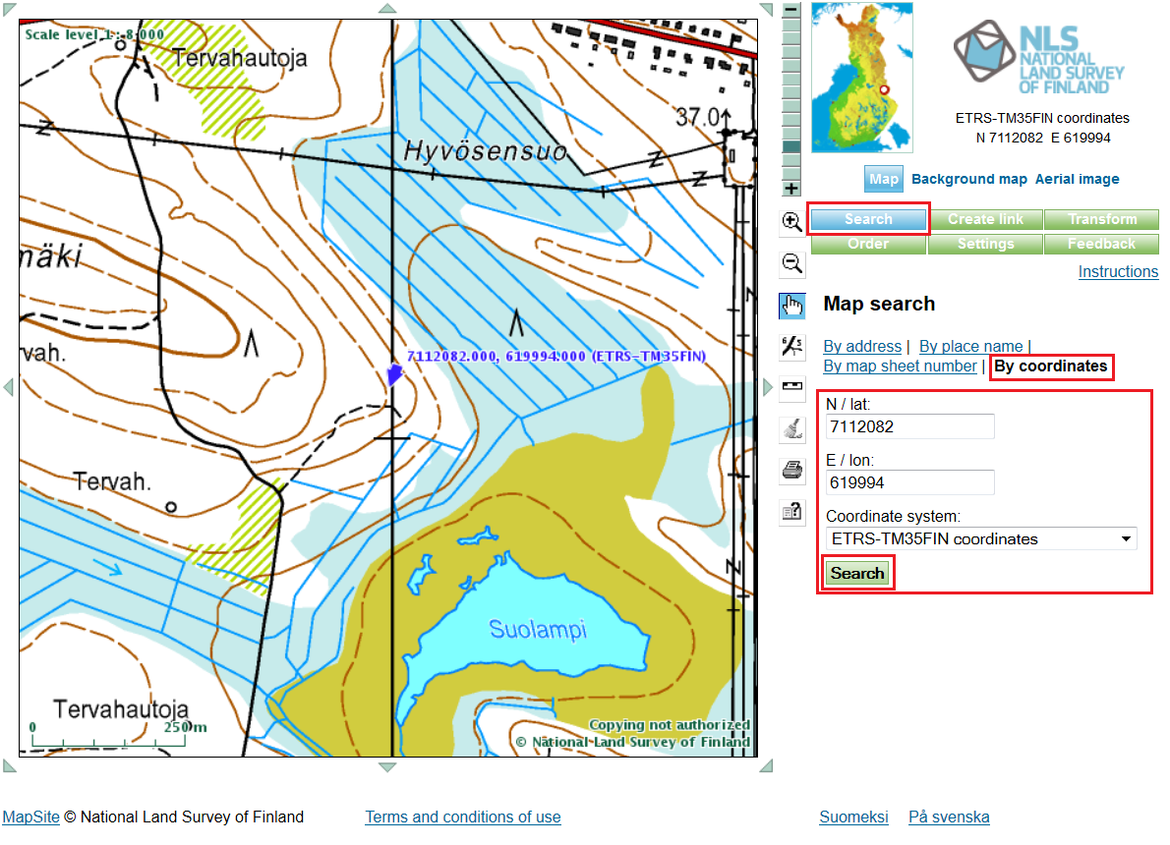

Figure 3 One way to locate nodes

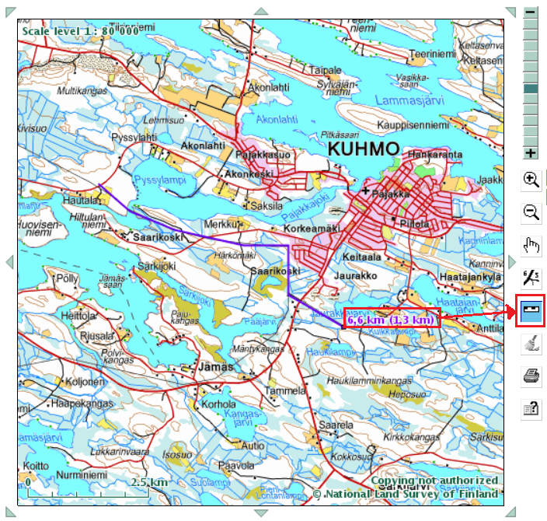

Figure 4 One way to calculate distances

## Appendix C: Cost Data, reliability and time parameters

Table 5. Network cost data. Note that remote switches and circuit breakers need one master station at each location (node).

|  |  |  |
| --- | --- | --- |
| manual switches | switch | 6100 € |
| remote switches | master station | 800 € |
| switching device | 11600 € |
| field circuit breakers | master station | 1000 € |
| circuit breaker | 25700 € |
| primary substation MV feeder connections (including main circuit breaker) | | 50000 € |

Table 6. Switching times

|  |  |
| --- | --- |
| Manual switch | 1 h |
| Remote switch | 0.08 h (~5 min) |
| Circuit breaker (substation and field) | 0.00015 h (~0.5 sec) |

Table 7. Line type data

|  |  |  |
| --- | --- | --- |
|  | OHL | UGC |
| fault rate (1/100km/a) | 7 | 1 |
| repair time (h) | 4 | 12 |
| Allowable max. normal/contingency Voltage Drop | 7% / 10% | 3.5% / 7% |
| Allowable max. normal/contingency Voltage Rise | 3.0% / 6.0% | 3.0% / 6.0% |

The line cost and technical data for underground cables (UGC) and bare conductor overhead line (OHL) are given in Tables 9 and 10. Advice on how to construct cost functions can be found in Appendices D and E, but note, for logistic reasons, try to avoid using too many cable sizes if you choose underground cables.

Table 9. OHL costs and parameters

|  |  |  |  |  |  |
| --- | --- | --- | --- | --- | --- |
|  | **Fixed cost**  (€/m) | **Resistance**  (Ω/km) | **Reactance**  (Ω/km) | **Imax**  (A) | **Ik,1s**  (kA) |
| Al/Fe 54/9 (Raven) | 22.75 | 0.535 | 0.368 | 280 | 5.3 |
| Al/Fe 85/14 (Pigeon) | 24.56 | 0.337 | 0.354 | 360 | 8.4 |
| Al/Fe 106/25 (Suur-Savo) | 27.66 | 0.279 | 0.344 | 430 | 10.5 |
| 2 x Al/Fe 106/25 | 55.32 | 0.140 | 0.172 | 860 | 21.0 |

Table 10. UGC costs and parameters (use these costs for underground and underwater cables)

|  |  |  |  |  |  |
| --- | --- | --- | --- | --- | --- |
|  | **Fixed cost**  (€/m) | **Resistance**  (Ω/km) | **Reactance**  (Ω/km) | **Imax**  (A) | **Ik,1s**  (kA) |
| AHXAMK 50 mm2 | 72.94 | 0.641 | 0.145 | 155 | 4.7 |
| AHXAMK 150 mm2 | 82.04 | 0.250 | 0.123 | 300 | 14.5 |
| AHXAMK 240 mm2 | 90.24 | 0.150 | 0.110 | 385 | 22.6 |
| 2 x AHXAMK 240 mm2 | 130.48 | 0.075 | 0.055 | 770 | 45.2 |
| Overhead line to underwater cable connection [2] | 6000.00€ per connection |  |  |  |  |
| Underground cable T-joint | 3000.00€ per T-joint |  |  |  |  |

## Appendix D: Discount factors, i.e., capitalization factors

Because of the effect of load growth and interest rates, the present value of costs over the review period is not just the number of years in the review period times the annual costs. This would only be the case if there were no interest rate and no load growth! For this assignment you need to be able to assess the present value of the network(s) in this assignment.

The total costs *C*LCC of each network will be (see Appendix E for some hints on conductor choice):

*C*LCC = *C*I + *C*L + *C*F

* *C*I, the investment costs
* *C*L, the cost of losses over the review period
* *C*F, the cost of outages over the review period

You need the following formulae:

,  and  (1), (2) and (3)

 (4)

 (5)

where

*r* is load growth

*p* is interest rate

*T* is review period and

*t*’ is load growth period.

One principle in the above formulae is that resistive line loss (3*I*2*R*) related costs vary quadratically with load growth, whereas load related costs (e.g. outage costs) rise linearly with load growth. The fact that money tends to lose value going into the future lessens the effect of these increases – the interest rate expressions are in the denominators...

For example, using the above formulae for a load growth *r* of 3% for a load growth period *t’* of 20 years, an interest rate *p* of 4 % over the full review period *T* of 40 years, you should get: *κlosses* = 45.04 and *κload* = 29.3. If *r* = 0.12 % for 40 years and *p* = 4 %, then *κlosses* = 20.55 and *κload* = 20.17. **Note, these are only examples, the load growth and interest rate for your assignment planning task may be different…**

## Appendix E: Conductor cost curves for each line type

For each line type there are a number of conductor sizes (conductor family), whose parameters are given in

Table 10. You will need to assess the appropriate conductor sizes when assessing the costs. For this, you need to consider the investment cost plus the loss related costs as a function of power transfer for each conductor size. The best thing to illustrate this is a graph; see Figure 2 below. However, for logistic reasons, the same conductor size would probably be used for all line sections in a given section of distribution network, especially with underground cables.



Figure 5. A typical cost curve for an underground cable conductor family (although you may prefer to find the best single-size for all sections if you have a suburban cable network)

The economic upper limit for the apparent power through a given conductor cross-section can be calculated using the equation:

 You should be able to derive this formula!

where

* *U* is the main voltage,
* *c*1a is the investment cost (€/km) for the given conductor size,
* *c*1b is the investment cost (€/km) for the next larger conductor size,
* *c*l is the cost of losses (€/kWh)
* *r*a is the resistance (Ω/km) for the given conductor size and
* *r*b is the resistance (Ω/km) for the next larger conductor size.

1. Loss utilisation time is the number of hours at maximum power that would yield the same losses that occur in a year of normal operation. To make things easier (since we are not giving you time series data), we assume loss times are the same (3000 h) and coincidence is 1.
2. Includes cable (pole) termination, surge arrestors, microtunneling, etc.