How does pornographic representations affect our perception on sexuality?

introduction

Porn has provoked a vague anxiety in me since the first time I came across it seven years old when I pressed an interesting looking icon on my uncle’s computer desktop. I knew this was a secret and I could nottell anyone what I saw. I felt ashamed wanting to see more. I had a feeling that this made me somehow dirty.

Since then, porn has been present in my life as something I have known to exist but I didn’t know how much more I want to know about it. From what I have seen I just have a feeling something is wrong with it. It took me a long time to understand it’s about the male gaze and to identify the difficulties to find myself in the pornographic representations of females. The older I’m growing the more I have had suspicions that porn impacted ideas of sexuality that might surround me more than I know of.

Ninja Thyberg’s film titled Pleasure (2021) opened new dimensions for me to understand what porn is about. She did many years of research to give an honest and fair review of porn and made the movie collaborating with people from the porn industry. The movie looks at porn industry from the gaze of a woman who wants to be part of it and navigates the world of male gaze on her own terms. From this film I could see it’s an industry that offers the kind of material customers want to pay for, it’s common work for some people and a lot of the material is made carefully and responsibly respecting the performers. And then it’s still dominated by white heterosexual male gaze and offers a platform for open misogyny and racism you could not see anywhere else. Seeing this has helped me to start trying to figure my way to understanding this subject.

I have come to conclusion that the problem with porn is the fact it offers main representation of sex and sexuality in our culture, but it has not succeeded to find a form that would serve all kinds of people. Instead, the amount made for men is huge compared to any alternative perspective and it leads to coloring the perception of sex and sexuality all over our culture through the male gaze. Because sexuality is a taboo we don’t get to have much any other representations on sex and sexuality and this gives too much power to pornographic representations.

As a costume designer, my job is to make representations of personifications that represent different groups in our culture. I want to be released from all the unknown power porn might have on me. I want to know how pornification of media might affect my thinking so I can make continuous choices when making representations on sexuality. I’m interested in whether I could learn how to make representations of sexuality that work against porn or could I even offer an alternative way to look at sexuality with my costume design.

Surprisingly to me, pornification of media has been discussed and criticized by feminists and media researchers for decades already. It’s hard for me to understand why I have not heard about this discussion before because I see it important. In this essay, I will briefly study this discussion by reading sociology books that have focused on this topic and discourse.
I will look at answers on how things are nowadays from history and then reflect upon this information in relation to my own knowledge of experiencing culture and how I see it in costume design. I wonder whether the community of costume designers has been aware of pornification of our culture and their role at it while making representations on sexuality.

Literature review

My main perspective comes from investigate media and sexuality. They are focused on porn affecting especially women but also questioning on looking at the subject from a strict/narrow black and white perspective.

“Our everyday porn - media, sexuality and pop culture” has been written by Kaarina Nikunen, Susanna Paasonen and Laura Saarenmaa. Nikunen and Paasonen are professors of media and communication sciences and Saarenmaa is doctor of philosophy and university lecturer of media and art. “Mediamarkets of sex” has been written by Sanna Karkulehto who is a professor of literature docent of literature and cultural studies and docent of gender studies.

Method

I have chosen sources that have studied the subject in a way that gives voice to different perspectives to the subject and can encapsulate most essential turns of happenings in the history of porn and discussion that has been had about it.
In this essay I am supplementing my own experience with this research and
I’m giving some examples of ways to approach the subject in the field of costume design.

Results

My research work includes information in outline about what has happened with media in relation to porn. I show some examples on how porn is present in media and then some examples on how costume designers have commented pornification and offered alternativity way to represent sexuality.

The ‘charm’ of porn is based on the fact that it is forbidden and watching it is a secret. The paradox of porn is that the more forbidden it is, the more desirable it becomes.
(Karkulehto, 2011 s.72) Feelings of shame I experienced while watching porn as a seven-year-old girl was not just my personal experience, but something collectively shared throughout our society. Interesting theory Karkulehto (2011 s.17) presents is that when porn is brought up and criticized, it tends to only promote the pornification in media and makes porn kind of imagery even more normal.

From around 1990 to 2000 selling with sex and showing sexuality openly all over the media became a norm. Because the media looks for inspiration from porn on what is thought to be sexual, this phenomenon has been called pornification of media. (Nikunen, Paasonen, Saarenmaa, 2005 s.7-9) As a 90's child I was a bit shocked to learn there has been discussion about how porn is going to affect children of my generation. There has been a worry about pornification affecting girls' perception of themselves as sexual beings, they thought it will narrow. I’m learning now that pornographic representations have lived all around me in media my entire life without me knowing about it. In this sense porn has been present in my life even though I have not consumed actual porn. I have not had a lot of choice on how I figure out what is sexuality but porn like representations has been pushed on me.

Pornification on media was probably most visible to me as a child in music videos we used to watch from MTV. At the beginning of 2000 artists' showing of sexuality had been more and more a trend. At the same time porn industry became global when the laws and restrictions controlling it was released (Karkulehto, 2011 s.7) As a child watching music videos, I learned that a strong woman is comfortable dressing in small outfits and expresses her sexuality by flirting to the camera and showing of her body.

When Britney Spears sang, “I am not a girl, not yet a woman, all I needed was time, a moment that is mine” I felt a strong connection to her. I also tried wearing the kind of fashionable clothing she had. Jeans at that time were very low waisted, which made it challenging to move without them falling too low exposing buttocks, in miniskirts you would also have to be careful for example how to sit without exposing too much. I remember feeling confused on how I’m supposed to be able to move or stay warm and I remember being weirded out by the looks they seemed to attract from men. It was a time of double standards in empowering girls. At the same time girls were given strong and powerful idols but what they were wearing was not empowering by being functional, instead the cut of clothing was designed to please the male gaze.

In 2003 music video Toxic Britney is no more thinking about growing up like in earlier mentioned song in 2001. In music video of Toxic she is in an airplane fulfilling a fantasy of a hot flight attendant action hero whose most powerful superpower is turning men on. Even though the lyrics talk about being madly attracted to someone and feeling tormenting erotic tension towards the person, this was no more relatable to me as a horny teenager. I remember losing interest in this content of the music video after being unable to understand what’s going on. It makes sense now, when I now watch the music video, I can see porn references in the narrative and in the esthetics.

In pornographic material you can see fetishizing an occupation reserved for women like being a Flight attendant. It’s another version of sexualized servant costume where woman is submissive in her clothing as much as in her actions pleasing men and enforcing their power doing so. The costume Briney is wearing is altered to be so short it shows her ass and the front shows a lot more cleavage than any real flight attendant uniform ever could. The shape of the shoulder piece and the color also look vintage, like something you could find from porn movies in it’s trendy time in 70’s.
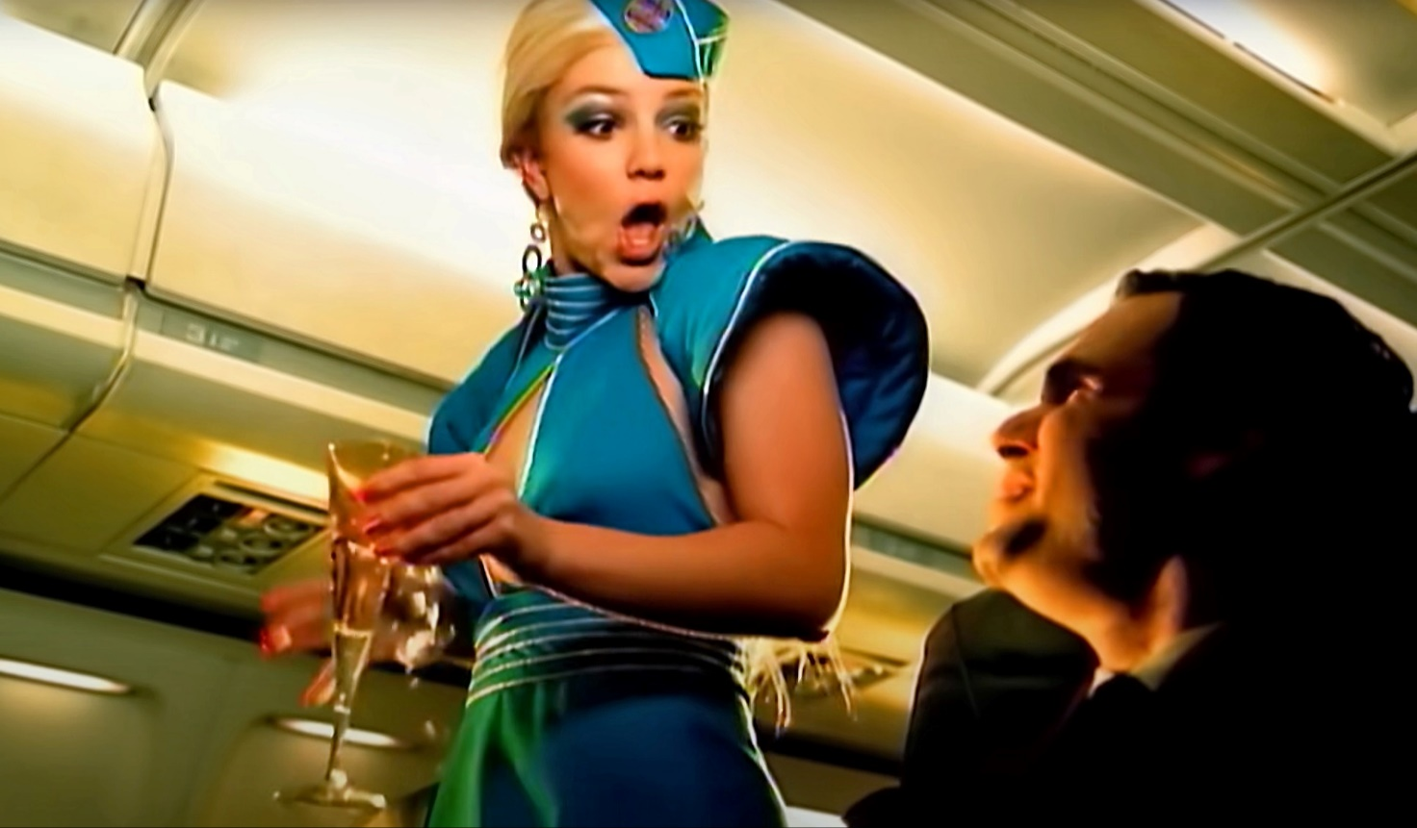

Figures 1, 2, 3, xxxxx

In the video she is also showed almost naked, only glittery nude stocking kind of material covering her body as she is crawling towards the camera. In its nudity it is testing the limits of the laws of chastity. You would never see men in this kind of clothing, it’s the women that have been wanted to undress in the media to this day. Towards the end of the video Briney is also changing to a black catsuit costume with high heels and black leather push up bra. The costume includes red hair and strong makeup. One of the reasons red and black color combination is known to remind something sexual is because it’s the colors of the red-light streets where prostitutes and strip bars can be found.

The same kind of images of women have been all over in commercials, films and tv-series. I can see the connection to porn now after reading about the history of sexualisation of womans body. Karkulehto (2011, s.109) tracks the sexualisation of womans body to 1950-1960. To this point women’s sexuality had been considered something mystical and threatening to men so to tame that fear magazines like playboy started to show woman’s body in a passive manner. Playboy called men to look and women to be the object that is looked at. It gave women the role as a submissive and passive where the role of men were enforced to be active and dominant. At this time after the second world war women were forced to go back from working jobs that were originally reserved to men and go back home giving birth and taking care of children. This was most beneficial for the social order at the time.

Sex works for capitalism if it’s tided to safe familiar values like heteronormativity and conservativity (Nikunen, Paasonen Saarenmaa 2005 s.161). When we look at tabloids today, they are just softer versions of the kind of posing in Playboy. Magazines are sold with sex, pictures that would arouse men but are not too irritating for women. Showing the female body is just often narrated with an interview so that the posing would be reasoned.

In 1970 porn become popular. Nikunen, Paasonen & Saarenmaa (2005 s.81) claim that porn has dominated the representation of sexuality ever since. From porn people could see what kind of things are considered to be arousing, what kind of clothing is sexy, what kind of situations and position and roles women and men have been considered to be arousing. These ideas were then used everywhere in the media, and they had a huge impact on how gender has been seen and also the power relationship between genders.

Perception on sexuality is tightly connected to gender. Although gender and sexuality are different things, they are often mixed because they are both difficult to define in a simple way and their meanings overlap. History of the change on how women’s sexuality is being perceived nowadays is rooted in the modernization of western culture where the power balance between men and women started to shake (Karkulehto 2011 s.63).

If we look at our society being build this way, it explains why there is such a strong relationship with sex and power. I have been wondering for a while, how come in sex there is so much playing with someone being dominant and someone dominating the other. Usually, the man is the dominant and if it’s another way around the exception only proves the rule. What’s has dominating have to do with lovemaking? I’m turning to believe it might be just a practice produced by culture. These ideas have guided my critical enquiry of how pornographic representations affect our perception on sexuality.

Discussion

I feel tempted to claim that porn has been made for men in a time where men are struggling to hold on their power in society where women are becoming to be more equal. Representation of sex has been maybe built in to asserting of male power, keeping women submissive to men trough sex. It is a bold idea, but I think worth investigating.

Sometimes pornification of media reveals itself in surprising ways. Women being on power is so strongly discording sexualized women of tabloids that combining these can arouse conflict. In 2008 chairman of SDP Jutta Urpilainen wore net stockings on tabloid interview at New Year’s Eve (see Image XX). Pictures caused a lot of trouble because it was thought that net stockings are not suitable for a political party chairman, taking away credibility from the chairman and the political party.

I think it is important to find alternative representations of sexuality for women. When women turn to porn to learn what i sex about malegaze is preventing women to find out their sexuality on their own terms. As long as women try to just fit the role of being looked at, they are not going to find out their own gaze and connection to their sexuality. Presenting and producing a self-willed woman's gaze and a woman's desire in pornography is difficult because there are no culturally defined ‘rules’ about what a woman's sexual pleasure consists of (Nikunen, Paasonen & Saarenmaa, 2005 s.249).
Fruzsina Nagy is a costume designer who has criticized pornographic imagery in her designs. In her Taboo collection (2016) she ridicules the idea of porn in costume installation where women are blowing air to almost God-like iron colored man figure in the middle (see Figure XX below). Using artificially sexy materials used in porn like latex and combining them with dishwashing gloves, in one of the scenes of the Taboo performance, makes a statement on the double standard where ideal women are supposed to be either housewives or prostitutes.
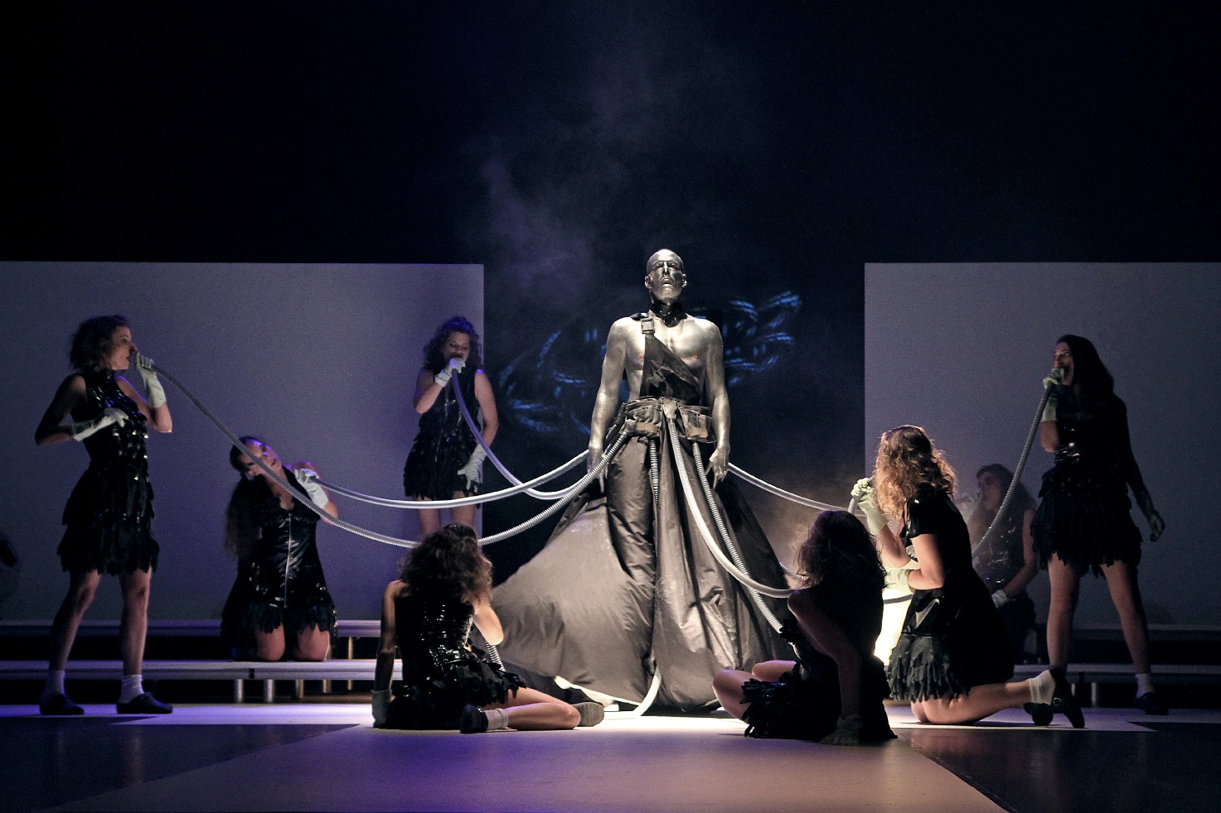
Figure XXX

When I start thinking about the possible alternative ways of representing sexuality I question: What kind of porn would there be in a less sexist society? The power of men and submissive attitude of women would not need to be part of the representation of sex. There would be no need for misogyny either.

I have now come across at least one alternative representation of sexuality on stage. In the dance performance Labia, three performers in soft knitwear kissed each other while dancing. Seeing three persons kissing each other in alternate ways violated the norm of both monogamy and heterosexuality and started to normalize an alternative way of loving.

The performers had costumes that resembled practice clothes in the sense that the cut of the clothes was in the style of leisure sportswear, but the material in all of them was a large looped knit or soft fluff like fleece. Gender didn't seem to matter. It didn't show in action or in costume, all the clothes could have been unisex.

Everything that happened on stage in this performance was based on treating each other as equal. When there was rough playing in pulling each other’s hair, having the consent and checking if the other one was still okay with it while doing it and also afterwards was important routine. It was wonderful to see a description of eroticism that felt closer to something I could be proud of than ashamed.

There was a scene where one of the dancers took off his shirt, looked at the audience and jerked his body so that we could see how the meat and fat shaking on his body; after that, he took off his pants so that little shiny pink panties were left. He shook his body again and the idea of ​​something perceived ugly was combined with something beautiful. The acceptance of one's own body was promoted. He seemed to enjoy himself and continued to flirtatious wild feminine dance in the tiny pink panties. The dance was about owning the panties and owning one’s femininity at the same time.

After he was done the other performers smiled at him and took care of him. We saw how he was accepted.

Conclusion

We are used to seeing sexuality in a costume in materials like leather, lace and satin. Colors used in such garments are usually red and black. Sexual clothing is considered to be underwear like pushup bras and strings, also fishnet thighs and stay up sock, all of which are familiar from erotic imagery. Just about everything we perceive sexy when considering clothing is built in that way in relation to history that enforces gender roles where woman is submissive. It is too easy to put women in a position of passive object being looked at and men to be the one who looks. In the future I will consider this and think about breaking the power relationships with my costume design, if and where I can.

There is a lot more to know when we deal with issues this big. This essay is just a start trying to start unravelling dynamics in sexual representation. Women can also feel powerful when they are in the role of being looked at and this is something I will also think about in future research. There is not really right or wrong answers to any of this, just many perspectives one can look at. One thing I know is that woman’s sexuality has been a taboo for long enough. The perception of a woman's sexuality has not developed also because of the old belief that a woman's sexuality threatens the order of society, which is still working under the surface (Karkulehto, 2011, s.110) It’s about time to produce something fresh and innovative to our culture for women and men too to mirror themselves off.

References
Our everyday porn - media, sexuality and popculture - Kaarina Nikunen, Susanna Paasonen and Laura Saarenmaa, 2005, Vastapaino, Tampere
Mediamarkets of sex - Sanna Karkulehto, 2011, Gaudeamus, Helsinki
Taboo collection - Fruzina Nagy 2016
Labia – dance performance by Kauri Sorvari and working group, 2023

