XRR Demo questions
CHEM-E4205 Crystallography Basics and Characterization

- XRR is one of the most efficient techniques for obtaining multiple thin film properties from a single measurement. You are planning to use atomic layer deposition (ALD) technique to grow multiferroic Fe₂O₃ thin films and you would like to find out the film thickness, density, and roughness of your thin film samples. For a successful XRR measurement, what is the most critical aspect to consider when planning the deposition?

- You are trying to fit the measured XRR patterns of Fe₂O₃ thin films but face difficulties in having a proper match. In the three following scenarios (A—C), what would be the most probable way to get a better match for your measured pattern? Remember to justify your answer! The black curve is the measured pattern, and the red curve is the fitted curve.

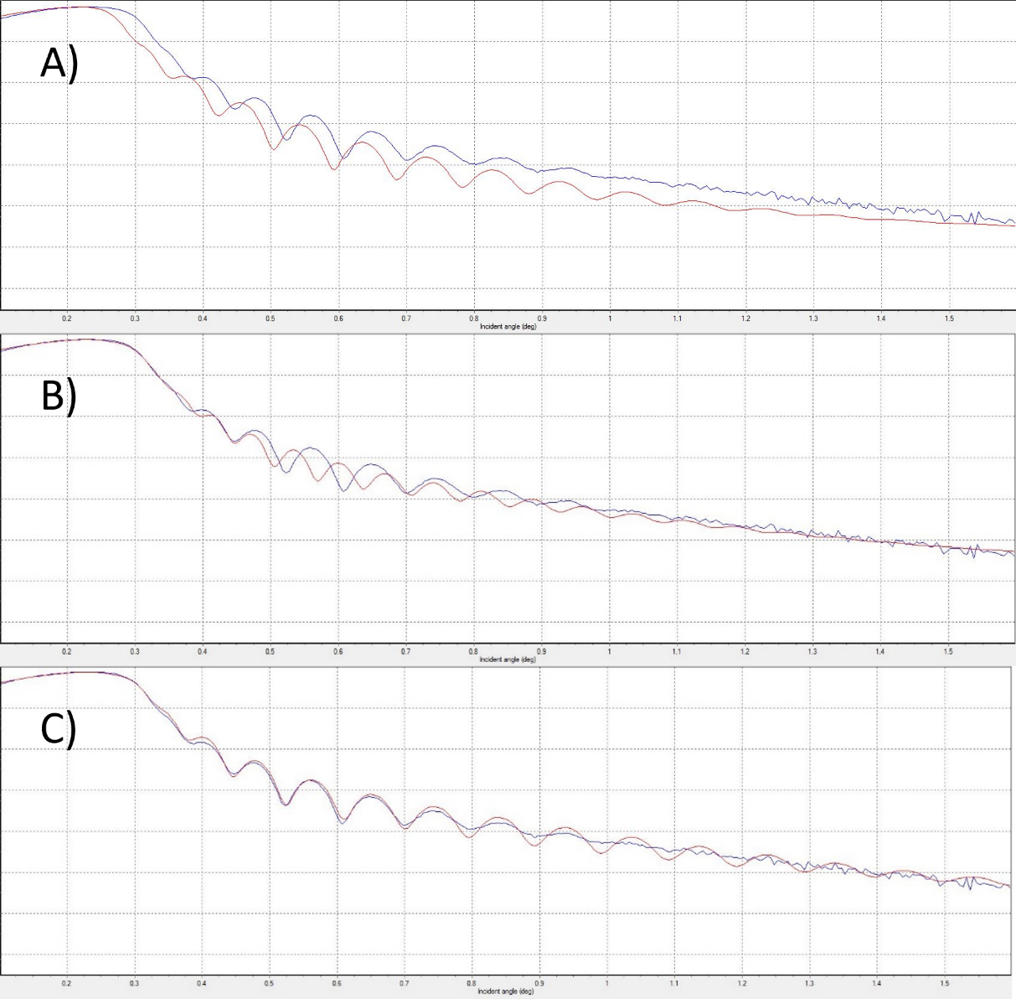

- The model which describes the basic structure of your sample is shown below. However, often more complex models are required to accurately describe the sample. Discuss with a few sentence, what additional layers could be needed for precise fitting (hint: atmospheric effects, interface)?

Fe₂O₃
SiO₂ (native oxide)
Si(substrate)

