**Management Information Systems - Final Exam**

*Overall directions: Answer questions 1-27 in a numbered list in Microsoft Word. By each number, have the letter of your answer. 28-31 can continue the numbered list but will be essay answers. 32 should be answered on a sheet of paper. 33 should be answered in an Access database. You will be turning three things in: a Word document (submitted electronically on MyCourses), an Access file (also electronic on MyCourses), and a physical sheet of paper with the ERD. Be sure your name is on the paper!*

*Section 1 (3 points each for 81 points total), Multiple Choice: You* ***MAY NOT*** *use any external resources (internet, notes, files) for this section. Note that there are only 27 questions here instead of the normal 40. The missing 13 questions were related to the “future directions” lecture that we did not have.*

1. What are “islands of information?”
   1. Separate pools of redundant data spread throughout the organization
   2. A centralized deposit of data
   3. Non repeated data
   4. None of the above
2. In order to combat the problems associated with islands of information, what were organizations looking for?
   1. Something central
   2. Something relational
   3. Communications technology
   4. All of the above
3. Generally, a flat file system access files in which way?
   1. Random access
   2. Linear access
   3. Accelerated access
   4. Hyper access
4. How does a database store data?
   1. In tables that consist of rows and columns
   2. Each row in each table is unique by way of a primary key
   3. Relationships are initiated with foreign keys
   4. All of the above
5. What are examples of DBMSs?
   1. Windows 7
   2. Microsoft Excel
   3. Oracle
   4. Chrome
6. What must a DBMS have?
   1. DB engine
   2. Web access
   3. Word processor
   4. None of the above
7. In the following SQL statement…  
   SELECT lastname FROM employeetbl WHERE employeeID = 79  
   what data will be displayed in the results?
   1. lastname
   2. employeetbl
   3. employeeID
   4. All of the above
8. In the following SQL statement…  
   SELECT lastname FROM employeetbl WHERE employeeID = 79  
   from where is the data being pulled?
   1. lastname
   2. employeetbl
   3. employeeID
   4. All of the above
9. In a relational database, how many times must a single piece of data be added?
   1. once
   2. once for each table
   3. unknown
10. In a flat file system, how many times must a single piece of data be added?
    1. once
    2. once for each table
    3. unknown
11. When a DBMS accounts for linked records when a parent record is deleted, what is this called?
    1. Referential Integrity
    2. Disposal protocol
    3. Cleanup routine
    4. None of the above
12. In an ERD, the boxes represent __________________.
    1. Relationships
    2. Entities
    3. Cardinality
    4. Attributes
13. In an ERD, the lines represent ___________________.
    1. Relationships
    2. Entities
    3. Cardinality
    4. Attributes
14. Which of the following situations is ethical?
    1. You violate an End User License Agreement (EULA) in order to make a copy of copyright protected software for the purpose of personal backup
    2. You violate a EULA in order to make a copy of copyright protected software for the purpose of sharing with a friend
    3. Your bank sells your information to a 3rd party without your permission
    4. None of the above is ethical
15. According to the lecture slide, what is an approach to applied ethics?
    1. Utilitarianism
    2. Interpretive
    3. Positivistic
    4. All of the above
16. What program does the US government use to collect data on all of your communications?
    1. CIA
    2. PRISM
    3. Dragonheart
    4. Linux
17. What issues are of concern with regards to intellectual property and ethics?
    1. Piracy
    2. Plagiarism
    3. State-based theft
    4. All of the above
18. Automation is predicted to lead to what percentage of unemployment within 25 years?
    1. 10%
    2. 20%
    3. 50%
    4. 100%
19. What is the highest level of Kohlberg’s stages of moral development?
    1. Social Norms
    2. Self Interest
    3. Universal Ethics
    4. Obedience
20. Which of the following approaches to applied ethics calls for doing the right thing regardless of the consequences?
    1. Utilitarianism
    2. Deontology
    3. Virtue
    4. Social Order
21. How can *legitimate* companies track you while you are online?
    1. Viruses
    2. Spyware
    3. 3rd party cookies
    4. All of the above
22. How can someone record *everything* you do on a computer?
    1. Phishing
    2. Keylogging
    3. 3rd party cookies
    4. 1st party cookies
23. What lasts an author’s lifetime plus 70 years?
    1. Copyright
    2. Patent
    3. Trademark
    4. All of the above
24. Who did Apple sue for their use of “rounded rectangles” in their interface?
    1. Microsoft
    2. Xerox
    3. Samsung
    4. Google
25. If you have a 2 Terabyte hard drive, how many file cabinets would be needed to replicate the amount of data storage you have in that hard drive?
    1. About 2600
    2. About 5200
    3. About 10400
    4. About 126000
26. What is an example of a deontological approach to ethics?
    1. Killing baby Hitler to prevent World War II
    2. Lying to your spouse in order to make them feel better about themselves
    3. Allowing your friend to die since stealing the medicine to heal them is wrong
    4. All of the above
27. What was George Hotz known for in the Intellectual Property arena?
    1. Founding PirateBay
    2. Hacking Visa’s payment systems
    3. Tearing down a PS2 to hack the motherboard and sharing that on YouTube
    4. Leaking government documents via WikiLeaks

*Section 2, Essay (20 points each for a total of 100 points): You* ***MAY NOT*** *use any external resources (internet, notes, files) for this section*

1. In 3-4 sentences, define and describe copyright piracy. What are its origins and where are we now? What are the long term likely outcomes given societal trends and governmental regulation?
2. In 2-3 *paragraphs,* answer the following: What are the main ethical considerations societies needs to consider when it comes to widespread dissemination and access to individual’s data? What can organizations or governments do to address these concerns?
3. In 3-4 sentences, describe what are the major drawbacks (and any benefits) of a flat file system. Why might organizations use such systems?
4. In 4-6 bullet points answer the following: What are the major components of a relational database? What should a Database Management System (DBMS) do? How does it usually work in an Information System? Does it stand alone in the management of data?
5. Create the ERD for the following: A Laboratory has several chemists who work on one or more projects. Chemists also may use certain kinds of equipment on each project. Attributes of CHEMIST include Employee_ID (Identifier), Name and PhoneNo. Attributes of PROJECT include Project_ID (Identifier), and Start_Date. Attributes of EQUIPMENT include Serial_No and Cost. The organization wishes to record Assign_Date, that is, the date when a given piece of equipment was assigned to a particular chemist on a particular project. A chemist must be assigned to at least one project and one equipment item. A given piece of equipment need not be assigned, and a given project need not be assigned either a chemist or equipment item.

*Section 3, Database building (67 points): You* ***MAY NOT*** *use any external resources (internet, notes, files) for this section*

33. Take the following Entity Relationship Diagram (ERD) and create the database in Access. Design each table with appropriate Primary Keys. Then, establish the relationships. Be sure to check "enforce referential integrity" when doing this.

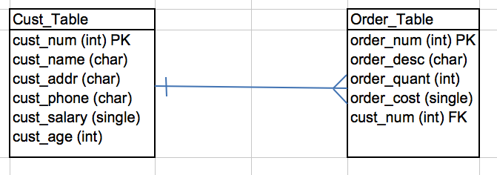

Fill in the customer table with the following data…

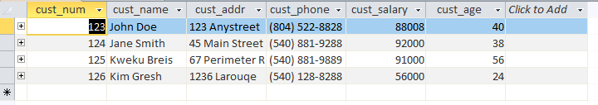

Fill in the order table with the following data…

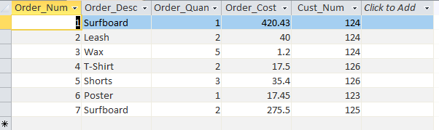

Create a query that returns a list of customers with each of their orders placed. It should include the customer’s name, description of the order, cost per unit, quantity, and total cost. Note that total cost is a calculated field.

Create a second query that is identical to the first *except* for the fact that the results should be restricted to customers who ordered a “Surfboard”.