**Ejercicios de los vídeos**

**EL GERUNDIO**

**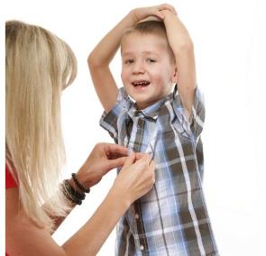****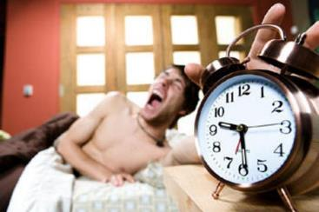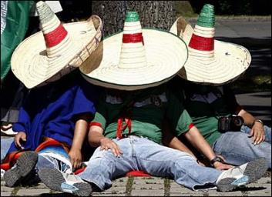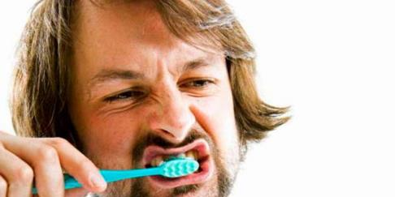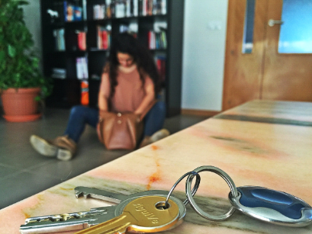¿Qué están haciendo?** Kerro kokonaisella lauseella.

**16**

**14**

**9**

**10**

**6**

**3**

**2**

**4**

**1**

**7**

**17**

**15**

**13**

**12**

**11**

**8**

**5**

1. ____*El niño está abriendo los regalos de Navidad.* ____________________________
2. _____________________________________________________________________
3. _____________________________________________________________________
4. _____________________________________________________________________
5. _____________________________________________________________________
6. _____________________________________________________________________
7. _____________________________________________________________________
8. _____________________________________________________________________
9. _____________________________________________________________________
10. _____________________________________________________________________
11. _____________________________________________________________________
12. _____________________________________________________________________
13. _____________________________________________________________________
14. _____________________________________________________________________
15. _____________________________________________________________________
16. _____________________________________________________________________
17. _____________________________________________________________________