R Markdown: knitr

Set working directory to director where data (PPT.Rdata) resides
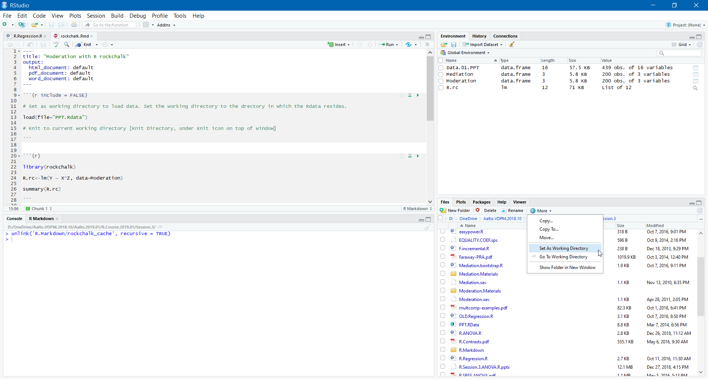
Set current working directory for knitr
