Controlled Exercise 2 - MEC-E5003 - Fluid Power Basics

Case
Load mass of cylinder 1 comes down with constant velocity. Piston of cylinder 1 causes flow rate with rotates a hydraulic motor which in turn rotates a hydraulic pump. Pump’s flow rate causes the piston of cylinder 2 to lift up. The flow rate and piston velocities of cylinders’ are restricted with an orifice.
Main question is:
- what are the pressures, flow rates and piston velocities in the system?
The cylinders are “ideal” with no leakage or friction.

Calculate and give the results here (table) + add an extra paper with actual calculations
output variables | values
cylinder 1, piston side pressure (p₁) | bar
cylinder 2, piston side pressure (p₂) | bar
motor torque (T) | Nm
pump pressure (p_{p}) | bar
orifice flow area (A_{ori}) | m²
pump flow rate (q_{v2}) | m³/s
cylinder 2 piston velocity (v₂) | m/s
shaft rotational speed (n) | 1/s
motor flow rate (q_{v1}) | m³/s
cylinder 1 piston velocity (v₁) | m/s

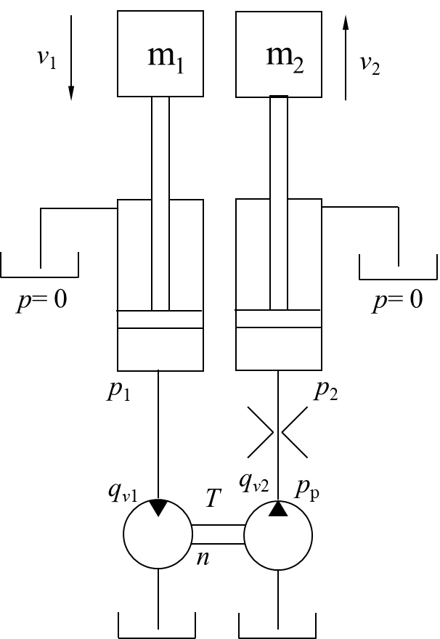 | Parameter  Gravitational constant g= 9.82 m/s²  Load mass 1 m₁= 5000 kg  Load mass 2 m₂= 4000 kg  Piston area 1 A₁= 0.00312 m²  Piston area 2 A₂ = 0.00312 m²  Orifice diameter d_{ori}= 0.003 m  Fluid density ρ = 870 kg/m³  Flow coefficient C_{q} =0.7  Motor volume (per revolution) V_{m}= 100⋅10⁻⁶ m³  Pump volume (per revolution) V_{p}= 80⋅10⁻⁶ m³  Motor’s volumetric efficiency η_{v,m}= 0.95  Pump’s volumetric efficiency η_{v,p}= 0.95  Motor’s hydromechanical efficiency η_{hm,m}= 0.9  Pump’s hydromechanical efficiency η_{hm,p}= 0.9

