LC-1114 Communicating Technology
Exercise 10-1
Identify the following elements in the presentation about ‘Botnets’ below.
 | INTRODUCTION |  | Sentence(s)
 | Gains attention by describing  a problem relevant to audience: |  | .............
 | Establishes Credibility: |  | .............
 | States Purpose: |  | .............
 | Overviewing Structure: |  | .............
 | Previewing first main point: |  | .............
 | CONCLUSION
 | Signaling the Close: |  | .............
 | Recommends a solution: |  | .............
 | Summarizes main arguments: |  | .............
 | Encourages audience to take action: |  | .............
 | Returns to problem from introduction: |  | .............
 | Invites questions: |  | .............
 |  | ¹Did you know that your home computer could be attacking the government of United States right now? ²Or sending spam to thousands of people? ³Did you also know that you could be held accountable for it, even if you didn’t know about it? ⁴Well, this all could be happening if your computer was part of a botnet. ⁵Botnets have become a major threat to companies like your own.
 |  | ⁶My name is Mikko Meikäläinen, and I’m a consultant with TurvaNet Security Consulting. ⁷Today, we’re going to look at some of the options available to help you avoid becoming a victim of botnets. ⁸And then we’ll evaluate these options to find the best solution to protect your company.
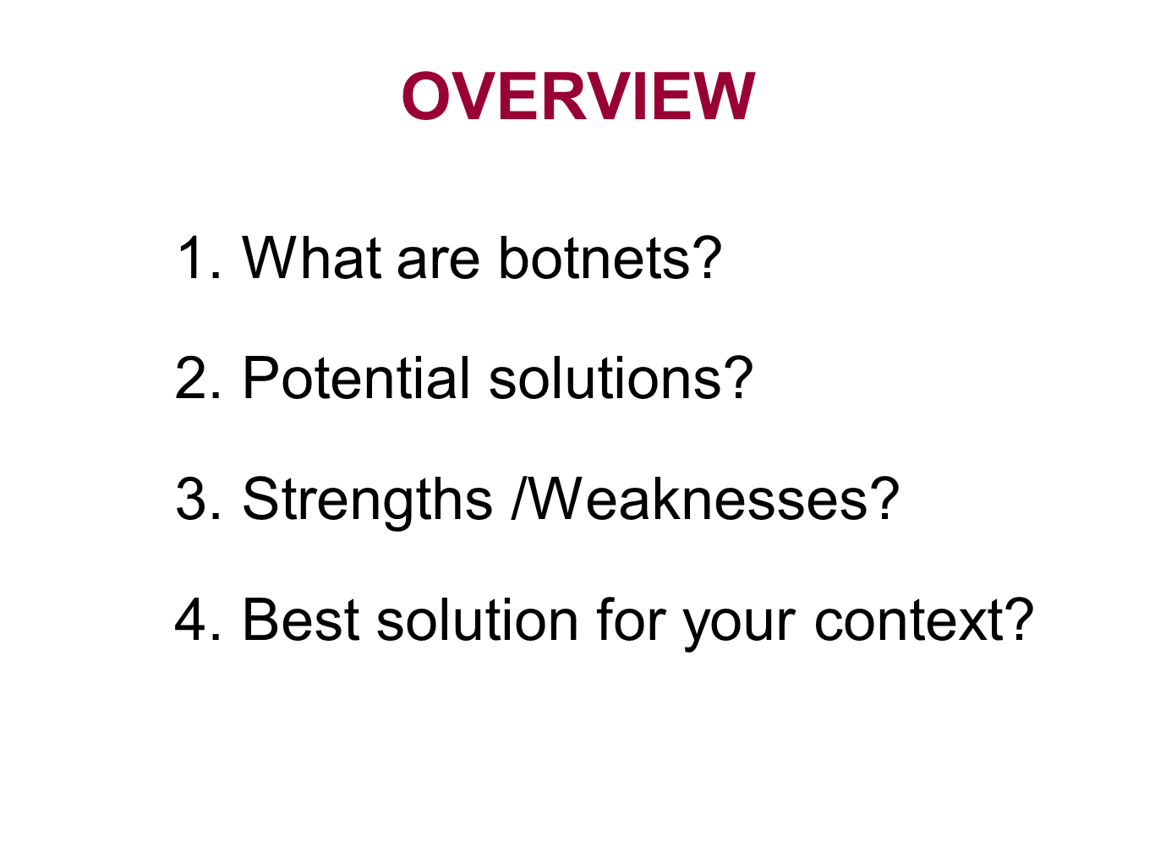 |  | ⁹I have divided my talk into three main areas. ¹⁰First, we’ll see what botnets are and the motivation behind them. ¹¹Then, we’ll examine some potential methods to avoid the threats posed by botnets. ¹²We’ll then evaluate these options. ¹³And finally, we will see which of these methods would be most suitable for your company. ¹⁴So, what are botnets?
BODY (sentences 15-85)
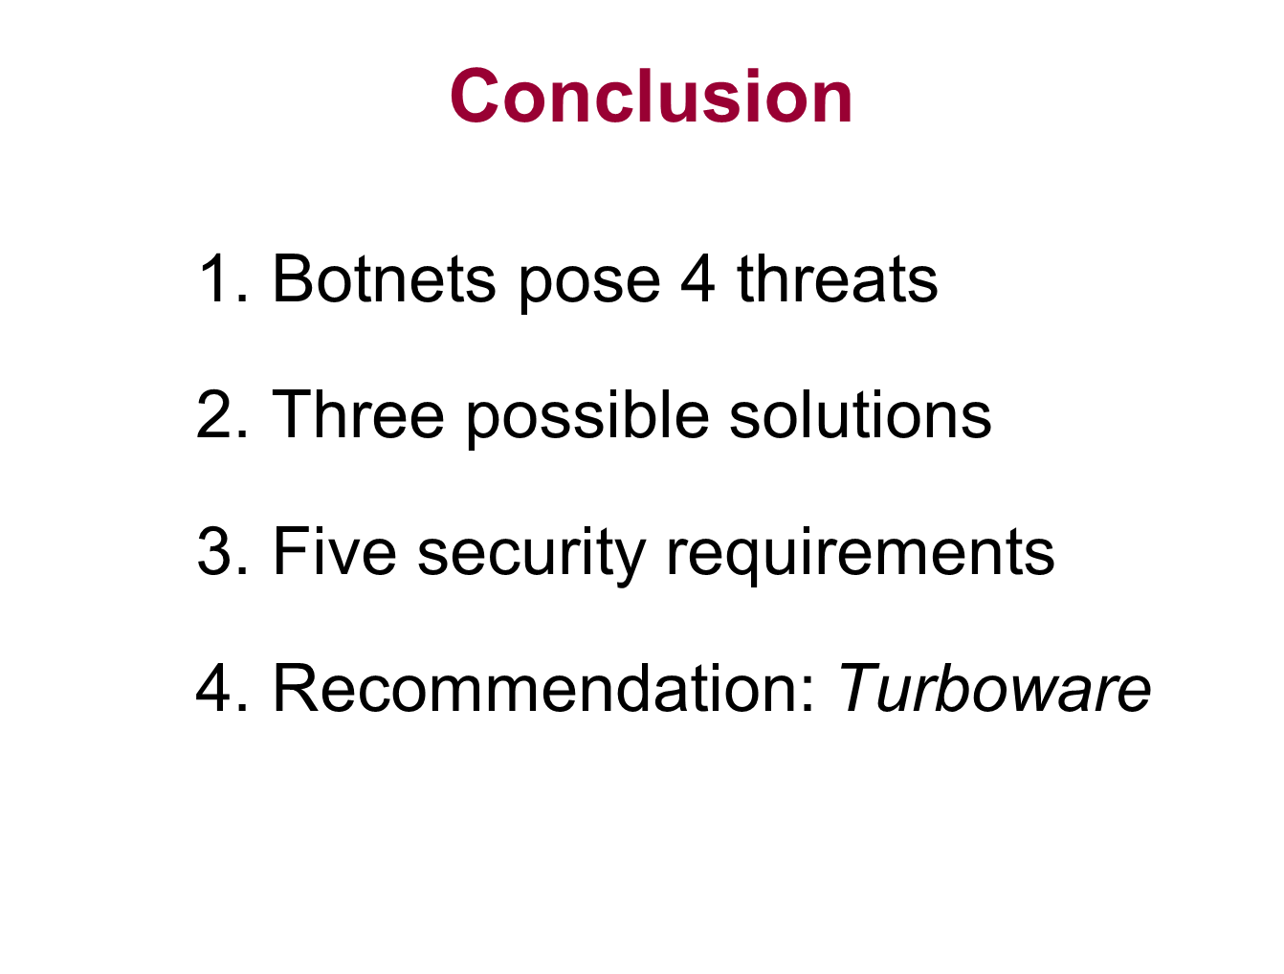 | ⁸⁶So, in conclusion, what we have learned today is that botnets are used for malicious purposes and pose four real threats to companies like your own. ⁸⁷We looked at three measures that you could use against these threats and evaluated the effectiveness of those measures on the basis of five criteria: cost, encryption capability, system performance and export control. ⁸⁸Based on what you’ve seen today, I’m sure you would agree that the best solution for your company is turboware. ⁸⁹Turboware not only offers superior encryption and export control features, but also provides adequate performance for dealing with the volume experienced by your company at a cost that you can afford.
 | ⁹⁰What you can do is to adopt this new technology within the next two weeks, so that your computer system doesn’t become a part of a botnet and…
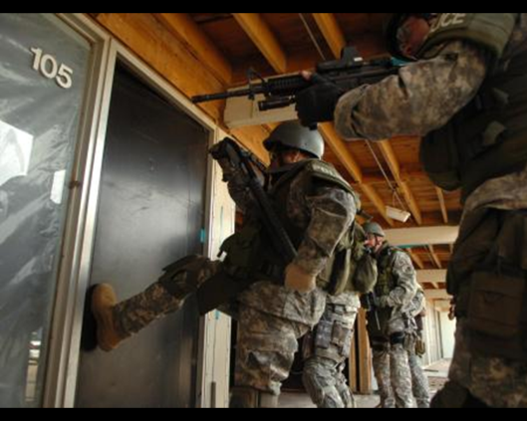 | … so that some government doesn’t come knocking on your door and asking difficult questions.
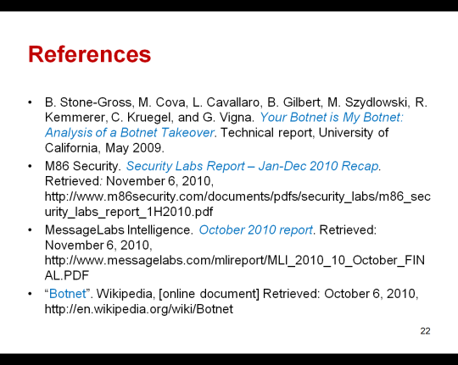 | ⁹¹Now, I’m sure you all have lots of questions, so let’s open the floor for discussion.

