LC-1114 Communicating Technology
Exercise 10-3

 | ¹A Gallup poll made in 2011 reported that 40% of American adults think it is very likely that scientists have falsified global warming research. ²Could this really be true? ³In fact, the earth’s average surface temperature has increased in the last three decades twice as much as it did in the previous seven decades. ⁴So, there must be a way to be less harmful to the environment. ⁵But how?
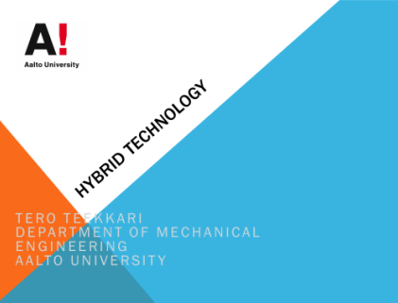 | ⁶My name is Tero Teekkari, and I’m an engineering student at Aalto University, majoring in machine design. ⁷Today, I want to tell you about a solution that will help you to decrease your carbon footprint. ⁸The solution is a new technology called the hybrid automobile.
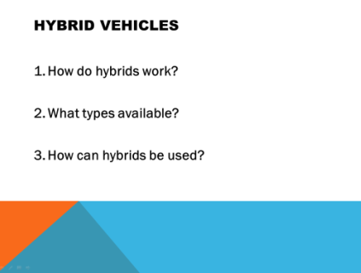 | ⁹I have divided my talk into three areas. ¹⁰First, we will look at what a hybrid vehicle is and how it works. ¹¹Then, we will go through the common types of hybrid engines. ¹²And finally, we will take a closer look at some of the applications of these hybrid systems.
Body… | What is wrong with this conclusion?
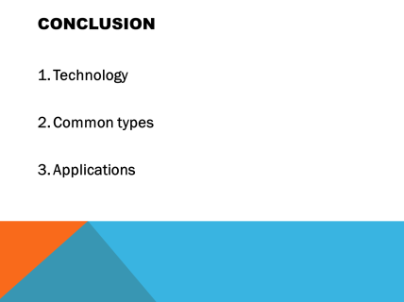 | ⁸³So, today we looked at the technology. ⁸⁴We also found out about the most common types of hybrids. ⁸⁵And finally, we saw that there are many applications. ⁸⁶Now, if you have any questions, go ahead and ask.
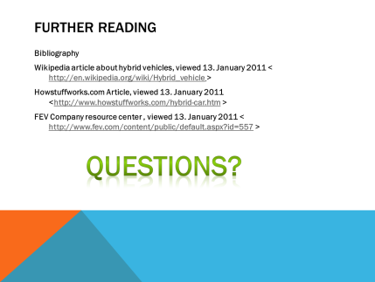 | ⁸⁷Here are some links to more reading. ⁸⁸Thank you.
Improved conclusion

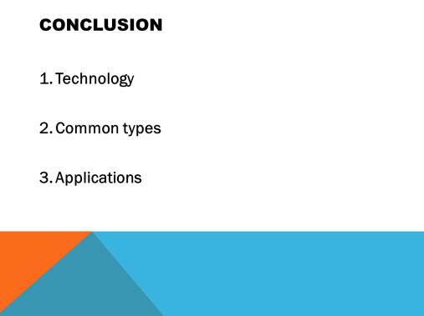 | ⁸³So, what we have learned today is that a hybrid is a vehicle that uses two engines for two reasons: The first reason is to increase energy efficiency, and the second reason is to re-capture the energy which is usually wasted in current internal combustion engines. ⁸⁴You also found out that two types of hybrid systems are currently available: the parallel hybrid system and the series hybrid system. ⁸⁵And finally, you saw that hybrid systems can be used to power not only automobiles but also trains and commercial vehicles, such as lorries, buses and even cranes.
 | ⁸⁶So, don’t just be skeptical about the global warming studies, do something about it. ⁸⁷Be a part of the solution. ⁸⁸Trade in your old car for a hybrid. ⁸⁹Your children and grandchildren will thank you, because that way you’ll help to ensure that the future will be greener for all of us.
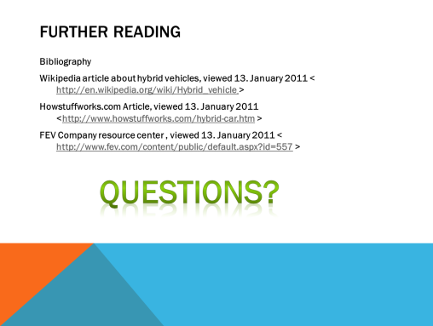 | ⁹⁰For those of you who’d like to find out more about this subject, I’d suggest the following sources. ⁹¹And now, if you have any questions I’ll try my best to answer them

