Business Feasibility

Have you ever worn a baseball cap while you were also wearing sunglasses at the same time? In that same scenario, to store your glasses while you weren’t wearing them have you ever placed them on the brim of your hat? If you are like me, you do that constantly, or you can at least can think of a time when that could’ve happened or saw someone else doing that same exact act; storing one’s sunglasses on top of one’s hat when the glasses are not in use. It is a great place to put them, the glasses are out of the way, out of sight and out of mind, but what happens when you forget that your expensive glasses are up there? Now that the scene is set and you have your glasses on top of your hat, what happens when you bend over, make unexpected adjustments, take off your hat, run, or do anything where you have the risk of your glasses moving around on the brim of your hat? Your glasses will most likely fall off the top of your head resulting in a minor heart attack, scuffing of the frame or lenses, or maybe even a complete casualty to your favorite pair of glasses. I have created a product to take away the uncertainty of losing glasses off the top of your hat. This is SpecClips, a product designed to help secure one’s glasses to one’s hat. “Saving everyone’s favorite pair of glasses, one pair at a time!” Within this paper, I am going to look at the consumer side (B2C) of SpecClips and with that being said, I will be touching base on the product’s business model canvas.

Attached pictures of design and how SpecClips works:
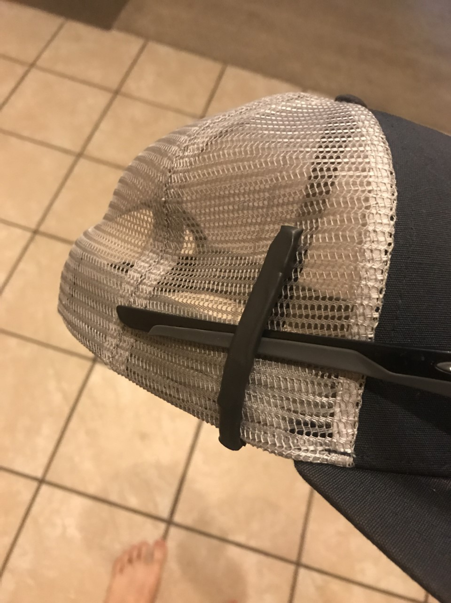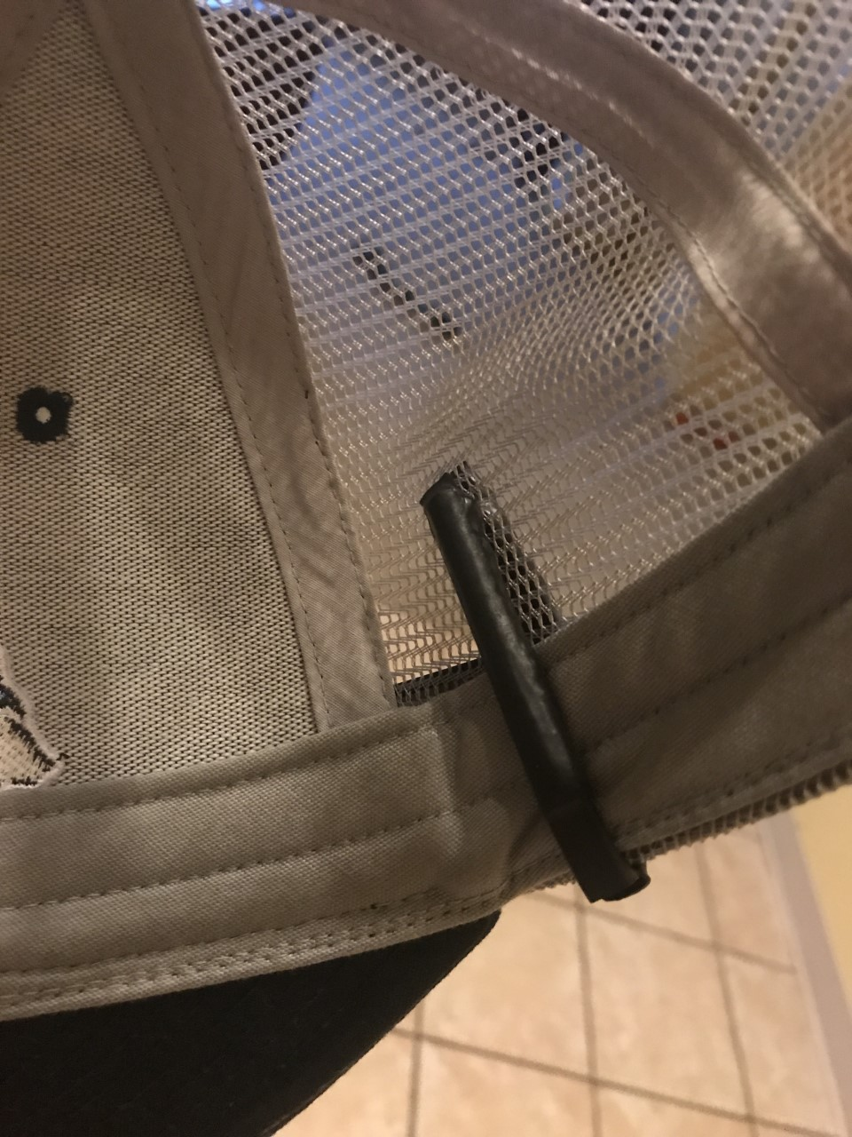

In order to sell a product, one must have a potential market to sell it to. So who will buy a SpecClip and what does the ideal customer look like, when looking at the consumer side alone? When looking at a potential customer for SpecClips, it is a very broad and a very wide variety of customers who should be interested in buying one. Anyone who wears sunglasses on top of their hat should be interested in buying one. Anyone who would want to spend an extra $10 on protecting their expensive sunglasses should be interested in buying one. Anyone who likes that extra cushion of security for next to nothing cost, should be interested in buying a SpecClip. When launching my product, one of the first people I want to target will be the athletic type of consumer. Selling to athletes is a huge potential market for SpecClips. When looking at athletes, there are so many different types of athletes who wear sunglasses on top of their hats. You have baseball and softball players; whether you are playing in the major leagues or the bar leagues, more than one person is bound to wear their sunglasses on top of their hat. Golfers should be interested in purchasing a SpecClip. I am a subpar golfer and I don’t know how many times my sunglasses fell off while I went to pick up my ball, or when I let the ball rip off of the tee. Even on the PGA Tour, you will see golfers hold on to their sunglasses while they are on top of their hats when they go down to pick up their ball from the hole. Being a part of an athletic team gives you a chance that you will wear sunglasses and hats at the same time and gives you a possibility that you will rest your glasses on top of your hat when they are not in use. If one would ever look on the sideline of any outdoors athletic game, one would most likely see a coach, trainer or referee wearing sunglasses and a hat. Another big market I will want to hit hard when launching SpecClips will be outdoorsman, hikers, and most importantly, fisherman (I will touch again on fisherman in Key Partners). When you are exposed to the elements as much as the outdoorsman, one is always trying to protect themselves from the harsh elements of the sun by wearing hats and sunglasses. Weather you put your sunglasses on your hat when you are hiking up that cliff face, pulling in that trophy fish or maybe even running for your life from that grizzly bear, losing your glasses shouldn’t be on your mind. There are so many different potential types of people who wear sunglasses on their hats including the average joe. I consider myself and average joe, I am not an athlete, I don’t hike and I don’t fish, but I use this device almost every day, just depends on the sun. So I think we can all agree, that no matter who you are, nobody likes breaking, scratching, or losing their favorite pair of glasses, so why isn’t there more companies trying to solve this problem?

When looking at the problem of sunglasses falling off the top of your hat, so few companies are solving the problem. My product, SpecClips, is doing just that, saving everyone’s favorite pair of sunglasses from falling off of their hat. Don’t get me wrong, I am not the only one doing it, but I do have advantages on the others. The first device that helps support sunglasses from falling is Croakies. Croakies pretty much turn your sunglasses into a necklace when they are not in use, one could let them hang around their neck or tighten them to the top of your hat. My product, the SpecClip is easier to use, less noticeable, and in a survey of more than 100 potential customer, they would be more likely to buy my product. Another device is called LidsLash. LidsLash is a magnetic device that one has two parts, a steel back plate that you have to mount to the inside of your hat and magnetic wrap around nose piece that one would have to wrap around the frame of the glasses and then constantly take on and off when wanting to use the glasses. My product, SpecClips, has many advantages over this product as well. It is easier to use, less noticeable and, unlike the LidsLash, my product can be used on more than one hat. The last competitor that I am facing when trying to sell the SpecClip, is a hat made by Real Tree. Their hat has a patented design that allows for a pocket built in to the side of a camouflage hat. Their design works well, but unlike the diehard hunter, most consumers probably own more than one hat, making it useless again without having the ability to take off the side pocket. All products, including mine, have the same price point, giving nobody an advantage. But when looking at my product, the SpecClip it has its advantages, it is sleeker, less noticeable, easier to use and you can use it on more than one hat, making it the ideal device for the consumer when wanting to secure one’s sunglasses to their hat. When looking at the numbers, just how big is this industry?
When looking at the numbers this industry is massive (All statistics were found online and referenced at the bottom). Although there is no data to show how many people wear sunglasses on top of their hats, there is data to show how many glasses and hats were sold in the U.S. In 2016 alone there were over 181.1 million pairs of glasses sold in the U.S., with over 95 million of those pairs being sunglasses. When looking at the average cost per pair it equaled around $125 per pair. Now looking at hats sold in the U.S., although there isn’t a number of every single baseball style cap sold (because there are so many manufacturers with all sorts of brands), there was a number on MLB baseball caps and that was 44 million sold in 2016 alone. There are so many different types of baseball style caps that Americans buy every year, just to name a few, there are caps from the NFL, NBA, NHL, Patagonia, Amazon dad hats, trucker hats, and so many more. There isn’t a doubt in my mind that there are people out there that would be interested in my product, I’m not worried about that, my main worry is surrounding myself with key partners.
When starting SpecClips, from a money situation, I am and still are, the key provider with bootstrapping this business. I have bootstrapped this product this far and If demand and production for this product takes off I will be forced to sell equity in the business to investors, more specifically I would want to partner with investors that would give me an advantage, open the doors to more things and have more connections that can bring SpecClips to new heights. One key potential partner that I reached out to is Brian Jensen, CEO and creator of Fishidy. Fishidy is a crowdsourced fishing app that, as of today, has over one million users. Brian would be a great partner when it comes to advertising this product. Fisherman is a huge potential market when trying to sell the SpecClip, and having that in with such a large population of fisherman and connections to professional fisherman for testimonials would be a huge leap forward when jump starting and launching SpecClips. Key partners would be great for an ideal situation, but when it comes to people who own no equity in the business, those partners are key as well. As of today, all of the partners that are necessary for SpecClips to be a thriving company include a manufacturer, parts providers, distribution and assembly plants, an attorney, and more. Right now I am leaning on Plastec, a manufacturing company based out of Lake Geneva, WI, to be the manufacturer of SpecClips. They would be in charge of mass producing the main shape of the SpecClip. They would produce the majority of the clip, but SpecClips still needs magnets (how the rubber clip stays together) and assembly. Starting off another key partner is a company found on AliExpress, Cheryl Chen. This company has very cheap magnets. When it comes to assembly my family and I (volunteers) will be assembling them until orders get too big and then I will be looking for an assembly plant to assemble the final product. So how much is this going to cost to start up?
SpecClips is a relatively inexpensive company to start off. The key costs that happens before launching this product includes filing for the patent, the LLC, engineer consulting, a website, how to videos and advertisement videos, and finally the mold of the product itself (since the manufacturer will be using injection molding, the machine needs a mold of the product to inject rubber like substance into). All together the final start-up cost is right under $3000. Some of that money is already covered by grants, equaling $1150 and hopefully more of that cost will be made up from more business competition prize money and from investors. How much will this company take to operate?
Looking at the operational costs to run SpecClips, it is relatively a simple process. Since I will be outsourcing manufacturing of the product, I have to pay for each product individually. It will be approx. $2 to produce, package, and ship one SpecClip ($0.60 each goes toward assembly per unit). For an example month, if I have 10,000 people who want a SpecClip, it will cost me $20,000. My salary is yet to be determined. Now is this a feasible idea and what is the profitability on a product like this?
I believe my product, SpecClips, is a very feasible idea. I already started on the product and I believe that the feasibility that I launch and start selling my product is very high as well. When looking at the profit margins on SpecClips, it is very high as well. The revenue model is very simple for the consumer model, simply sell the product to the consumer. If I am making one SpecClip at $2.00 and selling it at $9.99, I am looking at a profit margin of $6.99 a unit. Looking at short term sales, 1-2 years, I am going to use the number of people who bought sunglasses last year, 95 million. Granted, not everyone who bought sunglasses last year wears hats even if they did, not everyone would want to use a SpecClip; that being said, if I can target and get only 0.5%-1% of those people who bought sunglasses last year to buy a SpecClip, I am looking at selling anywhere between 475,000 - 950,000 units, giving me a grand total of $3.3 million - $6.6 million pre-taxes. Now looking at long term sales, two plus years, I think it would be feasible to target and get 1-5% of that same population to buy a SpecClip. Looking at the numbers, it would equal 950,000 - 4.75 million units sold and having a profit of anywhere between $6.6 million - $33.2 million. The feasibility and profit margins are bright with SpecClips.
In conclusion, SpecClips is a very feasible business to start and maintain. There is a very large market of people who should be interested in buying the product and based on the other products out there, that secure sunglasses to your hat while they are not in use, my product has advantages that will allow the market to choose SpecClips over all other products. I’ve personally been bootstrapping this business, but If I can surround myself with the right partners, I see no problem in turning SpecClips into a very profitable business.
“SpecClips, saving everyone’s favorite pair of sunglasses, one pair at a time!”

References

https://www.statisticbrain.com/hat-industry-statistics/

https://www.statisticbrain.com/sunglasses-industry-statistics/

https://www.statista.com/statistics/227429/number-of-softball-players-and-baseball-players-usa/

https://www.statista.com/statistics/227420/number-of-golfers-usa/

