Automatic TP
Dr. V
Management 386 12:30-1:45
December 4, 2017

Executive Summary

As a highly motivated student, researching ways to improve the environment is important. The Automatic TP is a progressive product that reduces the amount of toilet paper used, reducing clogging and waste. Our product is environmental friendly and high quality. The Automatic TP is taking the idea of a bidet toilet. Users might not feel comfortable using a bidet, but still want to help reduce paper waste. The Automatic TP uses toilet paper, but gives out seven sheets at a time by pressing a button.
With plenty of research, the success of this product is improving, hoping for this small business to become a larger one. The feasibility analysis will talk about how the Automatic TP will be placed in the bathroom fixtures industry. The industry has been increasing by 14% in sales. The factory is located in Chicago, Illinois due to manufacturing jobs. Our company rents the factory monthly, being a reasonable expense. Since our product is helping the environment, the customer base focuses on airports/airline, targeting 1,228 airports across the nation. These consumers understand how much paper waste their company produces, and we want to help. Our goal is to make a valuable product to our customers. Within the first year of business, we want to sell to smaller airports and move our way up to bigger airports and businesses (doubling the sales). The start-up costs of this company would be about $95,000 with the help of loans.

Table of Contents
Business Concept………………………………………………… 4
Industry/Market Analysis……………………………………. 4-6
Potential Customers……………………………………………..6
Competitors………………………………………………………...7-8
Product/Service Plan……………………………………………8
Marketing Plan…………………………………………………….8-10
Growth Plan…………………………………………………………10-11
Financial Plan………………………………………………………11-15

Business Concept

The Automatic TP is the new way to reduce toilet paper waste, clogging, and save money on toilet paper rolls. “Americans use close to 8 million tons of toilet paper every year, and forests are being destroyed to keep up with this demand (Mercola).” With a press of a button, the dispenser tears off seven sheets of toilet paper that are already folded. No ripping is necessary for this product; the machine does this already for the user. The dispenser can hold any type of toilet paper, and can hold up to three rolls at a time. This is a lot easier than a manual dispenser, and can replace a bidet if a user is not comfortable with that form of cleaning.
Our “first customer” would be a smaller airport. Overall there are about 1,228 airports nationwide. The locations where to find the Automatic TP would be in a larger city, or a town outside of it that produces too much waste (limiting geographically at first). Selling to top managers/janitorial services at airports will help educate travelers that it matters wherever they go to not over produce.
Industry Analysis
The industry that the Automatic TP will operate with is NKBA (National Kitchen and Bath Association). It is a trade association for the kitchen and bath industry that products information and certifications of thousands professionals. This industry also makes a vision of well-designed kitchen and bath spaces for consumers. Living in an environment that has a clean restroom a user is willing to improve their designs and utilities. They constantly are up to date with technology, improving their products for efficiency and for a low price. Our product will be sold under the demand chain, producing bathroom supplies that are environmental friendly will make a user feel better about using the product. Also, selling through channels such as distributors and possibly having a business partner will help develop our product on the market.
In 2013, Americans spend about $150 billion on bathroom improvements.
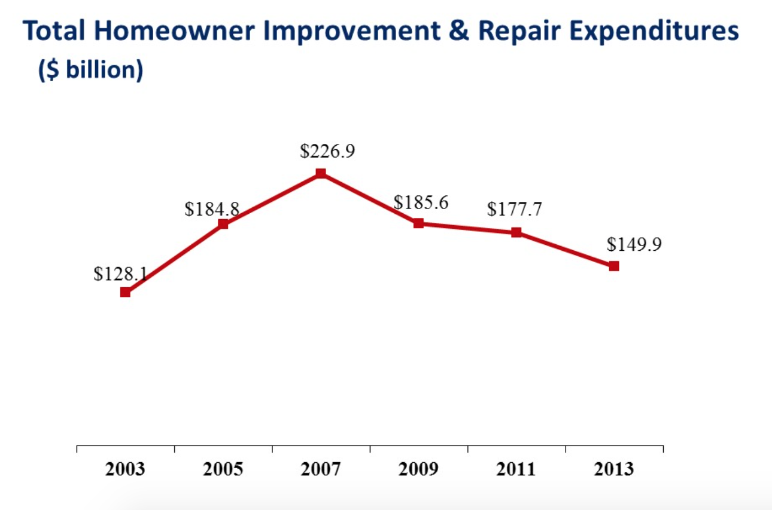
NAHB Analysis on eyeonhousing.org
According to eyeonhousing.org, these are the total amount of improvement and repair expenditures in Millions for Bathrooms:
2003: $7,161
2005: $11,174
2007: $14,496
2009: $11, 672
2011: $16, 956
2013: $12, 988
Most of the expenditures come from additions and alterations, which have been increasing by every year. Our product fits right under the new additions for bathrooms because it is a fast waste to receive the toilet paper with a press of a button. Besides the bidet, more public places have trouble with finding a way to decrease the amount of waste they produce. Many people over use toilet paper, and this option will help reduce over buying toilet products.

Potential Customers
Our “first customer” will target smaller airports across the nation. The majority will be top managers and the department of the janitorial services. Along with the American Association of Airport Executives, they are in charge of planning and the finance of airports. With the amount of waste that is being produced across the country, these customers are willing to spend money on this product to keep their restroom clean and less maintenance. The Automatic TP is necessary when it comes for oral hygiene. When people are traveling, they most likely use the restroom before boarding a plane. It is important for these users to understand the importance of saving the environment. Boomers and Millennials are more likely going to purchase this product, because they are either at the peak of their career or have a substantial home equity.
With selling to a larger business, it can influence smaller companies to also look into buying this product. Therefore, the numbers would be greater in sales based on certain populations. Starting out with airports in major cities such as Chicago, Los Anglos, and New York it will be limited geographically. Our customer will only need to purchase the product once, unless they added more restrooms in the building.
Competitors
Our major competitor is the bidet and the manual toilet paper dispensers. I will mainly focus on the bidet, because the manual dispenser the most common form of a dispenser. A bidet is a plumbing fixture to wash the user after using the bathroom. A bidet is inexpensive and a space saver, but is not meant to replace toilet paper. This product is more compared to a sink because of the water jet. Bidets can mostly be found in hospitals and some public areas. The bidet can reduce the amount of paper waste, but increases the amount of water and heat used causing the owner to be spending more money on those utilities.
The disadvantage of the bidet, they are more expensive and have separate attachments. A bidet cost between $250 and $700. Some bidets are separate from the toilet, which take up more space in the restroom. If a user does not have space in their restroom, they can buy a washlet, which is a toilet seat with an electric bidet. These costs are $300 on the market. It comes with different features such as blow-dry and temperature, this is more popular in Asia. The Automatic TP is affordable, space friendly, and requires no attachments. If a user is not comfortable with a bidet and wants to reduce their use of toilet paper, this product is the one for them.
The bidet sell their products online such as Amazon or their website, and in retail stores such as JCPennys, Lowes, and Sears. The user is most likely to find the bidet online rather in stores. The Automatic TP will be sold online through Amazon and our personal website with the growth of social media, this will increase sales at stores such as Menards, Lowes, and Home Depot.

Product/Service Plan
The product and service plan requires installment and repairs if the machine does have a problem that is not discovered yet. With customer service, our company will provide a fast and easy way to connect to our customers. This will allow customers ask questions, put in requests, and have comments about the product. The more feedback we have about the Automatic TP, it will help our business grow and have more people save the environment. Our staff will handle any situation and explain to the customer that we will solve their problem quickly.

Marketing Strategy
Targeting Market, Branding, and the Competition
The target market will be airports across the nation. Americans use about 36.5 billion rolls, which is about 15 million trees. Customers want to feel comfortable using a public restroom and most businesses are switching to recycled toilet paper. Airports need certain documents explaining what materials can be reduced, reused and recycled. Providing this product in airports will educate users that the environment is in need of our help. The Automatic TP will branch out to other businesses in the near future.
The Automatic TP is the next step for opportunity. It will help users make their bathroom time more comfortable by not over using toilet paper. The bidet eliminates toilet paper, but users might not feel contented. The manual toilet paper dispenser does not help with waste, leaving troubles in the restroom. With the dispenser ripping off seven sheets at a time, there is no worry about clogging the toilet in a public area. Any type of toilet paper will be able to fit into the machine, but we do recommend recycled toilet paper.
Marketing Strategy
Our way of marketing would be by social media, trade shows, and commercials. Starting out with advertising campaigns will help produce start up customers to purchase our product. Having a personal website with information that has demonstrations of how the dispenser works will help influence the purchase. Also, in retail stores we will have a dispenser on the shelf that users can try. Also, we can advertise on HTV; this will help home/business designers to research about the product and make their bathrooms futuristic. Our competitor does not advertise on television in the U.S. but does in other countries. We will have advertisement with explaining how the product works, and why it is important to save the environment.
Distribution
The distribution method would mainly be through Amazon, our website, and retail stores such as Lowes, Menards, and Home Depot. Eventually in the future, the Automatic TP might partner with Kohlers Co. Kohler can benefit from the Automatic TP because its another option for users to buy in bulk. It would create more frequent purchases because it is labeled with a brand name. The Automatic TP would also have a good reputation since Kohler Co. is a main bathroom supply store online. Promoting the product will help companies realize what we are trying to do to help businesses save the environment.
Pricing
The Automatic TP will be sold online and in stores. Our product will be sold at $50.00 per machine, or the bulk price (10 machines) at $400. By selling online, the customer will have the option to buy one machine or the bulk package but if the customer decides to buy at the store they will only have the option of buying one machine at a time. The bidet mostly sell online in America, but in other European countries users are more likely to find them in retail stores. By selling the product online, there will be a small fee of shipping and handling. This might scare some customers away, but our policy insists of free returns if bought online under some conditions.
We want our product to be affordable for local and big businesses. It is important to us that customers are willing to spend a reasonable price to help reduce toilet paper waste. For a bidet, it is expensive for one machine and for public restrooms and plenty of businesses will decide to spend their money on a different expense. The Automatic TP is want companies want, which affordable and creates convenience in the bathroom.
Goals
The Automatic TP has many goals for the future. With the amount of research development and advertising we plan for our product to be a nationwide utility. We want to start off by commercials on HTV so that homeowners and business owners are able to see how the product can impact their savings. We expect to target small airports in cities that produce too much paper waste. This will have an effect on word of mouth advertising for bigger airports to realize the impact it is making. Having our product sit on a shelf at retail stores will also help our sales go up because customers will be interested by using the demonstration in the ale. We expect this product to be slow in sales in the beginning and then market off within the following year and slow back down because businesses already have purchased this item. Also, eventually we will be able to make different styles of the dispenser and upgrade our technology to avoid any problems that we do come across.
Estimated Financial Statements

- Automatic TP will sell for $50.00 per dispenser, $400 per bulk package (10 dispensers)
Start-up Costs
- Legal Work $300
Having Legal Work will provide common stock and financing from a lawyer.

- Logo Design $200
A small simple logo design would approximately be about $200. It would be clear and professional. The cheaper logo, the more simple it is and for the customers to understand what the product is.

- Advertisement/Marketing $1,500
Advertising the product with an audio/visual form of how the product works will promote the product. It is a non-personal message that is communicated through mass media. This will advertise about 15 minutes a month, which is about 15 seconds each time it is aired on television.

- Website $5,000
Having a small website will cost about $5,000 it depends on how much is on the website. Adding new links to the site will help customers be informed how to get the product into their hands.

- Equipment/Machinery $25,000
Machinery and Equipment will cost about $25,000 to make the product. Going to a factory where the machines are already there the company will be able to make the product for a low quality price. Raw materials would be included in the contract.

- Insurance $1,500
Having insurance for the product will be convenient if damage does occur. This will also help with the companies safety overall.

- Research and Development $1,500
The product will need a lot of research, on how to make the product, getting the correct equipment, finding out who to target, and what it takes to get the product out in the media.

- Supplies & Office Space $14,000
Office space and supplies are important when developing a new product. Office space will have meetings held there to develop new ideas. This will be monthly rent in the beginning, with rented office furniture.

- Employee expenses $2,500
Employees will get paid on average of $17 an hour; these employees will talk to customers on the floor about the product. Managers/Supervisors would have a set salary.

- Technological expenses $12,000
Having the latest technology such as computers, tablets, IPads, and IPhones. This will help the company develop the product around the technology instead of paper and pen.

- Inventory $20,000
Having a set inventory would be about $20,000. This will keep the goods in stock, and will be ready to be sold. We value our inventory as FIFO (first in first out), which the material purchased the earliest will go out first.

- Travel $15,000
Traveling around to trade shows (to advertise), this will provide car rental, hotels, airplanes, and more.

- Shipping $150 (bulk package)
Shipping is able to get the product from one place to another. The bigger the package the higher the shipping price is going to be. Since this product is on the medium size, it will cost more to ship.

_________________________________________________________________________________________
Total $98,650

The start-up funds will come from loans from the bank, extra savings, and donations.

Quarter 1 Units Profit
Month 1: Automatic TP Sales 30 $1,500
Units Produced 90

Month 2: Automatic TP Sales 40 $2,000
Units Produced 90

Month 3: Automatic TP Sales 55 $2,750
Units Produced 90

Quarter 2 Units Profit
Month 4: Automatic TP Sales 80 $4,000
Units Produced 100

Month 5: Automatic TP Sales 85 $4,250
Units Produced 100

Month 6: Automatic TP Sales 90 $4,500
Units Produced 100

Quarter 3 Units Profit
Month 7: Automatic TP Sales 120 $6,000
Units Produced 250

Month 8: Automatic TP Sales 140 $7,000
Units Produced 250

Month 9: Automatic TP Sales 165 $8,250
Units Produced 250

Quarter 4 Units Profit
Month 10: Automatic TP Sales 220 $11,000
Units Produced 345

Month 11: Automatic TP Sales 290 $14,500
Units Produced 345

Month 12: Automatic TP Sales 330 $16,500
Units Produced 345

*This is for individual machines ($50.00 per dispenser) for the first year

Quarter 1 Units Profit
Month 1: Automatic TP Sales 10 $4,000
Units Produced 30

Month 2: Automatic TP Sales 15 $6,750
Units Acquired 30

Month 3: Automatic TP Sales 19 $8,550
Units Produced 30

Quarter 2 Units Profit
Month 4: Automatic TP Sales 25 $11,250
Units Produced 40

Month 5: Automatic TP Sales 30 $13,500
Units Produced 40

Month 6: Automatic TP Sales 32 $14,400
Units Produced 40

Quarter 3 Units Profit
Month 7: Automatic TP Sales 40 $18,000
Units Produced 50

Month 8: Automatic TP Sales 45 $20,250
Units Produced 50

Month 9: Automatic TP Sales 50 $22,500
Units Produced 50

Quarter 4 Units Profit
Month 10: Automatic TP Sales 55 $24,750
Units Produced 75

Month 11: Automatic TP Sales 65 $29,250
Units Produced 75

Month 12: Automatic TP Sales 70 $31,500
Units Produced 75

*This is for the bulk package (10 dispensers for $400.00) for the first year.
The income statements show the start-up expenses throughout the 1st year of business. Starting off with producing 90 units, it will cost about $30 to make each machine, our company would make $600. Each month the company has to pay sourcing amount for the product. By looking online, there are similar products such as a automatic paper towel dispenser that averages out between $25-$30 to make per machine. The demand for the Automatic TP should grow throughout each year, and with that being said the break-even should be within year 2 or 3. Each month we will produce more machines and by the end of the year on a demand agreement the maximum would be 345 units.

Income Statement

For individual Machines
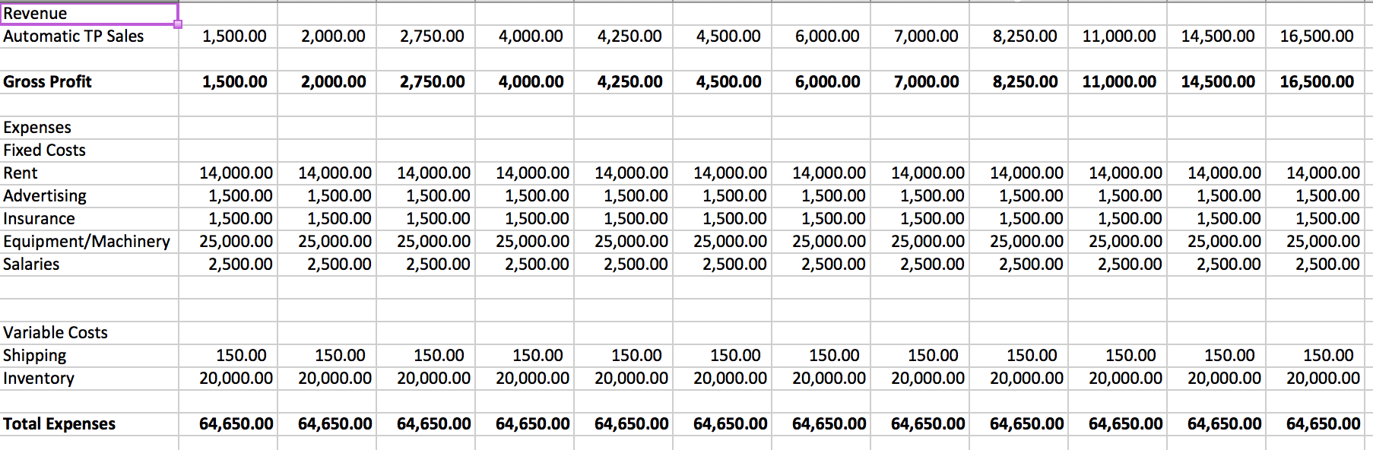

\

For Bulk Packages
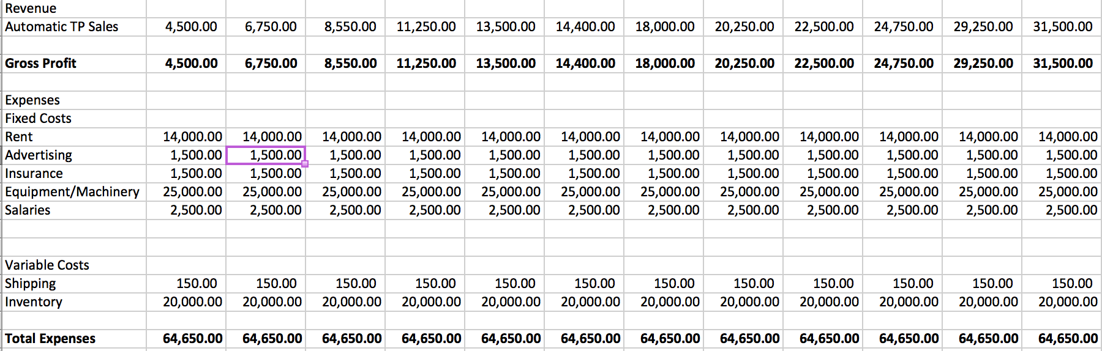

We are going to make sure our schedule is on budget, with the increase of sales every month and quarter we are able to keep track of our revenue and expenses.

Work Cited

Why Most Americans Don't Own a Bidet in Their Toilet. (n.d.). Retrieved November 30, 2017, from https://articles.mercola.com/sites/articles/archive/2014/10/18/bidet-use.aspx

(n.d.). Retrieved November 30, 2017, from http://www.kohler.com/corporate/index.html

(n.d.). Retrieved November 30, 2017, from http://www.kohler.com/corporate/index.html

Zhao, N., Dietz, R., Neal, M., Melman, S., & Fu, J. (n.d.). Eye On Housing. Retrieved November 30, 2017, from http://eyeonhousing.org/

International, I. A. (n.d.). Home. Retrieved November 30, 2017, from https://www.aaae.org/

