- Chiang Kai-shek (1887-1975)
Chiang Kai-shek was the leader of the Chinese Nationalist Party which eventually become know as the Kuomintang Party. Promoted by Sun Yat-sen, he rose to leadership of the Nationalist Party shortly after Sun Yat-sen's death in 1925. Chiang Kai-shek was best known for the defeat of his Kuomintang party by the communists in 1949. Chiang Kai-shek and his party were driven from the mainland and set up an government in exile in Taiwan with it's capital in Taipei. He then became the leader of the government in exile until his death in 1975.
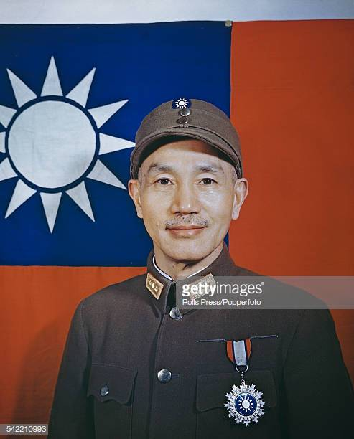

- Sun Yat-sen (1866-1925)
A revolutionary leader of the Chinese Kuomintang party that overthrew the Manchu dynasty. Known as "The Father of the Revolution, Sun Yat-sen was an idealistic leader who sought to unite China under one stable government. He died of cancer in 1925.
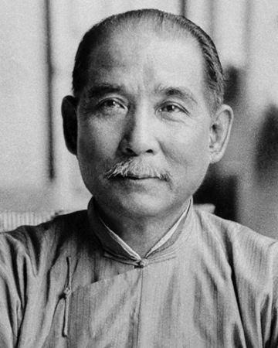

- Dalai Lama
The Dalai Lama is the religious head of Lamaism, a branch of Buddhaism in Tibet. This religion believes the Dalai Lama rules for life and upon death, he is re-incarnated into the body of a baby boy. The current Dalai Lama is the 14th Dalai Lama, Gyalwa Tenzin Gyatso. He was born in 1935 and selected Dalai Lama at the age of two.
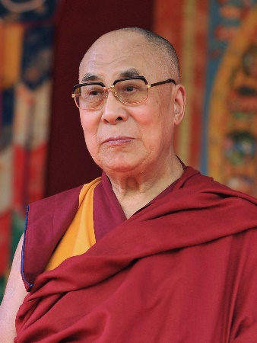

- Confucius:
Confucius(or K'ung-fu-tzu) was one of the greatest philosophers in Chinese and world history. Confucius , was born in 551B.C. His teachings did not become popular for centuries after his death, dominating the religious beliefs of China from 100B.C. until the early 1900's. Even today, his teachings have a great impact upon the culture and people of china.
Confucius had five cardinal(Social) relationships:
- Ruler and ruled
- Husband and Wife
- Parents and Children
- Older and younger brothers
- Friends
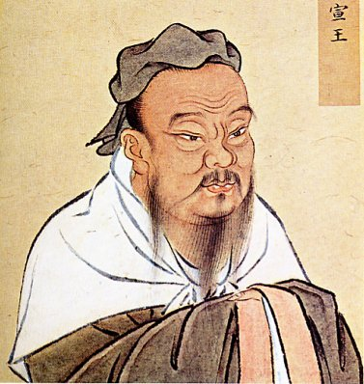

- Chairman Mao(Mao Zedong):
Mao Zedong (1893 — 1976)
Chinese history, central figure, The founder of communist China and one of the most influential figures of the 20th century, Mao Zedong was born in 1893 to a wealthy farming family in Hunan province of south-central China.

During Mao’s childhood, the nation was undergoing turmoil. Protests against famine and corruption spread across the nation, and military crackdowns by the forces of the Qing emperor were brutal. In 1911, the empire was overthrown and a limited republican government was established.
Discontent remained across China, however, and by 1921 Mao had joined the newly-formed Communist Party. Between 1927 and 1949, the Chinese Communist Party began to fight an open war against the government, in rebellions triggered by brutal crackdowns and massacres. Mao commanded large forces throughout this period, and by 1935 was the undisputed leader.
By 1949, a coalition led by Mao overthrew the ineffectual Chinese government and created the new People’s Republic of China. Over the next 30 years of his life, Mao ruled China with few challengers. During this period, he sent Chinese troops to Korea, persecuted political challengers, and instituted the “Great Leap Forward,” a program of land redistribution and agricultural changes that led to massive famine. He also oversaw the Great Proletarian Cultural Revolution, an initiative to weed out all “counter-revolutionary” elements from Chinese society.
He remains a controversial figure in world history, remembered as a dictator who oversaw human rights abuses, but also as an influential political theorist who modernized China and rid it of imperialism.
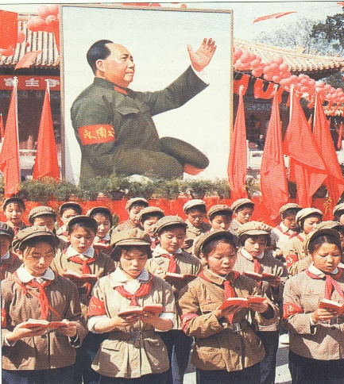

- Deng Xiaoping
Deng became the leader of China shortly after Mao's death in 1976. He died in 1997 of Parkinson's disease and a lung infection.
Deng's relationship and loyalty to Mao dates back to the long march in 1934 -1935. Deng's leadership style was significantly different from Mao Zedong, preferring a low key style of leadership. Deng never assumed the position of Communist Party Chief or head of the government, stating "It doesn't matter if the cat is black or white as long as it catches the mice."
Some of the highlights of Deng and his life:
- Participated in the Long March with Mao Zedong(1934-1935)
- Started the country on a course of reform and liberalization
- Key goals were to bring wealth, modernization and power to China
- Opened the country to investment from the west paving the way for true growth and prosperity
- established ties to the U.S. and most western governments
- His biggest challenge was Tiananmen Square, where he staunchly upheld communist rule
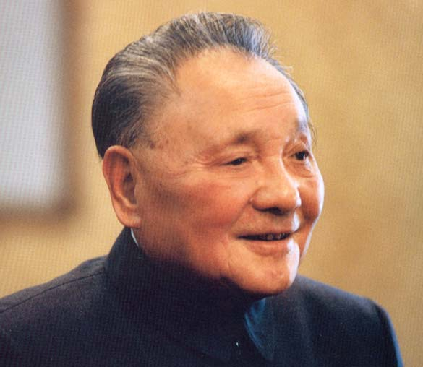

- Lao Zu (c. 571 BC — 471 BC)
Lao Zu, Chinese history, central figure. Not many societies can claim that a philosopher-poet is central to their history, but the Chinese can. Lao Zu (also Laozi or Lao-Tzu) is a legendary figure in Chinese folk history. It is believed that Lao Zu lived around 500 BC. He is most famous as the author of the Tao Te Ching 道德经— and as such, the founder of the religion/philosophy Taoism.
Taoism is based on the concept of Tao, the source and basis of all existence, a sort of spiritual anima that permeates the universe. In the Tao Te Ching, Lao Zu asks readers to be humble and work in harmony with this natural force. One central concept is We wei, or “non-action,” which is often translated to relate to the importance of not forcing anything.
His influence on Chinese culture (and indeed, all of East Asia) has been massive, even reaching beyond the region. Many westerners involved in anti-authoritarianism cite Lao Zu as a foundational thinker. Some people claim that Lao Zu tutored the young Siddartha Gautama, who would become Buddha.

